Gloucester, Massachusetts, USA
America's oldest seaport (est. 1623) still smells of salt and fish. Tender ashore to a working harbor town of maritime museums, whale-watch boats, Rocky Neck galleries, and the freshest clam chowder on the Eastern Seaboard.
⚓ Tender port · 🕒 Typical call: 6–8 hrs · 💵 US Dollar (USD) · 🗣️ English · 🦞 New England seafood
✍️ MY DAY IN PORT (FILL IN)
Ship / Date
In port | arrive ______ · all aboard ______
Booked excursion
Notes / meeting point
GETTING ASHORE
- Docking: Tender — ships anchor in Gloucester Harbor; 10–15 min boat ride to Cruiseport Gloucester (Rowe Square) downtown
- Walk to center: 2–5 min from the tender dock to downtown Main Street
- Best For: Maritime history, whale watching, seafood, Cape Ann beaches
- Don't Miss: The Fisherman's Memorial (Man at the Wheel) on Stacy Boulevard
GETTING AROUND
- 🚕 Taxi: $5–$15 — Local taxis (Gloucester Taxi & Livery 978-283-0099, Fisherman's Taxi 978-283-1600) serve the port. Short hops downtown t
- 📱 Rideshare: ✅ Uber, Lyft
TOP THINGS TO DO
- Man at the Wheel & Stacy Boulevard — Walk the HarborWalk to Gloucester's most photographed landmark — the 1925 bronze Fisherman's Memorial honoring 10,000 fishermen…
- Stellwagen Bank Whale Watch — Gloucester sits at the edge of Stellwagen Bank National Marine Sanctuary — one of the world's top whale-feeding grounds.
- Cape Ann Museum — A world-class regional museum housing the largest collection of maritime painter Fitz Henry Lane's work, alongside full-scale…
- Rocky Neck Art Colony — America's oldest continuously working art colony occupies a little peninsula east of downtown.
- Hammond Castle Museum — Eccentric inventor John Hays Hammond Jr.
BEST WALKS
- HarborWalk to the Fisherman's Memorial: 2.5 km • ~45 min • Easy, flat — Walk west along the Stacy Boulevard HarborWalk from the Cruiseport Gloucester tender dock at Rowe…
- Downtown & Maritime Gloucester: 1.5 km loop • ~30 min • Easy — From the tender dock, stroll north on Rogers Street to Main Street, browse the historic downtown…
WEATHER · DAYLIGHT · MONEY
Month | High °F | Low °F | Rainy days
May | 62 | 46 | 12
Jul | 71 | 56 | 11
Sep | 66 | 52 | 9
Daylight: May 5:20AM–7:58PM · Jul 5:18AM–8:18PM · Sep 6:23AM–6:51PM
Representative sunrise/sunset — 2025, 15th of each month; local civil time including DST (America/New_York). Source: Astral; not a forecast or climate average.
cruiseports.org/gloucester-ma · Confirm terminal & all-aboard time with your ship

Gloucester, Massachusetts, USA — Port Map
Red = walkable sights · Amber = excursions farther out · P = cruise terminal
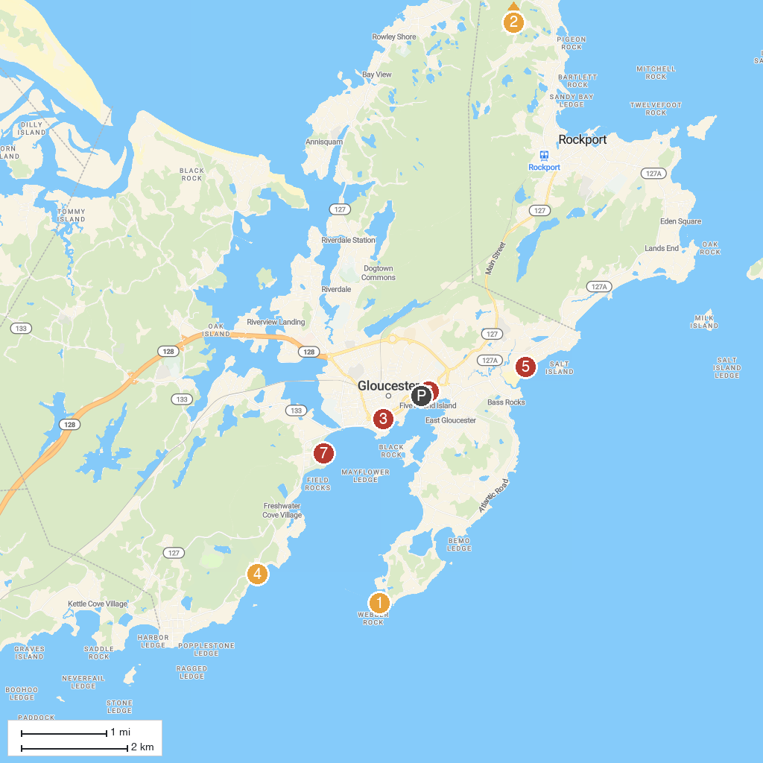
MAP KEY
1. Eastern Point Lighthouse | 5. Good Harbor Beach
2. Halibut Point State Park | 6. Cape Ann Whale Watch
3. 7 Seas Whale Watch | 7. Stage Fort Park
4. Hammond Castle Museum | 8. Castle Hill on the Crane Estate
P. Cruise port / terminal
Map © MapTiler © OpenStreetMap contributors · cruiseports.org

