Golfito, Puntarenas, Costa Rica
A sleepy ex-banana-company town hugging the Golfo Dulce — one of only four tropical fjords in the world — Golfito rewards adventurous cruisers with scarlet macaws, resident dolphins, and virgin rainforest with almost no crowds.
⚓ Pier (small/expedition ships) · 🕒 Typical call: 6-8 hrs · 💵 USD widely accepted · 🗣️ Spanish · 🌿 Eco / Wildlife
✍️ MY DAY IN PORT (FILL IN)
Ship / Date
In port | arrive ______ · all aboard ______
Booked excursion
Notes / meeting point
GETTING ASHORE
- Docking: Pier (Muelle Turístico) for expedition ships; tender for rare larger calls
- Walk to center: 5 min to main street; American Zone ~15 min
- Best For: Wildlife, sportfishing, dolphins, rainforest hiking
- Don't Miss: Dolphin tour on the Golfo Dulce & historic American Zone
GETTING AROUND
- 🚕 Taxi: $3–5 USD — Official red taxis are available near the pier. Fares within Golfito are short and inexpensive; confirm the fare with th
TOP THINGS TO DO
- Golfo Dulce Dolphin & Snorkel Tour — The Golfo Dulce shelters resident pods of bottlenose and spotted dolphins year-round.
- Piedras Blancas National Park Hike — A short boat ride across the bay leads into one of Costa Rica's most biodiverse rainforests — home to all four native monkey…
- Sportfishing Charter — Golfito is world-famous for sportfishing.
- Finca Kobo Chocolate Farm Tour — Across the gulf, this organic cacao farm takes you through the full journey from tree to bar — picking, fermenting, and tasting.
- American Zone Historic Walk — Explore the distinct wooden stilt houses and administrative buildings built by the United Fruit Company for its managers in the…
BEST WALKS
- Muelle to American Zone Historic Stroll: 1.5 km · 20 min · Easy · Flat — Walk north from the pier along the main road through the town centre, past local sodas and the…
- Playa Cacao Beach (Water Taxi): 5-10 min by lancha · Easy · Bring bug spray — Cross the bay by water taxi to Playa Cacao, a dark-sand beach lined with palms and a couple of…
WEATHER · DAYLIGHT · MONEY
Month | High °F | Low °F | Rainy days
May | 83 | 73 | 29
Jul | 81 | 73 | 30
Sep | 82 | 72 | 29
Daylight: May 5:13AM–5:44PM · Jul 5:21AM–5:55PM · Sep 5:22AM–5:32PM
cruiseports.org/golfito · Confirm terminal & all-aboard time with your ship

Golfito, Puntarenas, Costa Rica — Port Map
Red = walkable sights · Amber = excursions farther out · P = cruise terminal
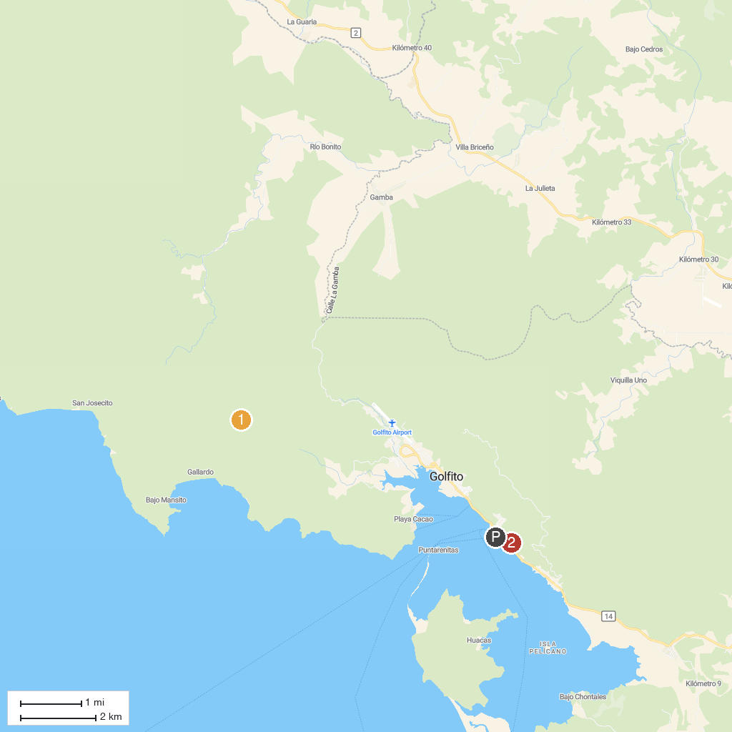
MAP KEY
1. Refugio Nacional de Vida Silvestre Golfito | 3. Pueblo Civil de Golfito (Zona Americana)
2. Piedras Blancas National Park
P. Cruise port / terminal
Map © MapTiler © OpenStreetMap contributors · cruiseports.org

