Golfo Dulce, Osa Peninsula, Costa Rica
One of only four tropical fjords on Earth, Golfo Dulce wraps calm, whale-nursery waters in some of the planet's densest rainforest. Expedition ships anchor offshore; mornings here belong to scarlet macaws, howler monkeys, and the occasional tapir track.
⚓ Tender port (anchor out) · 🕒 Typical call: 6–8 hrs · 💵 USD widely accepted / Costa Rican Colón · 🗣️ Spanish (English common in tourism) · 🌿 Eco & expedition destination
✍️ MY DAY IN PORT (FILL IN)
Ship / Date
In port | arrive ______ · all aboard ______
Booked excursion
Notes / meeting point
GETTING ASHORE
- Docking: Tender — ships anchor; Zodiacs or pangas ferry passengers ashore to Golfito or Puerto Jiménez
- Walk to center: 5–10 min flat from Golfito pier; Puerto Jiménez main street is directly at the dock
- Best For: Wildlife, birdwatching, rainforest hikes, Corcovado access, whale-watching
- Don't Miss: Wild scarlet macaws in flight, a fresh ceviche at the waterfront, and the drive or boat to Corcovado
GETTING AROUND
- 🚕 Taxi: $5–$15 — Local taxis are available near the Golfito pier. Short rides within Golfito town are inexpensive; confirm the fare befor
TOP THINGS TO DO
- Corcovado National Park Hike — National Geographic's 'most biologically intense place on Earth.' A certified guide is required by law.
- Whale & Dolphin Watching — Golfo Dulce is one of few places where both Northern and Southern Hemisphere humpback whales breed.
- Casa Orquídeas Botanical Garden — A private garden on the gulf's inner shoreline accessible only by boat.
- Mangrove Kayaking (Coto or Esquinas River) — Paddle through ancient mangrove tunnels that shelter caimans, herons, kingfishers, and boa constrictors.
- Playa Cacao Beach Day — A 10-minute water taxi from Golfito, Playa Cacao offers calm, warm dark-sand swimming, a couple of rustic beach bars, and far…
BEST WALKS
- Golfito Waterfront & American Zone: ~1.5 km · 25 min · Flat · Free — Walk north from the marina along the waterfront to the 'Zona Americana,' a cluster of raised wooden…
- Puerto Jiménez Town Stroll: ~1 km · 15 min · Flat · Free — From the dock, walk along Calle Principal past tour operators, Café Monka for coffee, and the…
WEATHER · DAYLIGHT · MONEY
Month | High °F | Low °F | Rainy days
May | 83 | 73 | 29
Jul | 81 | 73 | 30
Sep | 82 | 72 | 29
Daylight: May 5:13AM–5:44PM · Jul 5:21AM–5:55PM · Sep 5:22AM–5:32PM
cruiseports.org/golfo-dulce · Confirm terminal & all-aboard time with your ship

Golfo Dulce, Osa Peninsula, Costa Rica — Port Map
Red = walkable sights · Amber = excursions farther out · P = cruise terminal
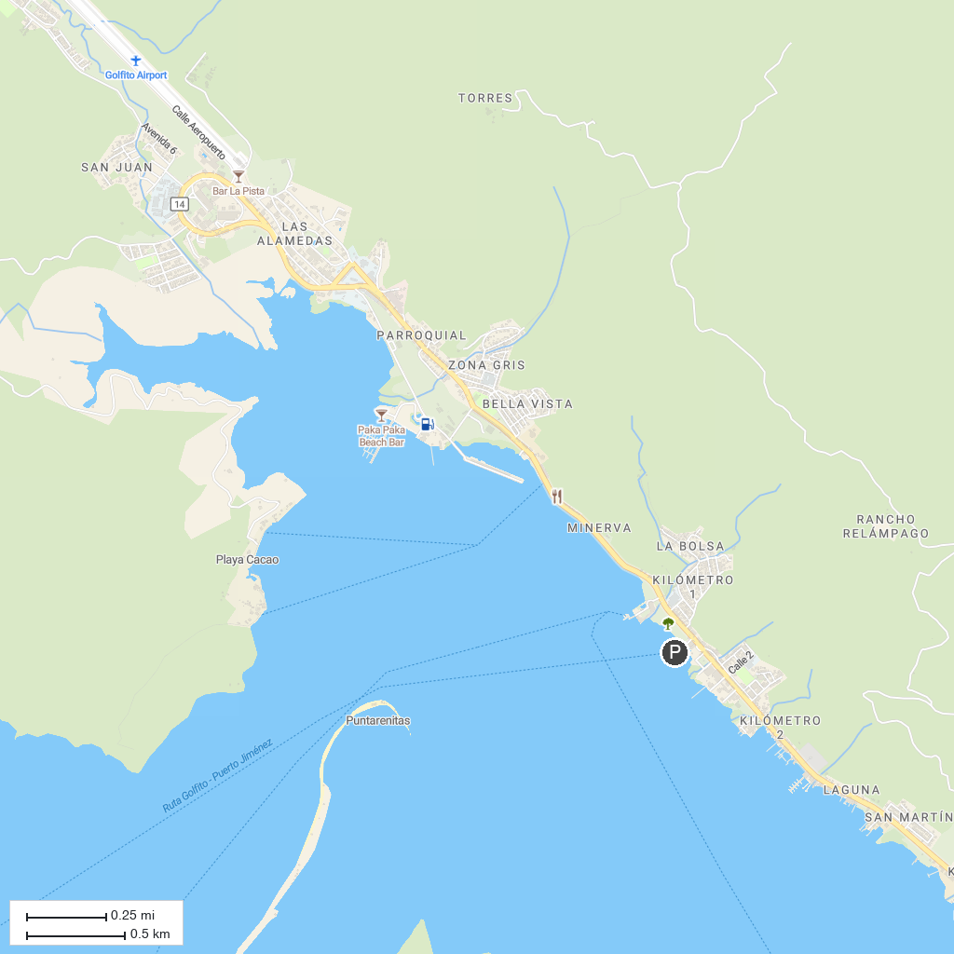
MAP KEY
1. Piedras Blancas National Park | 2. Casa Orquideas Botanical Garden
P. Cruise port / terminal
Map © MapTiler © OpenStreetMap contributors · cruiseports.org

