Gouda, South Holland, Netherlands
Said with a throaty Dutch 'G' (roughly 'KHOW-da,' like clearing your throat — not the English 'Gooda'), Gouda is more than a cheese. It's one of the Netherlands' most intact medieval canal towns, with a fairytale town hall, the longest church in the country, and the world's finest Renaissance stained glass.
⚓ River cruise (pier/quay) · 🕒 Typical call: 6-8 hrs · 💶 Euro (cards preferred) · 🗣️ Dutch (English widely spoken)
✍️ MY DAY IN PORT (FILL IN)
Ship / Date
In port | arrive ______ · all aboard ______
Booked excursion
Notes / meeting point
GETTING ASHORE
- Docking: River cruise ships dock along Turfsingel or IJsselkade — no tender, flat walk to center
- Walk to center: 5–15 min from quay to the Markt (market square)
- Best For: History, food, architecture, photography
- Don't Miss: Sint-Jan's 72 Renaissance stained-glass windows and a warm stroopwafel at the market
GETTING AROUND
- 🚕 Taxi: €85–€110 — Door-to-door taxi from Rotterdam Cruise Terminal to Gouda city center takes about 26–27 min. Convenient but significantl
- 📱 Rideshare: ✅ Uber, Bolt
TOP THINGS TO DO
- Sint-Jan Church & the Goudse Glazen — At 123 m, the longest church in the Netherlands houses 72 breathtaking 16th-century stained-glass windows that survived the…
- Gouda Cheese Experience — Interactive museum tracing the history of Goudse Kaas from farm to wheel, ending with a tasting of aged, cumin, and truffle…
- Thursday Cheese Market (seasonal) — From April to September every Thursday morning, farmers and traders seal deals with the traditional handjeklap hand-clap ritual…
- Museum Gouda — Housed in a 14th-century former hospital, this local history museum holds 17th-century militia paintings, historic clay pipes…
- Stroopwafel at Kamphuisen Bakery — The stroopwafel was invented in Gouda in 1810.
BEST WALKS
- The Markt & Old Town Loop: 1.5–2 hrs · 2.5 km · Easy — Start at the 15th-century Gothic Stadhuis in the center of the Markt, whose mechanical carillon…
- Canal Stroll to the City Beach: 1 hr · 2 km · Easy — Walk from the Markt to the Veerstal and take the tiny volunteer foot ferry across the Hollandse…
WEATHER · DAYLIGHT · MONEY
Month | High °F | Low °F | Rainy days
May | 63 | 48 | 12
Jul | 72 | 58 | 14
Sep | 67 | 54 | 10
Daylight: May 5:47AM–9:28PM · Jul 5:39AM–9:54PM · Sep 7:16AM–7:55PM
cruiseports.org/gouda · Confirm terminal & all-aboard time with your ship

Gouda, South Holland, Netherlands — Port Map
Red = walkable sights · Amber = excursions farther out · P = cruise terminal
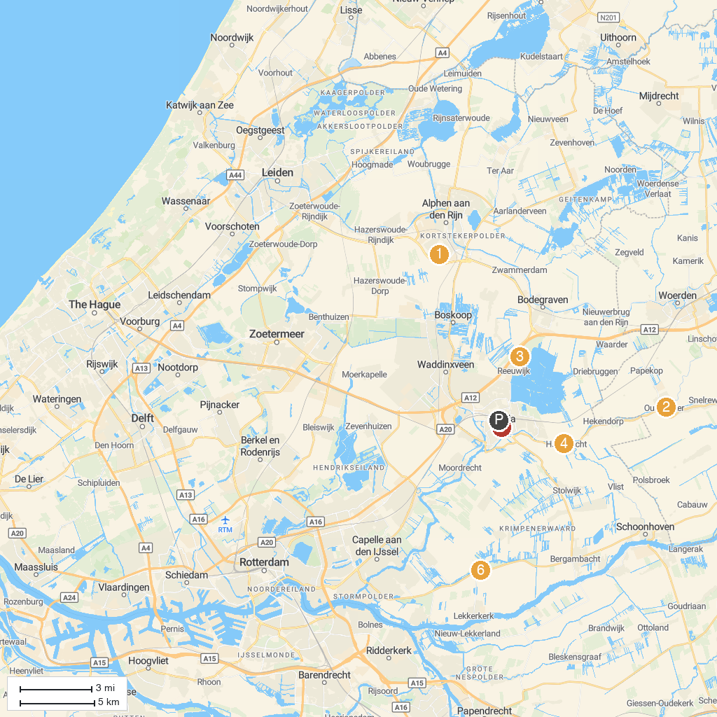
MAP KEY
1. Hoge Bergse Bos | 5. Streekmuseum Reeuwijk
2. Vogelpark Avifauna | 6. Museum Paulina Bisdom van Vliet
3. Archeon Museum Park | 7. Saint-John Church
4. Waag, Oudewater | 8. Recreatiepark Loetbos Lekkerkerk
P. Cruise port / terminal
Map © MapTiler © OpenStreetMap contributors · cruiseports.org

