Graciosa Island, Azores, Portugal
The quietest island in the Azores, Graciosa rewards those who seek it out: a dramatic volcanic cavern with a sulfur lake, red-domed Flemish windmills, warm thermal pools, and a sandy beach right at the tender pier.
⚓ Tender port (no cruise pier) · 🕒 Typical call: 6–8 hrs · 💶 Currency: Euro (€) · 🗣️ Language: Portuguese
✍️ MY DAY IN PORT (FILL IN)
Ship / Date
In port | arrive ______ · all aboard ______
Booked excursion
Notes / meeting point
GETTING ASHORE
- Docking: Tender to Porto da Praia, Vila da Praia
- Walk to center: 2–5 min to Vila da Praia village; Santa Cruz capital is 6 km (needs transport)
- Best For: Volcanic caves, windmills, thermal baths, off-the-beaten-path Azores
- Don't Miss: Furna do Enxofre sulfur cavern & queijadas pastries from the factory
GETTING AROUND
- 🚕 Taxi: €7–€15 — Taxis are available at the port and can take you to any point on the island. Short hops around Santa Cruz run €7–€10; cr
- 📱 Rideshare: ❌ not available
TOP THINGS TO DO
- Furna do Enxofre — Volcanic Sulfur Cavern — Descend a 183-step spiral staircase into a massive volcanic dome to find a cold, sulfurous lake and towering basalt columns.
- Termas do Carapacho — Thermal Baths & Natural Pools — Soak in ~40°C (104°F) volcanic spring water at the island's thermal spa on the southeast coast, or swim in the adjacent natural…
- Santa Cruz da Graciosa — Island Capital Walk — Explore the whitewashed capital with its 16th-century Igreja Matriz, the Praça dos Pauis (tree-lined square with ancient…
- Flemish Windmills & Wine Cooperative — Graciosa's red-domed windmills are an icon of Azorean heritage, introduced by Flemish settlers in the 15th century.
- Island Loop — Ponta da Barca Lighthouse & Ilhéu da Baleia — Drive the island perimeter to the dramatic Ponta da Barca Lighthouse on the northwest tip, then stop at the Ilhéu da Baleia sea…
BEST WALKS
- Vila da Praia Village Stroll: 0.5 km · 15 min · Flat · Free — From the tender pier walk along the seafront to Praia de São Mateus beach, then loop back through…
- Santa Cruz to Monte da Ajuda: 1.5 km one-way · 45 min · Uphill · Free — From Santa Cruz's Praça dos Pauis, walk up to the hilltop Monte de Nossa Senhora da Ajuda for…
WEATHER · DAYLIGHT · MONEY
Month | High °F | Low °F | Rainy days
May | 65 | 60 | 15
Jul | 73 | 68 | 14
Sep | 73 | 69 | 14
Daylight: May 6:39AM–8:58PM · Jul 6:38AM–9:16PM · Sep 7:33AM–7:59PM
cruiseports.org/graciosa-island-azores · Confirm terminal & all-aboard time with your ship

Graciosa Island, Azores, Portugal — Port Map
Red = walkable sights · Amber = excursions farther out · P = cruise terminal
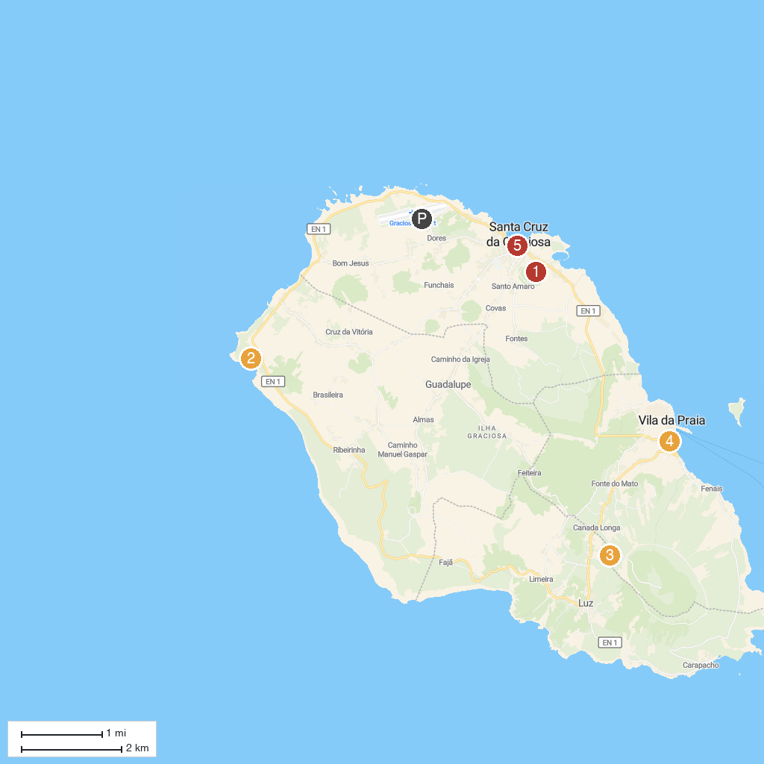
MAP KEY
1. Hermitage of Nossa Senhora da Ajuda | 4. Praia de São Mateus
2. Porto Afonso | 5. Museu da Graciosa
3. Furna do Abel
P. Cruise port / terminal
Map © MapTiler © OpenStreetMap contributors · cruiseports.org

