George Town, Grand Cayman, Cayman Islands
Brilliant turquoise water, one of the world's friendliest stingray encounters, and a famous seven-mile beach — all reached by tender into the heart of George Town.
⚓ Tender port (no pier) · 🕒 Typical call: 7-9 hrs · 💵 Cayman dollar (USD widely accepted) · 🗣️ English
✍️ MY DAY IN PORT (FILL IN)
Ship / Date
In port | arrive ______ · all aboard ______
Booked excursion
Notes / meeting point
GETTING ASHORE
- Docking: Tender only — ships anchor in George Town Harbour; 10-15 min ride to Royal Watler, North, or South Terminal
- Walk to center: Terminals drop you in the heart of George Town — shops, museum, and restaurants are steps away
- Best For: Stingray City, reef snorkeling, Seven Mile Beach, duty-free shopping
- Don't Miss: Stingray City sandbar — one of the Caribbean's signature wildlife encounters
GETTING AROUND
- 🚕 Taxi: CI$3–8 (~US$4–10) within George Town; ~US$15–20 to Seven Mile Beach — Government-regulated fares with mandatory rate cards in every cab. The Cayman Islands CI:GO app provides a digital fare
- 📱 Rideshare: ❌ not available
TOP THINGS TO DO
- Stingray City Sandbar — Waist-deep water on a mid-harbour sandbar where wild Southern stingrays glide around you.
- Seven Mile Beach — One of the Caribbean's top-rated beaches — powdery coral sand, calm clear water, and a long stretch of resorts, beach bars, and…
- Reef Snorkeling & USS Kittiwake — Grand Cayman's reefs are some of the clearest in the Caribbean.
- Starfish Point — A sheltered north-coast cove in calm, gin-clear shallows where bright red cushion starfish are easy to spot.
- Cayman Crystal Caves — Guided tour through underground chambers on the island's north side, with stalactites, crystals, and a colony of fruit bats.
BEST WALKS
- George Town Waterfront & Historic Quarter: 1.5 km · Flat · 30–45 min · Easy — From Royal Watler Terminal, walk south along Harbour Drive past the Cayman Islands National Museum…
- Smith's Barcadere (Smith Cove) Snorkel Stop: 20 min taxi south · Easy beach access · Free — A short taxi ride south of town brings you to Smith Cove, a protected rocky cove with calm, clear…
WEATHER · DAYLIGHT · MONEY
Month | High °F | Low °F | Rainy days
May | 86 | 78 | 28
Jul | 86 | 78 | 22
Sep | 85 | 77 | 27
Daylight: May 5:50AM–6:53PM · Jul 5:56AM–7:06PM · Sep 6:13AM–6:27PM
Representative sunrise/sunset — 2025, 15th of each month; local civil time including DST (America/Cayman). Source: Astral; not a forecast or climate average.
ESSENTIAL TRAVEL QUALIFICATIONS
Official peg CI$1 = US$1.20 (CIMA, checked 3 October 2026); retail/bank/card rates or fees may differ. Confirm currency, conversion and change before paying.
cruiseports.org/grand-cayman-island · Confirm terminal & all-aboard time with your ship

George Town, Grand Cayman, Cayman Islands — Port Map
Red = walkable sights · Amber = excursions farther out · P = cruise terminal
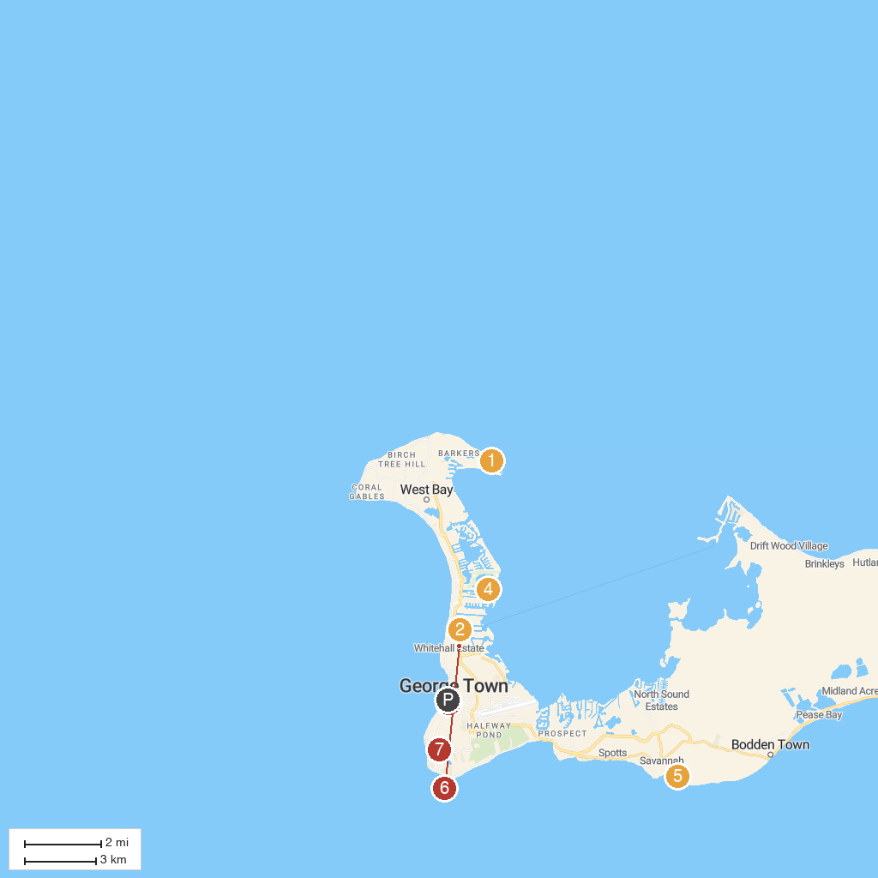
MAP KEY
1. Barker's National Park | 5. Pedro St James
2. Camana Bay | 6. The National Gallery of the Cayman Islands
3. Cayman Islands National Museum | 7. ignatius.ky
4. Stingray City Cayman Islands
P. Cruise port / terminal
Map © MapTiler © OpenStreetMap contributors · cruiseports.org

