Great Yarmouth, Norfolk, England
A Victorian seaside resort with real medieval bones — Great Yarmouth pairs Britain's best-preserved town walls with golden North Sea beaches, a 1903 circus, and the kind of fish-and-chips you can't get anywhere else.
⚓ Docked (Outer Harbour) · 🕒 Typical call: 6-8 hrs · 💷 GBP (British Pound) · 🗣️ English · 🌊 Beach port
✍️ MY DAY IN PORT (FILL IN)
Ship / Date
In port | arrive ______ · all aboard ______
Booked excursion
Notes / meeting point
GETTING ASHORE
- Docking: Docked at Outer Harbour — shuttle bus required to reach town (~10 min)
- Walk to center: Not walkable from port; free/paid shuttle to Market Gates or the seafront
- Best For: Classic British seaside, history buffs, beach days, day trips to Norwich
- Don't Miss: Hippodrome Circus (Britain's only surviving purpose-built circus still in use) and the 1932 wooden roller coaster
GETTING AROUND
- 🚕 Taxi: £5–£15 — Local cabs (Albies Taxis, Yella Cabs) are available at the quay. Short town-centre hops are at the lower end; longer tri
- 📱 Rideshare: ✅ Uber
- 🚌 Hop-on hop-off: ✅
TOP THINGS TO DO
- Medieval Walls & Minster Walk — Great Yarmouth has the second-best preserved medieval town walls in England.
- Time and Tide Museum — Housed in a Victorian herring curing works, this award-winning museum covers Great Yarmouth's fishing and maritime heritage with…
- Pleasure Beach — 1932 Wooden Roller Coaster — One of only two remaining wooden scenic railways in the UK that still uses a live brakeman on the train.
- The Hippodrome Circus — Built in 1903, this is Britain's only surviving purpose-built circus building still used for circus, and one of just a handful…
- Day Trip to Norwich — Just 30 minutes by train, Norwich offers a Norman cathedral, a 900-year-old castle, medieval cobbled Elm Hill, and excellent…
BEST WALKS
- The Golden Mile Seafront Promenade: 2 km · easy · 45-60 min — Walk the full length of Great Yarmouth's famous seafront from the Venetian Waterways and Cotman…
- Medieval Town Walls Circuit: 2 km loop · easy · 1 hr — Follow the surviving sections of Great Yarmouth's medieval flint walls — among the best-preserved…
WEATHER · DAYLIGHT · MONEY
Month | High °F | Low °F | Rainy days
May | 58 | 48 | 12
Jul | 69 | 58 | 11
Sep | 65 | 55 | 9
Daylight: May 4:56AM–8:43PM · Jul 4:48AM–9:08PM · Sep 6:27AM–7:07PM
cruiseports.org/great-yarmouth · Confirm terminal & all-aboard time with your ship

Great Yarmouth, Norfolk, England — Port Map
Red = walkable sights · Amber = excursions farther out · P = cruise terminal
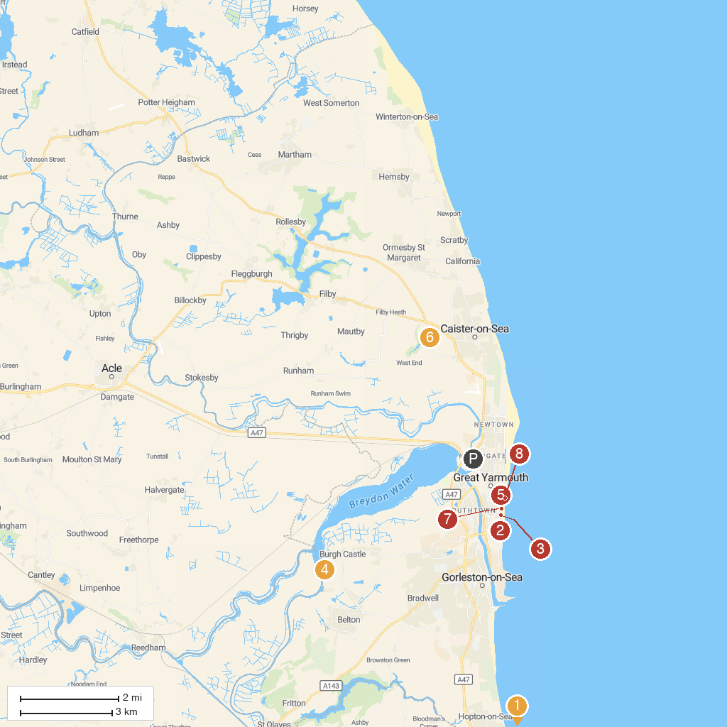
MAP KEY
1. Pleasurewood Hills Family Theme Park | 5. Jurassic Journey
2. Great Yarmouth Pleasure Beach | 6. Caister Castle
3. Merrivale Model Village | 7. SEA LIFE Great Yarmouth
4. Burgh Castle | 8. Great Yarmouth Beach
P. Cruise port / terminal
Map © MapTiler © OpenStreetMap contributors · cruiseports.org

