Greencastle, County Donegal, Ireland
A working Irish fishing village on the mouth of Lough Foyle, Greencastle is the tender gateway to one of Europe's finest walled cities — Derry — and the wild, cliff-edged Inishowen Peninsula.
⚓ Tender port · 🕒 Typical call: 7-9 hrs · 💵 Euro (€) in Greencastle; Pounds (£) in Derry · 🗣️ English
✍️ MY DAY IN PORT (FILL IN)
Ship / Date
In port | arrive ______ · all aboard ______
Booked excursion
Notes / meeting point
GETTING ASHORE
- Docking: Tender — ships anchor in Lough Foyle; tender boats land at Greencastle Harbour
- Walk to centre: Greencastle village is 2 min from the tender pier; Derry city is ~35 km away (taxi/excursion)
- Best For: History lovers, walkers, seafood enthusiasts, and anyone keen on authentic, uncrowded Ireland
- Don't Miss: Walking Derry's 17th-century walls; Kinnagoe Bay beach (Spanish Armada wreck site)
GETTING AROUND
- 🚕 Taxi: €40–50 — Local taxis cover the ~20-mile (32 km) journey to Londonderry in roughly 25 minutes. Availability at the port can be lim
- 📱 Rideshare: ✅ Uber, Bolt
- 🚌 Hop-on hop-off: ✅
TOP THINGS TO DO
- Derry's Walled City — Walk the complete 1.5 km circuit of 17th-century city walls, visit the neo-Gothic Guildhall, and explore the powerful Bogside…
- Malin Head & the Wild Atlantic Way — Drive to the northernmost point of mainland Ireland for dramatic sea cliffs, crashing Atlantic surf, and the famous EIRE sign — a…
- Doagh Famine Village — An open-air living museum on Inishowen that walks visitors through Irish life from the Great Famine of the 1840s to the present…
- Kinnagoe Bay Beach — A breathtaking, secluded golden-sand cove surrounded by green hills — and the resting place of the La Trinidad Valencera, a…
- Inishowen Maritime Museum — Right on the tender pier in Greencastle's old Coastguard station.
BEST WALKS
- Greencastle Harbour to Stroove Lighthouse: 3.5 km one-way | Easy | ~45 min — A flat, scenic coastal walk from the tender pier north along the Lough Foyle shore to Stroove…
- Derry City Walls Circuit: 1.5 km loop | Easy | ~45 min walking, 2+ hrs with stops — The full rampart walk atop Derry's 17th-century walls, with views over the Bogside and city centre.
WEATHER · DAYLIGHT · MONEY
Month | High °F | Low °F | Rainy days
May | 58 | 44 | 13
Jul | 64 | 53 | 15
Sep | 61 | 50 | 14
Daylight: May 5:19AM–9:30PM · Jul 5:08AM–9:58PM · Sep 7:00AM–7:44PM
Representative sunrise/sunset — 2025, 15th of each month; local civil time including DST (Europe/Dublin). Source: Astral; not a forecast or climate average.
cruiseports.org/greencastle-londonderry · Confirm terminal & all-aboard time with your ship

Greencastle, County Donegal, Ireland — Port Map
Red = walkable sights · Amber = excursions farther out · P = cruise terminal
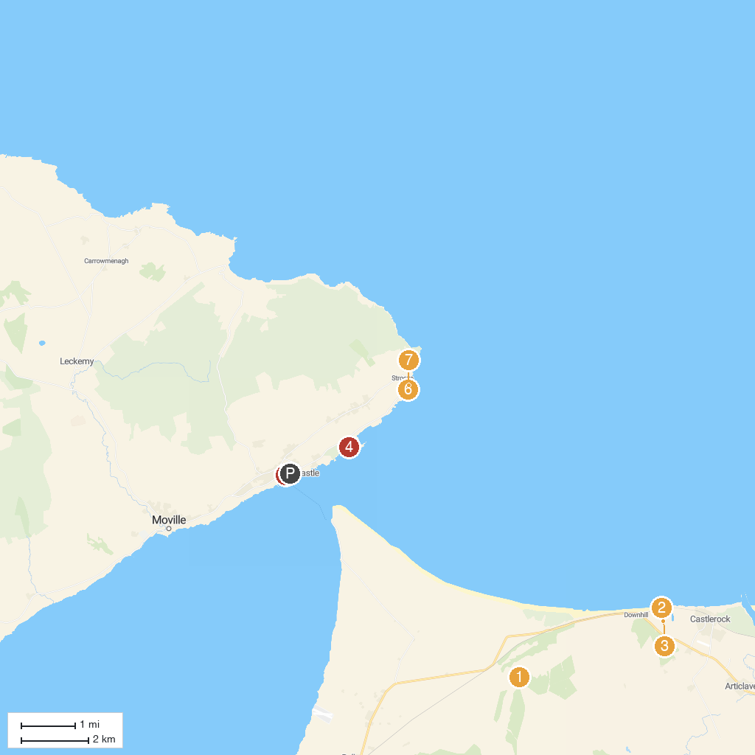
MAP KEY
1. Gortmore Viewpoint | 5. Greencastle Golf Club
2. Mussenden Temple | 6. Inishowen Maritime Museum
3. Crindle Stables | 7. Inishowen Lighthouse
4. National Trust - Mussenden Temple and Downhill Demesne | 8. Big White Bay
P. Cruise port / terminal
Map © MapTiler © OpenStreetMap contributors · cruiseports.org

