Grevenmacher, Luxembourg
Luxembourg's wine capital on the Moselle River, where sparkling Crémant cellars, a tropical butterfly garden, and medieval town walls are all a short stroll from the quay.
⚓ Docked (river quay) · 🕒 Typical call: 6–8 hrs · 💶 Euro (€) · 🗣️ Luxembourgish / French / German / English · 🚌 Free public transport nationwide
✍️ MY DAY IN PORT (FILL IN)
Ship / Date
In port | arrive ______ · all aboard ______
Booked excursion
Notes / meeting point
GETTING ASHORE
- Docking: Tied up at Quai de la Moselle — no tender, gangway to open esplanade
- Walk to center: 2–3 min flat walk to the pedestrian zone
- Best For: Wine tasting, easy strolling, a quick day trip to Trier or Luxembourg City
- Don't Miss: A guided tour and tasting at Caves Bernard-Massard
GETTING AROUND
- 🚕 Taxi: €15–€20 (short trips) — Local taxis charge approximately €3 base fare plus €3/km. Useful for reaching nearby villages or vineyards along the Mos
- 📱 Rideshare: ✅ Uber
TOP THINGS TO DO
- Caves Bernard-Massard Cellar Tour & Tasting — Luxembourg's most celebrated Crémant producer sits 300 m from the quay.
- Jardin des Papillons (Butterfly Garden) — An indoor tropical greenhouse filled with hundreds of free-flying exotic butterflies, chameleons, and quails — kept at a balmy 27…
- Medieval Town Walls & Hockerturm — Grevenmacher's 13th-century fortifications are partially intact.
- Day Trip to Trier, Germany — The oldest city in Germany is just 20 minutes by free bus from Grevenmacher.
- Border Walk to Wellen, Germany — Cross the Moselle on the pedestrian-friendly Wellen Bridge and set foot in Germany in under 10 minutes.
BEST WALKS
- Quay to Old Town & Crémant Caves: 1 km loop · 20 min · flat · free — From the quay head south along the promenade to Caves Bernard-Massard, then continue into the…
- Riverside Walk to the Butterfly Garden: 2.4 km round-trip · 30 min · flat — Follow the Moselle promenade north from the quay through willows and vineyards to reach the Jardin…
WEATHER · DAYLIGHT · MONEY
Month | High °F | Low °F | Rainy days
May | 65 | 48 | 11
Jul | 77 | 59 | 11
Sep | 69 | 53 | 9
Daylight: May 5:49AM–9:12PM · Jul 5:43AM–9:36PM · Sep 7:10AM–7:47PM
cruiseports.org/grevenmacher · Confirm terminal & all-aboard time with your ship

Grevenmacher, Luxembourg — Port Map
Red = walkable sights · Amber = excursions farther out · P = cruise terminal
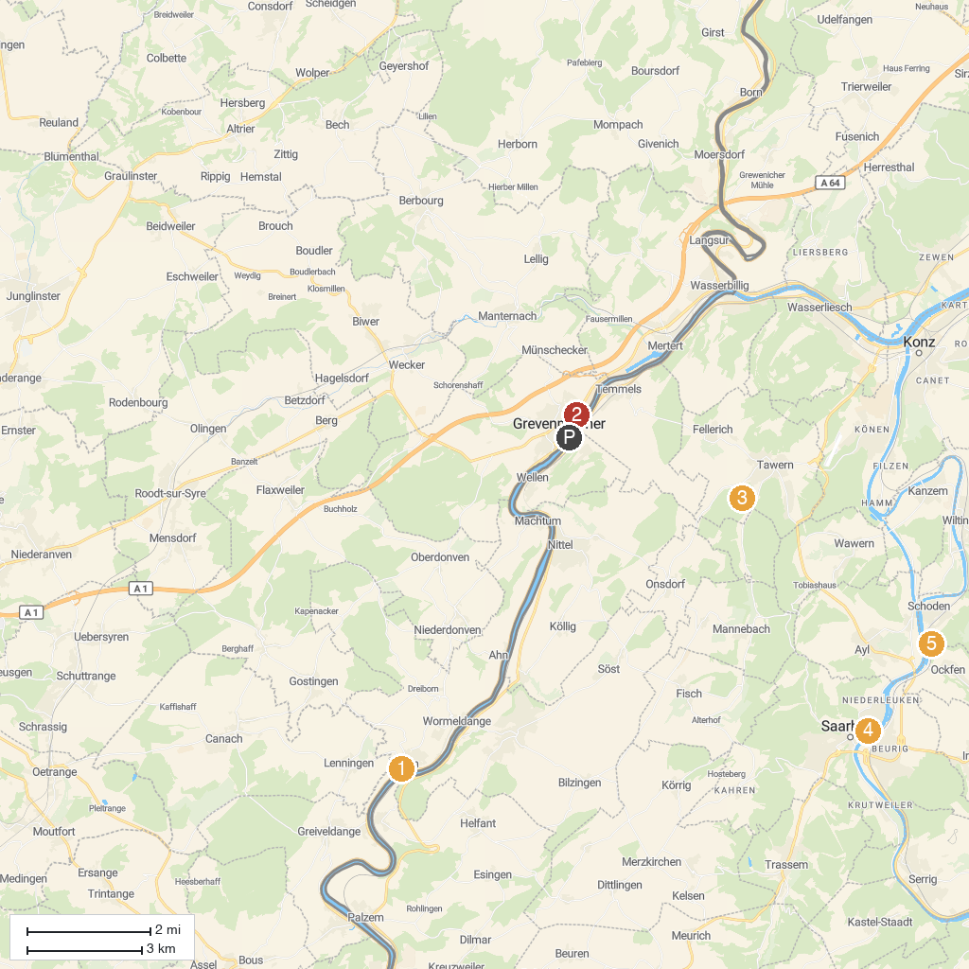
MAP KEY
1. Wäinhaus - Maison et musée du vin | 5. Bismarck Tower Schoden
2. Butterfly Garden, Grevenmacher | 6. Bulldog- und Landmaschinenmuseum Robert Willkomm
3. Roman Temple of Tawern | 7. Roman Villa Echternach
4. Saarburg | 8. Schiessentümpel Waterfall
P. Cruise port / terminal
Map © MapTiler © OpenStreetMap contributors · cruiseports.org

