Grundsund, Bohuslän, Sweden
A time-warp fishing village on Sweden's granite coast, split by a hand-dug canal lined with red boathouses and smelling of fresh shrimp. No crowds, no cruise terminal — just an honest Swedish summer afternoon.
⚓ Tender (no pier) · 🕒 Typical call: 5–7 hrs · 💳 SEK — cashless society, cards everywhere · 🗣️ Swedish (English widely spoken) · 🦐 Seafood destination
✍️ MY DAY IN PORT (FILL IN)
Ship / Date
In port | arrive ______ · all aboard ______
Booked excursion
Notes / meeting point
GETTING ASHORE
- Docking: Tender to Grundsund Gästhamn (guest harbor) on the canal
- Walk to center: 0 min — tender drops you in the village heart
- Best For: Slow walks, fresh shrimp, kayaking the archipelago
- Don't Miss: Pelles Rökeri seafood restaurant and the Islandsberg Lighthouse hike
GETTING AROUND
- 🚕 Taxi: SEK 500–550 to Lysekil (~25 km) — Two local taxi operators serve Skaftö: Taxi Väst Skaftö (+46 523-45 90 00) and Taxi Bertil Allansson (+46 70-512 30 72,
TOP THINGS TO DO
- Canal Walk & Boathouses — Stroll both sides of Grundsunds Kanal, the hand-dug channel that splits the village.
- Islandsberg Lighthouse Hike — A trail of about 2.7 km each way leads to the old Islandsberg Lighthouse on Skaftö's southern cape — a treeless granite headland…
- Sea Kayaking the Archipelago — Rent a kayak from Balanspunkten (by the harbor) and paddle through calm inner channels and out among the granite skerries.
- Fresh Shrimp at the Pier — Buy cold-water shrimp (räkor) by the kilo directly from local fishing boats at the harbor and eat them on the dock with bread and…
- Grundsund Church & Votive Ships — The red wooden church from 1799 contains hanging votive ships — traditional Swedish offerings for sailors lost at sea.
BEST WALKS
- Canal & Village Loop: 1.5 km · 30 min · Easy — Start at the guest harbor, walk south along the east bank of the canal past Pelles Rökeri…
- Strandpromenaden Sea Walk: 0.75 km · 15 min · Easy — Follow the Strandpromenaden waterfront promenade along the rocky outer shore, with benches and open…
WEATHER · DAYLIGHT · MONEY
Month | High °F | Low °F | Rainy days
May | 57 | 47 | 11
Jul | 67 | 59 | 12
Sep | 61 | 54 | 13
Daylight: May 4:48AM–9:34PM · Jul 4:34AM–10:05PM · Sep 6:44AM–7:33PM
cruiseports.org/grundsund · Confirm terminal & all-aboard time with your ship

Grundsund, Bohuslän, Sweden — Port Map
Red = walkable sights · Amber = excursions farther out · P = cruise terminal
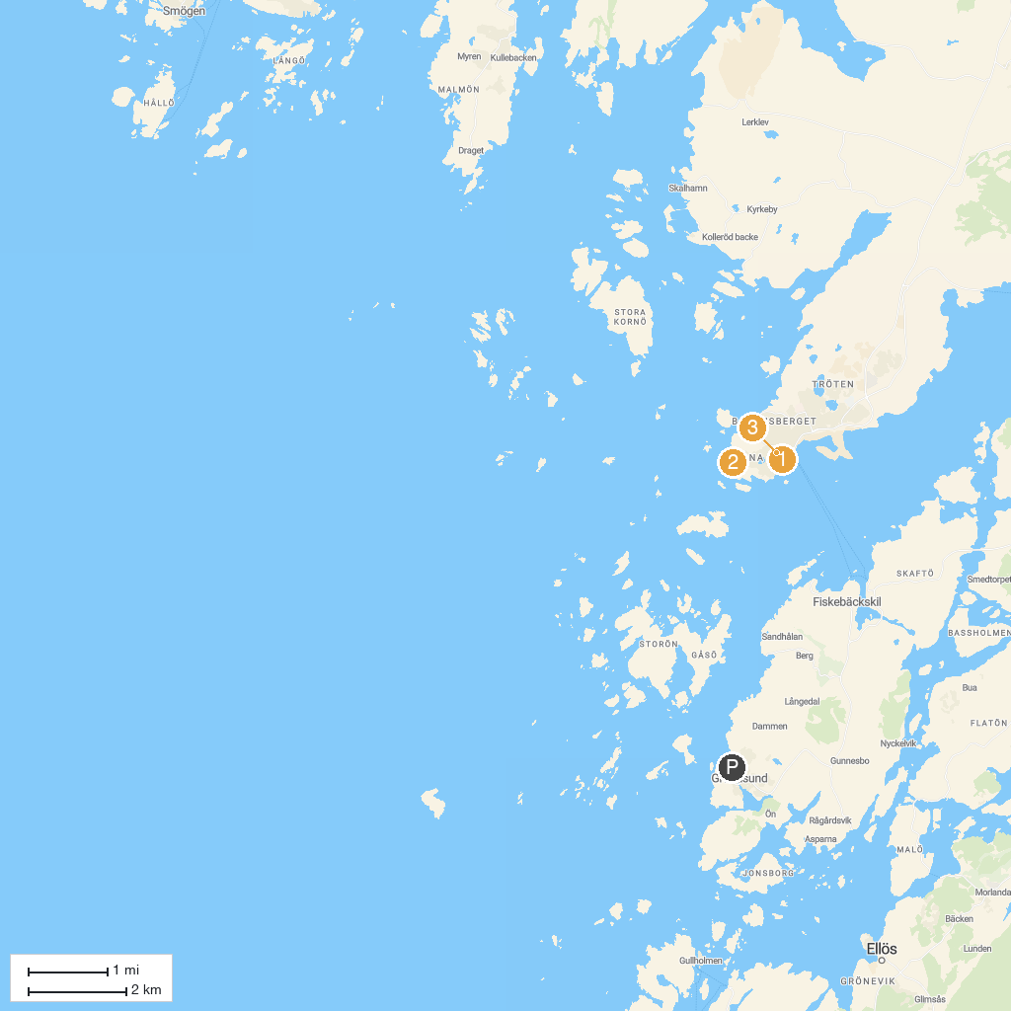
MAP KEY
1. Lysekils Kyrka | 3. Lysekils utsiktstorn
2. Stångehuvuds nature reserve
P. Cruise port / terminal
Map © MapTiler © OpenStreetMap contributors · cruiseports.org

