Guanaja Island, Bay Islands, Honduras
The most untouched of the Bay Islands, Guanaja trades highways for water-taxi lanes and resort crowds for pristine Mesoamerican reef. Christopher Columbus landed here in 1502 — it's still that remote.
⚓ Tender only (no cruise pier) · 🕒 Typical call: 6–8 hrs · 💵 USD & Lempira (HNL) · 🗣️ English widely spoken · 🌊 World-class snorkeling & diving
✍️ MY DAY IN PORT (FILL IN)
Ship / Date
In port | arrive ______ · all aboard ______
Booked excursion
Notes / meeting point
GETTING ASHORE
- Docking: Tender to Bonacca cay or resort docks — no cruise pier
- Walk to center: Bonacca is fully walkable once ashore (15–20 min end to end)
- Best For: Diving, snorkeling, unspoiled reef, waterfall hike, car-free cay wandering
- Don't Miss: Strolling Bonacca's stilt-house canals and snorkeling Black Rock Canyon
GETTING AROUND
- 🚕 Taxi: $5–$15 per trip — Primary way to get around the island and between cays. Water taxis can be flagged at any dock; the main hub is Bonacca C
- 📱 Rideshare: ❌ not available
TOP THINGS TO DO
- Snorkeling at Black Rock Canyon — A volcanic underwater crevice near the island's western end with dramatically healthy coral and abundant fish.
- Guanaja Waterfall Hike — Water taxi to Michael's Rock beach on the main island's north side, then a short hike through lush jungle and pine forest to the…
- Beach Day at Graham's Place (Josh's Cay) — A private cay resort with white sand, shallow turquoise lagoon, a restaurant serving cold SalvaVida beer and fresh seafood, plus…
- Scuba Diving — Bay Islands Reef — Guanaja's dive sites see a fraction of the traffic that Roatan's do.
- Mangrove Canal Kayaking — A hand-cut canal splits Guanaja's main island in two.
BEST WALKS
- Bonacca Cay Stroll: Easy · ~1.5 km · 20–30 min · Free — Wander the narrow alleys and bridges of Bonacca, the densely packed stilt-house island that holds…
- Michael's Rock to Big Gully Waterfall: Moderate · ~2 km round trip · 1.5 hrs · Requires water taxi — Take a water taxi to Michael's Rock beach on the main island's north side, then follow the jungle…
WEATHER · DAYLIGHT · MONEY
Month | High °F | Low °F | Rainy days
May | 83 | 80 | 7
Jul | 83 | 80 | 19
Sep | 84 | 81 | 17
Daylight: May 5:13AM–6:06PM · Jul 5:19AM–6:19PM · Sep 5:32AM–5:44PM
cruiseports.org/guanaja-island · Confirm terminal & all-aboard time with your ship

Guanaja Island, Bay Islands, Honduras — Port Map
Red = walkable sights · Amber = excursions farther out · P = cruise terminal
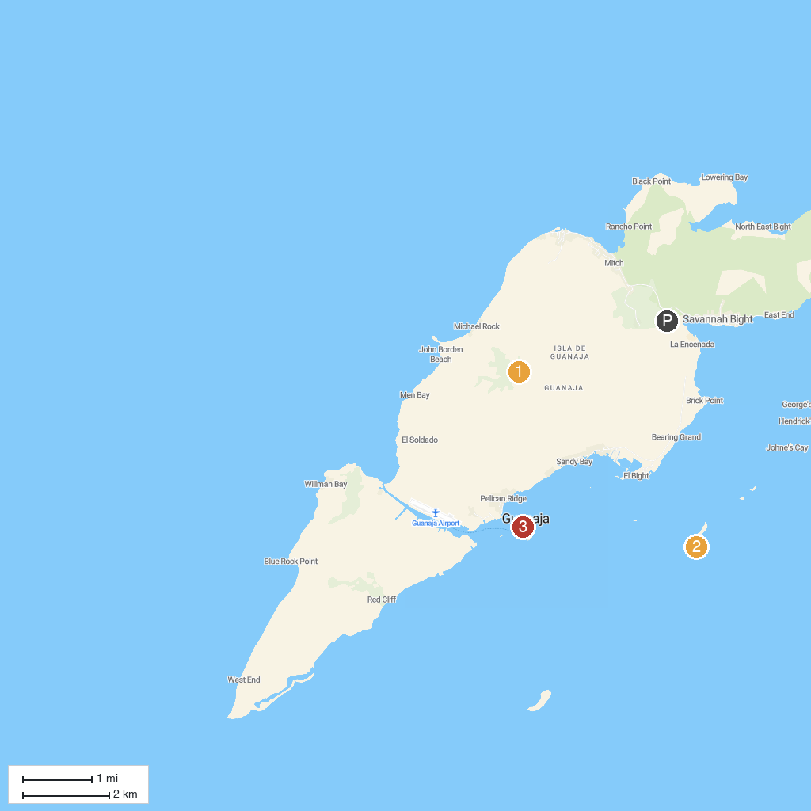
MAP KEY
1. Michael Rock Trail | 3. Bonacca Town
2. Jado Trader Wreck
P. Cruise port / terminal
Map © MapTiler © OpenStreetMap contributors · cruiseports.org

