Guayaquil, Guayas, Ecuador
Ecuador's largest port city blends a palm-lined riverfront, free-roaming iguanas in Seminario Park, and the colorful hillside barrio of Las Peñas — plus it's the launch pad for Galápagos cruises. Ships dock at the industrial Puerto Marítimo, so taxis or cruise shuttles are the way in.
⚓ Docked — Puerto Marítimo · 🕒 Typical call: 7-10 hrs · 💵 US Dollars (USD) · 🗣️ Spanish
✍️ MY DAY IN PORT (FILL IN)
Ship / Date
In port | arrive ______ · all aboard ______
Booked excursion
Notes / meeting point
GETTING ASHORE
- Docking: Puerto Marítimo, 8-10 km south of downtown — taxi or shuttle required
- Walk to center: Not walkable from pier; taxi ~$10-15, cruise shuttle common
- Best For: City culture, wildlife (iguanas!), Galápagos embarkation, river views
- Don't Miss: Seminario Park iguanas, Cerro Santa Ana climb, Malecon 2000 riverfront
GETTING AROUND
- 🚕 Taxi: $10–$15 USD — Taxis are readily available at the industrial port terminal, about 8–10 km south of the city center. Most taxis do not u
- 📱 Rideshare: ✅ Uber, DiDi, inDrive
- 🚌 Hop-on hop-off: ✅ Turibus Guayaquil
TOP THINGS TO DO
- Malecon 2000 & Seminario Park — Walk the 2.5-km Guayas riverfront promenade, then stroll two blocks to Seminario Park where dozens of land iguanas roam freely…
- Las Peñas & Cerro Santa Ana — Wander the colorful colonial houses and art studios of Las Peñas — Guayaquil's oldest barrio — then climb 444 steps up Cerro…
- Guayaquil Historical Park — A living open-air museum combining a wildlife zone with native species, replica 19th-century colonial architecture, and mangrove…
- Puerto El Morro Dolphin & Mangrove Tour — A 90-minute drive south leads to Puerto El Morro's ecological reserve, where bottlenose dolphins regularly feed among the…
- Isla Santay Day Trip — A short ferry hop from the Malecon to this estuary island offers cycling rentals, birdwatching trails through mangroves, and a…
BEST WALKS
- Malecon 2000 to Cerro Santa Ana: 2.5 km one-way | 1-2 hrs | Easy to Moderate — Start at the southern end of Malecon 2000 near the Bahía shopping center, walk north along the…
- Seminario Park & Cathedral Loop: 0.5 km | 30-45 min | Easy — From the Malecon, walk two blocks east on Calle Chile to Parque Seminario (Parque de las Iguanas)…
WEATHER · DAYLIGHT · MONEY
Month | High °F | Low °F | Rainy days
May | 84 | 74 | 16
Jul | 83 | 71 | 8
Sep | 84 | 70 | 6
Daylight: May 6:15AM–6:16PM · Jul 6:25AM–6:25PM · Sep 6:11AM–6:17PM
cruiseports.org/guayaquil · Confirm terminal & all-aboard time with your ship

Guayaquil, Guayas, Ecuador — Port Map
Red = walkable sights · Amber = excursions farther out · P = cruise terminal
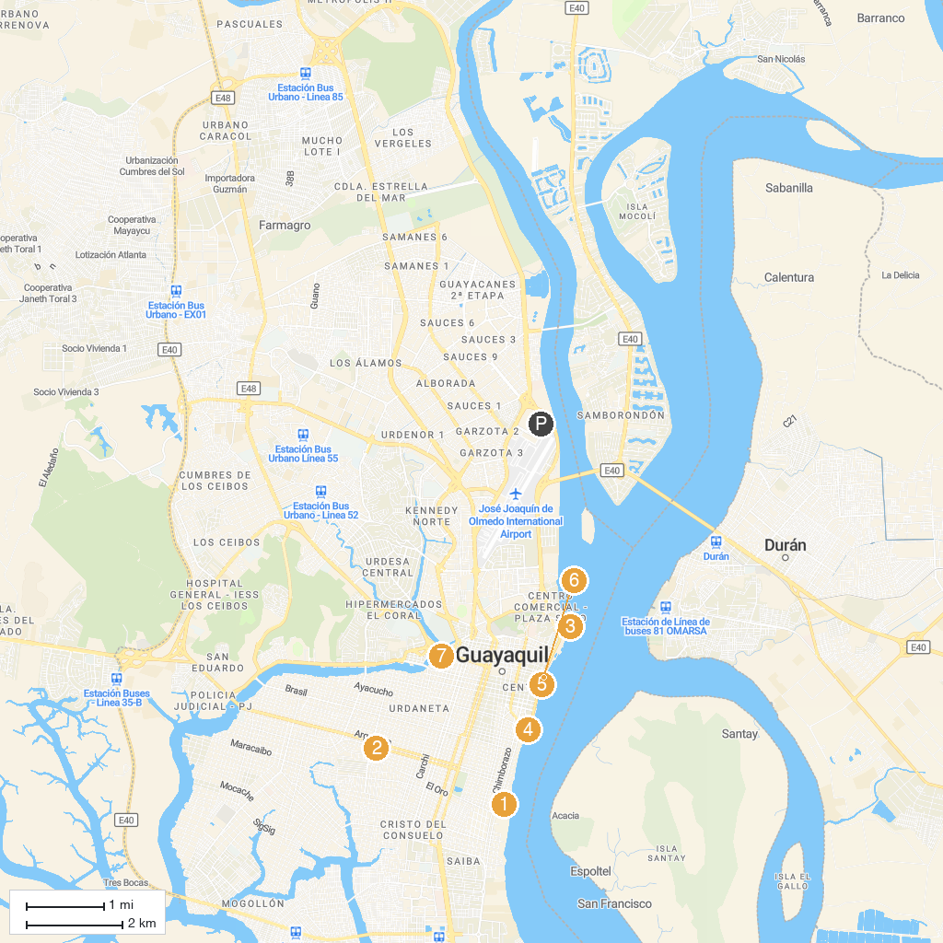
MAP KEY
1. Museo Naval Contemporáneo | 5. Malecon 2000
2. Parque Acuatico "Puerto Lisa" | 6. Malecón 2000 Garden
3. Julio Jaramillo Museum of Popular Music | 7. Malecón del Salado
4. José Joaquín de Olmedo Monument
P. Cruise port / terminal
Map © MapTiler © OpenStreetMap contributors · cruiseports.org

