St. Peter Port, Guernsey, Channel Islands
A British Crown Dependency adrift between England and France, Guernsey blends cobblestoned harbour charm with 800-year-old fortifications, Victor Hugo's extraordinary exile home, and a WWII occupation story found nowhere else on British soil.
⚓ Mostly tender (small ships may dock) · 🕒 Typical call: 7-9 hrs · 💷 Guernsey Pound (GBP accepted) · 🗣️ English · 🛍️ No VAT — tax-free shopping
✍️ MY DAY IN PORT (FILL IN)
Ship / Date
In port | arrive ______ · all aboard ______
Booked excursion
Notes / meeting point
GETTING ASHORE
- Docking: Tender to Albert Pier (most ships); Berth 1 docking for vessels ≤130 m
- Walk to centre: 2 min flat from Albert Pier to High Street
- Best For: History buffs, walkers, foodies, duty-free shoppers
- Don't Miss: Castle Cornet noon gun & Hauteville House (book ahead)
GETTING AROUND
- 🚕 Taxi: £3.60 base + £2/km — Licensed taxis wait at the tender dock. Use the official Guernsey Taxi App or Goto app to book; meter fares are regulate
- 📱 Rideshare: ❌ not available
TOP THINGS TO DO
- Castle Cornet — Eight centuries of island history packed into one sea-girt fortress.
- Hauteville House — Victor Hugo's Exile — Hugo spent 15 years here, writing Les Misérables and personally decorating every room into a three-storey work of art.
- German Occupation Sites — Guernsey was the only part of the British Isles occupied by Nazi forces during WWII (1940–45).
- Fermain Bay Cliff Walk — A stunning 45–60 minute cliff path south from St.
- West Coast Beaches — Cobo Bay and Vazon Bay on Guernsey's west coast offer broad stretches of pale sand and turquoise water — a world away from the…
BEST WALKS
- Harbour & Castle Cornet Waterfront Walk: 1.5 km · 20-25 min · Easy/flat — A classic flat stroll along the harbourfront from Albert Pier to Castle Cornet.
- High Street to Candie Gardens: 1 km · 20 min · Moderate (uphill) — Head up from the High Street through the historic quarter to Candie Gardens — Victorian public…
cruiseports.org/guernsey-island · Confirm terminal & all-aboard time with your ship

St. Peter Port, Guernsey, Channel Islands — Port Map
Red = walkable sights · Amber = excursions farther out · P = cruise terminal
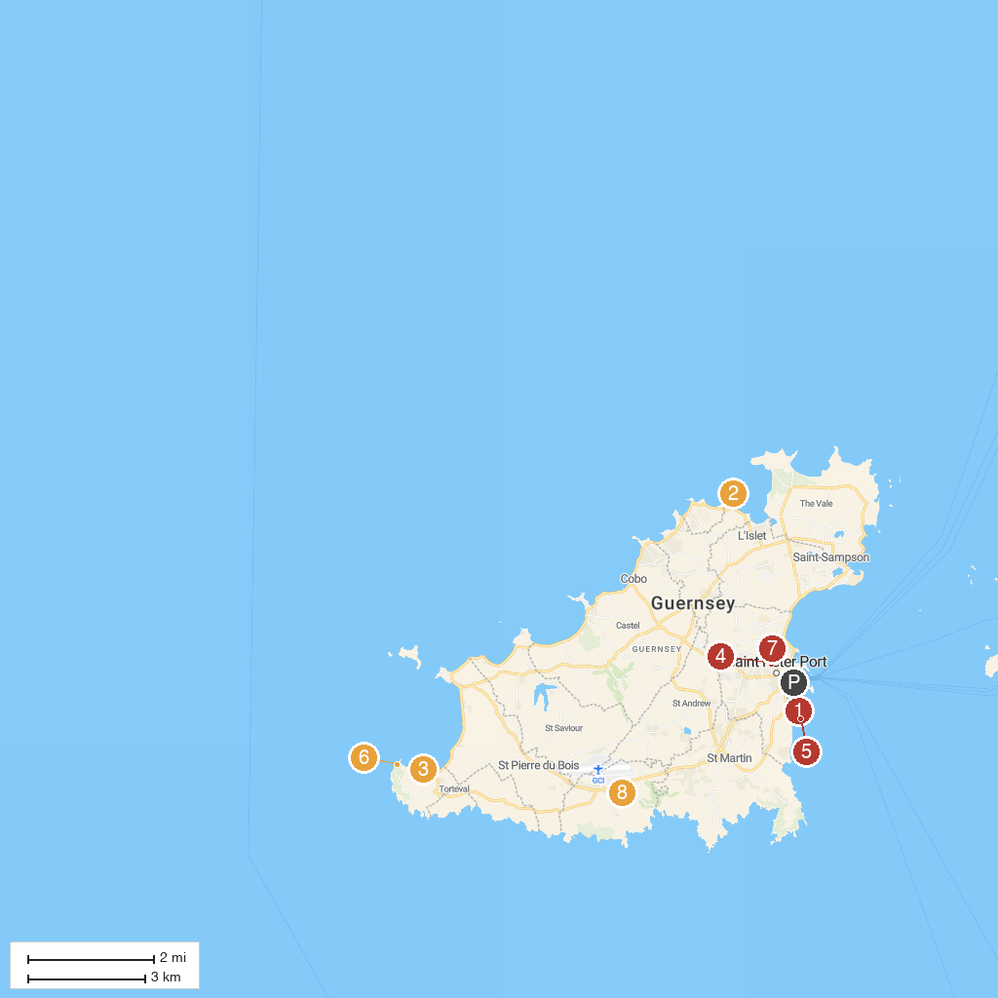
MAP KEY
1. La Valette Underground Military Museum | 5. Clarence Battery
2. Rousse Tower | 6. La Table des Pions
3. Portelet Harbour | 7. Beau Sejour Leisure Centre
4. Guernsey Museum at Candie | 8. German Occupation Museum
P. Cruise port / terminal
Map © MapTiler © OpenStreetMap contributors · cruiseports.org

