Guy Fawkes Island, Galápagos, Ecuador
A cluster of crescent-shaped volcanic islets rising from the Pacific northwest of Santa Cruz, Guy Fawkes is an all-water experience — drift-snorkel beneath tuff cliffs surrounded by sea lions, sharks, and a vibrant reef.
⚓ Zodiac/Tender (no landing) · 🕒 Typical call: 2-4 hrs · 💵 USD (no shore facilities) · 🗣️ Spanish · 🌊 Expedition cruises only
✍️ MY DAY IN PORT (FILL IN)
Ship / Date
In port | arrive ______ · all aboard ______
Booked excursion
Notes / meeting point
GETTING ASHORE
- Docking: Zodiac from ship — no landings permitted
- Walk to Center: No land access — water activities only
- Best For: Snorkeling, drift diving, marine wildlife
- Don't Miss: Drift-snorkeling along the tuff cliffs with sea lions
GETTING AROUND
TOP THINGS TO DO
- Drift Snorkel — Crescent Islets — The signature experience: drift along the semi-sheltered crescent of volcanic islets while sea lions, white-tip reef sharks, sea…
- Scuba Diving — Wall & Pelagic Site — Walls drop 20 meters to a sandy bottom draped in black coral and zoanthids.
- Zodiac Panga Ride — Islet Circumnavigation — Some ships offer a slow Zodiac tour around the islets to spot blue-footed boobies nesting on the rock faces, Nazca boobies, and…
cruiseports.org/guy-fawkes-island · Confirm terminal & all-aboard time with your ship

Guy Fawkes Island, Galápagos, Ecuador — Port Map
Red = walkable sights · Amber = excursions farther out · P = cruise terminal
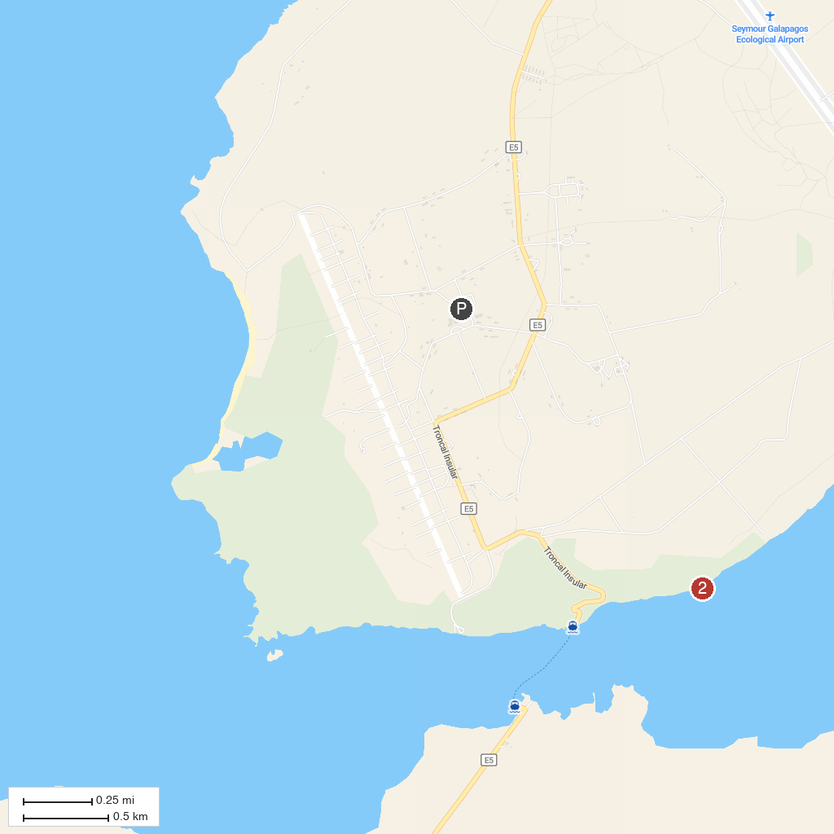
MAP KEY
1. Guy Fawkes Islets | 2. Itabaca Channel
P. Cruise port / terminal
Map © MapTiler © OpenStreetMap contributors · cruiseports.org

