Hachijojima Island, Tokyo, Japan
Technically part of Tokyo, Hachijojima feels like a world apart — twin volcanoes draped in subtropical forest, black-lava coastlines, thermal baths perched above the Pacific, and a culinary identity forged by centuries of island exile.
⚓ Tender or pier (Kaminato/Sokodo Port) · 🕒 Typical call: 6-8 hrs · 💴 Currency: Japanese Yen (JPY) — cash essential · 🗣️ Language: Japanese (very little English) · 🐢 Famous for sea turtles & clifftop onsen
✍️ MY DAY IN PORT (FILL IN)
Ship / Date
In port | arrive ______ · all aboard ______
Booked excursion
Notes / meeting point
GETTING ASHORE
- Docking: Usually tender; large ships may dock at Kaminato (Sokodo) Port — no gangway bridge
- Walk to center: Minimal at pier; Mitsune town 20-30 min walk or shuttle uphill
- Best For: Snorkeling with sea turtles, volcanic scenery, traditional onsen
- Don't Miss: Miharashi-no-yu cliffside hot spring & Shimazushi with karashi mustard
GETTING AROUND
- 🚕 Taxi: ¥1,000–¥2,000 port to town (est.) — Several local taxi companies serve the island including Aikou Kanko, Akamatsu Transportation, and Sueyoshi Taxis. Sokodo
- 📱 Rideshare: ❌ not available
TOP THINGS TO DO
- Sokodo Beach Snorkeling — Sea Turtles — The island's famous 'Hachijo Blue' water visibility can exceed 30 m.
- Miharashi-no-yu Clifftop Onsen — Perched on a lava cliff with panoramic ocean views, this municipal rotenburo (outdoor bath) is one of Japan's most dramatic hot…
- Mount Hachijo-fuji Hike — Hike the crater rim of this 854 m dormant volcano for sweeping views of both island peaks and the open Pacific.
- Kihachijo Silk Weaving Workshop — Kihachijo is a centuries-old silk textile unique to this island, dyed from local plants in bold yellows, blacks, and browns.
- Hachijo Historical Village & Museum — Discover the island's Edo-period exile history — samurai and political prisoners were banished here for centuries, shaping its…
BEST WALKS
- Sokodo Beach & Pier Stroll: 20 min · flat · free — From the pier, walk the short waterfront path to Sokodo Beach for a look at the crystal-clear…
- Hachijo Botanical Garden Loop: 1-1.5 hrs · gentle · free — A pleasant subtropical forest walk with paths through tree ferns, hibiscus, and banyan-like…
WEATHER · DAYLIGHT · MONEY
Month | High °F | Low °F | Rainy days
May | 69 | 66 | 12
Jul | 79 | 77 | 12
Sep | 80 | 77 | 18
Daylight: May 4:41AM–6:33PM · Jul 4:42AM–6:50PM · Sep 5:24AM–5:47PM
cruiseports.org/hachijojima-island-japan · Confirm terminal & all-aboard time with your ship

Hachijojima Island, Tokyo, Japan — Port Map
Red = walkable sights · Amber = excursions farther out · P = cruise terminal
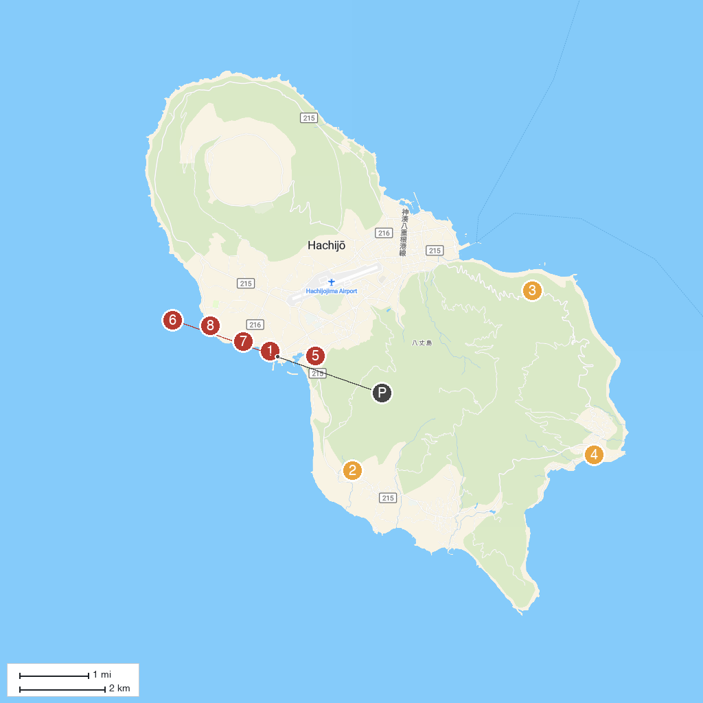
MAP KEY
1. Yakengahama Coast Swimming Area | 5. Ubaihomei Shrine
2. Fureai-no-Yu Hot Spring | 6. Yaene Archaeological Site
3. Noboryo Pass Observation Park | 7. Ōkataura Barbecue Square.
4. Miharashi-no-Yu Hot Spring | 8. Nanbara Senjoiwa Coast
P. Cruise port / terminal
Map © MapTiler © OpenStreetMap contributors · cruiseports.org

