Haida Gwaii Islands, British Columbia, Canada
The Galápagos of the North — a remote, rainforest-draped archipelago where ancient Haida totem poles decay back into the moss and humpback whales breach offshore. This is wilderness and living culture, not a port town.
⚓ Tender / Zodiac landings · 🕒 Typical call: 6-8 hrs · 💵 Canadian Dollar (CAD) · 🗣️ English / Haida · 🌲 Expedition cruises only
✍️ MY DAY IN PORT (FILL IN)
Ship / Date
In port | arrive ______ · all aboard ______
Booked excursion
Notes / meeting point
GETTING ASHORE
- Docking: Tender to Daajing Giids wharf or Zodiac landings (expedition)
- Walk to Centre: 5-10 min flat walk from Daajing Giids tender dock to town
- Best For: Indigenous culture, wildlife, old-growth rainforest, UNESCO sites
- Don't Miss: SGang Gwaay UNESCO totems, Haida Heritage Centre, whale watching
GETTING AROUND
- 🚕 Taxi: CAD $85+ minimum — Edge of the World Transportation (formerly Gwaii Taxi and Tours) serves Queen Charlotte City/Daajing Giids and Skidegate
- 📱 Rideshare: ❌ not available
TOP THINGS TO DO
- SGang Gwaay UNESCO World Heritage Site — The largest collection of original in-situ Haida totem poles on Earth.
- Haida Heritage Centre at Ḵay Llnagaay — Six traditional longhouses facing the ocean at Skidegate.
- Whale & Wildlife Watching — Humpback and fin whales, orcas, Pacific white-sided dolphins, Steller sea lions, and black bears foraging along the tideline.
- Burnaby Narrows Intertidal Walk — At K'iid Xyangs K'iidaay (Burnaby Narrows), the densest intertidal zone on Canada's Pacific coast — a carpet of sea stars…
- Hotspring Island (G̱andll K'in Gwaay.yaay) — Natural hot springs perched above the ocean in Gwaii Haanas — soak in geothermal pools while scanning the horizon for whales.
BEST WALKS
- Daajing Giids Waterfront Walk: 1-2 hrs · Easy · Free — From the tender dock, follow the flat waterfront path along Oceanview Drive past the visitor…
- Balance Rock (Skidegate): 30 min · Easy · Free — A glacial erratic boulder balanced improbably on a rocky beach just north of Skidegate — a short…
WEATHER · DAYLIGHT · MONEY
Month | High °F | Low °F | Rainy days
May | 56 | 45 | 13
Jul | 65 | 54 | 14
Sep | 61 | 52 | 16
Daylight: May 5:48AM–9:42PM · Jul 5:40AM–10:07PM · Sep 7:23AM–8:02PM
cruiseports.org/haida-gwaii-islands · Confirm terminal & all-aboard time with your ship

Haida Gwaii Islands, British Columbia, Canada — Port Map
Red = walkable sights · Amber = excursions farther out · P = cruise terminal
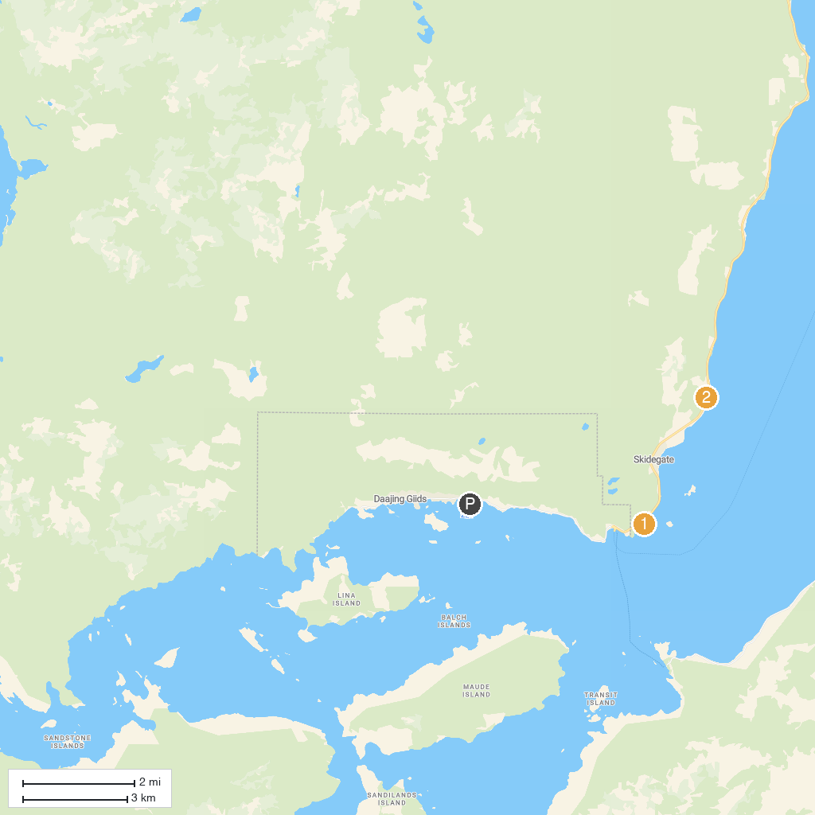
MAP KEY
1. Haida Heritage Centre | 2. Balance Rock
P. Cruise port / terminal
Map © MapTiler © OpenStreetMap contributors · cruiseports.org

