Haikou, Hainan, China
China's tropical island capital blends dynasty-era exile temples with coconut-palm boulevards, volcanic craters just outside town, and duty-free shopping on a grand scale. Haikou rewards curious walkers and those ready to plunge into authentic southern Chinese street life.
⚓ Pier — Xiuying Cruise Terminal · 🕒 Typical call: 8–10 hrs · 💴 Chinese Yuan (RMB/CNY) · 🗣️ Mandarin Chinese · 🌴 Tropical island; warm year-round
✍️ MY DAY IN PORT (FILL IN)
Ship / Date
In port | arrive ______ · all aboard ______
Booked excursion
Notes / meeting point
GETTING ASHORE
- Docking: Pier at Xiuying Port — no tender required
- Walk to center: ~15–20 min by taxi to Qilou Old Street; not walkable from pier
- Best For: History, local food, volcanic scenery, duty-free shopping
- Don't Miss: Qilou Old Street, Hainan Volcanic Geopark, cdf Duty-Free Complex
GETTING AROUND
- 🚕 Taxi: ¥26–¥32 (~USD 3.50–4.50) — Metered taxis are readily available at Xiuying Port. The ride to downtown Haikou (Qilou Old Street area) takes about 10–
- 📱 Rideshare: ✅ DiDi
TOP THINGS TO DO
- Qilou Old Street (Zhongshan Road) — Haikou's most atmospheric corner: a long arcade of 1920s–30s shophouses blending Chinese and colonial-European architecture.
- Haikou Volcanic Cluster Geopark — About 15 km southwest of the city, this UNESCO-recognized geopark (part of the Leiqiong UNESCO Global Geopark) features dormant…
- Hainan Provincial Museum — Free and passport-accessible, this well-presented museum covers Hainan's history, Li and Miao ethnic minority cultures, and…
- Five Officials Temple (Wugong Ci) — A serene complex dedicated to five Tang and Song Dynasty officials exiled to Hainan.
- Holiday Beach (Jiari Haibin Yuchangdi) — Haikou's main city beach — a 6 km palm-lined promenade with calm warm water, food stalls, and a laid-back vibe.
BEST WALKS
- Qilou Historic Quarter Loop: ~2 km | 45–60 min | Easy | Cultural — Start at the southern end of Zhongshan Road and walk north through the Qilou arcade streetscape.
- Haidian Island Waterfront: ~3 km | 1 hr | Easy | Scenic — Walk along Haidian Island's waterfront promenade past Dongpo Old Wharf, with views of Haikou Bay…
WEATHER · DAYLIGHT · MONEY
Month | High °F | Low °F | Rainy days
May | 89 | 78 | 18
Jul | 90 | 80 | 19
Sep | 86 | 78 | 20
Daylight: May 6:02AM–7:07PM · Jul 6:07AM–7:21PM · Sep 6:26AM–6:41PM
cruiseports.org/haikou · Confirm terminal & all-aboard time with your ship

Haikou, Hainan, China — Port Map
Red = walkable sights · Amber = excursions farther out · P = cruise terminal
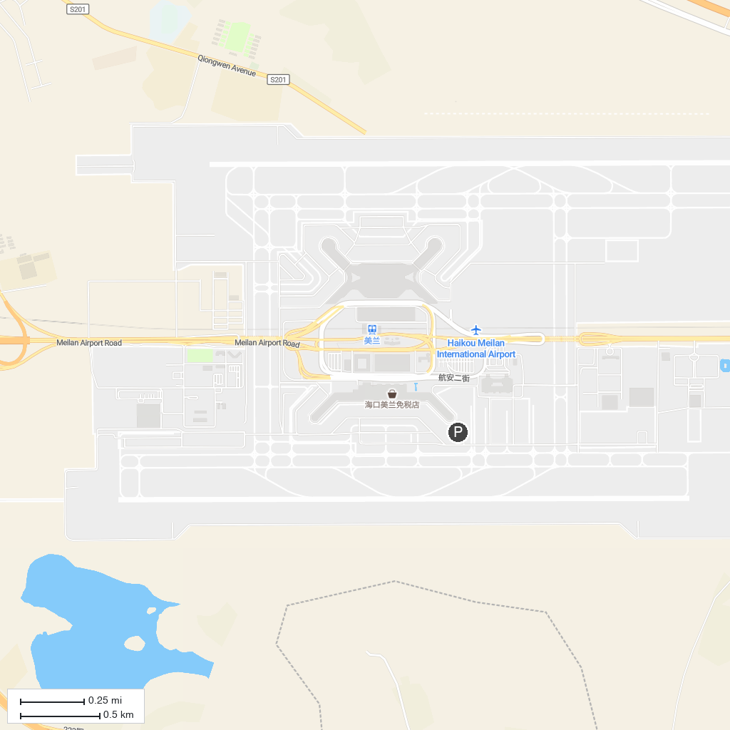
MAP KEY
1. 海口公园 | 4. Guanlan Lake Huayi Feng Xiaogang Film Commune
2. Haikou arcaded streets | 5. 万绿园
3. Hainan Museum
P. Cruise port / terminal
Map © MapTiler © OpenStreetMap contributors · cruiseports.org

