Halifax, Nova Scotia, Canada
Nova Scotia's salty maritime capital — a walkable waterfront of seafood shacks and tall ships, a star-shaped hilltop fort, and the iconic lighthouse at Peggy's Cove just down the coast.
⚓ Docked (downtown waterfront) · 🕒 Typical call: 8–10 hrs · 💵 Canadian Dollar (CAD) · 🗣️ English
✍️ MY DAY IN PORT (FILL IN)
Ship / Date
In port | arrive ______ · all aboard ______
Booked excursion
Notes / meeting point
GETTING ASHORE
- Docking: Halifax Seaport (downtown)
- Walk to center: Steps away
- Best For: Waterfront · Peggy's Cove
- Don't Miss: Peggy's Cove lighthouse
GETTING AROUND
- 🚕 Taxi: CAD $10–15 — Metered taxis queue directly outside the terminal. Fare to downtown is typically CAD $10–15; regulated by Halifax Region
- 📱 Rideshare: ✅ Uber, Lyft
- 🚌 Hop-on hop-off: ✅ Ambassatours / Gray Line
TOP THINGS TO DO
- Peggy's Cove — The most photographed lighthouse in Canada, on wave-battered granite boulders at a tiny fishing village ~45 min away.
- Halifax Citadel — The star-shaped hilltop fortress over downtown, with kilted soldiers, the noon gun, and sweeping harbor views.
- Waterfront, Pier 21 & Titanic — The Maritime Museum's Titanic gallery (many victims are buried here), Pier 21 immigration museum (Canada's Ellis Island), and the…
- Lunenburg & South Shore — A longer trip to UNESCO-listed Lunenburg, a perfectly preserved colorful colonial port town and home of the Bluenose schooner.
BEST WALKS
- Harbourwalk boardwalk: ~3 km · 1.5 hrs · easy — The lively waterfront boardwalk from Pier 21 past the Maritime Museum, the Historic Properties…
- Citadel & Old Town Clock: ~2 km · 1.5 hrs · moderate (uphill) — Up from the waterfront past the Old Town Clock to the star-shaped Citadel for the noon gun and…
- Public Gardens: ~1.5 km · 1 hr · easy — The exquisite Victorian-era Halifax Public Gardens — formal beds, fountains, and a bandstand — a…
WEATHER · DAYLIGHT · MONEY
Month | High °F | Low °F | Rainy days
May | 56 | 42 | 11
Jul | 72 | 61 | 11
Sep | 68 | 57 | 10
Daylight: May 5:46AM–8:35PM · Jul 5:43AM–8:56PM · Sep 6:53AM–7:24PM
cruiseports.org/halifax · Confirm terminal & all-aboard time with your ship

Halifax, Nova Scotia, Canada — Port Map
Red = walkable sights · Amber = excursions farther out · P = cruise terminal
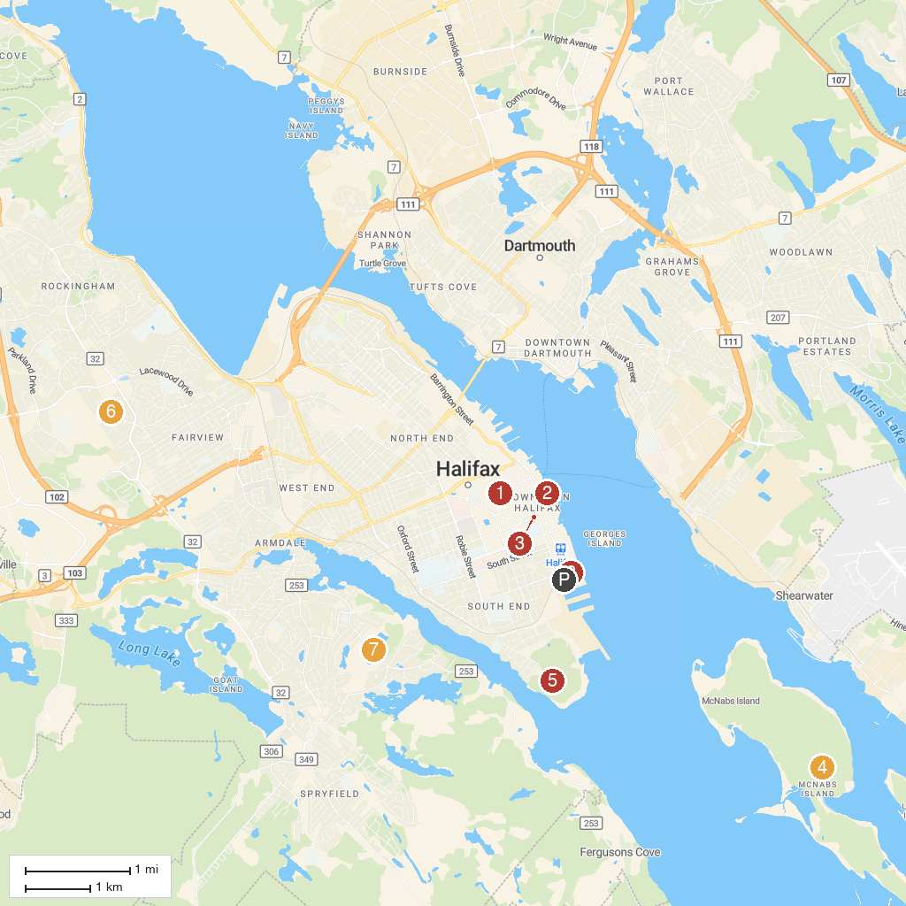
MAP KEY
1. Halifax Citadel National Historic Site | 5. Prince of Wales Tower National Historic Site
2. Maritime Museum of the Atlantic | 6. Mary Clayton Memorial Park
3. Saint Mary's Cathedral Basilica | 7. Frog Pond Park
4. Fort McNab National Historic Site | 8. Halifax Seaport Farmers' Market
P. Cruise port / terminal
Map © MapTiler © OpenStreetMap contributors · cruiseports.org

