Halle (Saale), Saxony-Anhalt, Germany
One of Germany's best-preserved medieval cities, Halle grew rich on salt and gave the world Handel. Home to the 3,600-year-old Nebra Sky Disc, it rewards curious visitors with world-class museums, a lively market square, and almost no tourist crowds.
⚓ River berth (Saale — small ships only) · 🕒 Typical call: 6-8 hrs · 💶 Currency: Euro (€) · 🗣️ Language: German · 🎭 Culture & History
✍️ MY DAY IN PORT (FILL IN)
Ship / Date
In port | arrive ______ · all aboard ______
Booked excursion
Notes / meeting point
GETTING ASHORE
- Docking: River mooring on the Saale; small expedition/boutique ships berth at Sophienhafen (~1.8 km to Marktplatz). Elbe cruise passengers arrive by excursion coach.
- Walk to center: 20–25 min walk or 5-min tram/taxi from Sophienhafen to Marktplatz
- Best For: History lovers, music fans (Handel), world prehistory (Nebra Sky Disc), off-the-beaten-path Germany
- Don't Miss: The Nebra Sky Disc at the State Museum of Prehistory — the oldest known depiction of the cosmos
GETTING AROUND
- 🚕 Taxi: €5–15 — Metered taxis available at the port and city stands. Base fare €3.90; most city-center trips run €5–15 depending on dist
- 📱 Rideshare: ✅ Uber, Bolt
TOP THINGS TO DO
- Nebra Sky Disc & State Museum of Prehistory — The star attraction: a 3,600-year-old bronze disc inlaid with gold that depicts the sun, moon, and stars — the oldest known…
- Handel House Birthplace — The home where Georg Friedrich Handel was born in 1685 is now an interactive museum covering his life and baroque instruments.
- Moritzburg Castle & Art Museum — A partly ruined 15th-century castle that was given a striking modern glass roof and now houses Saxony-Anhalt's state art…
- Marktplatz & Marktkirche — Halle's vast market square — one of Germany's largest — is anchored by the four-towered Marktkirche where Handel was baptised…
- Halloren Chocolate Factory & Salt Heritage — Germany's oldest chocolate factory (1804) produces the iconic Halloren Kugeln — chocolate spheres shaped like the buttons on…
BEST WALKS
- Sophienhafen to Marktplatz — Old Town Loop: 2.5 km | 45–60 min | Flat | Self-guided — Walk north from the Sophienhafen berth along the Saale riverbank, cross into the Altstadt via the…
- Peißnitz Island & River Stroll: 2 km | 30–45 min | Very flat | Free — From the Ziegelwiese mooring, cross the footbridge onto Peißnitz Island and follow the paths around…
WEATHER · DAYLIGHT · MONEY
Month | High °F | Low °F | Rainy days
May | 66 | 49 | 9
Jul | 77 | 60 | 10
Sep | 69 | 54 | 8
Daylight: May 5:20AM–8:57PM · Jul 5:13AM–9:22PM · Sep 6:47AM–7:26PM
cruiseports.org/halle · Confirm terminal & all-aboard time with your ship

Halle (Saale), Saxony-Anhalt, Germany — Port Map
Red = walkable sights · Amber = excursions farther out · P = cruise terminal
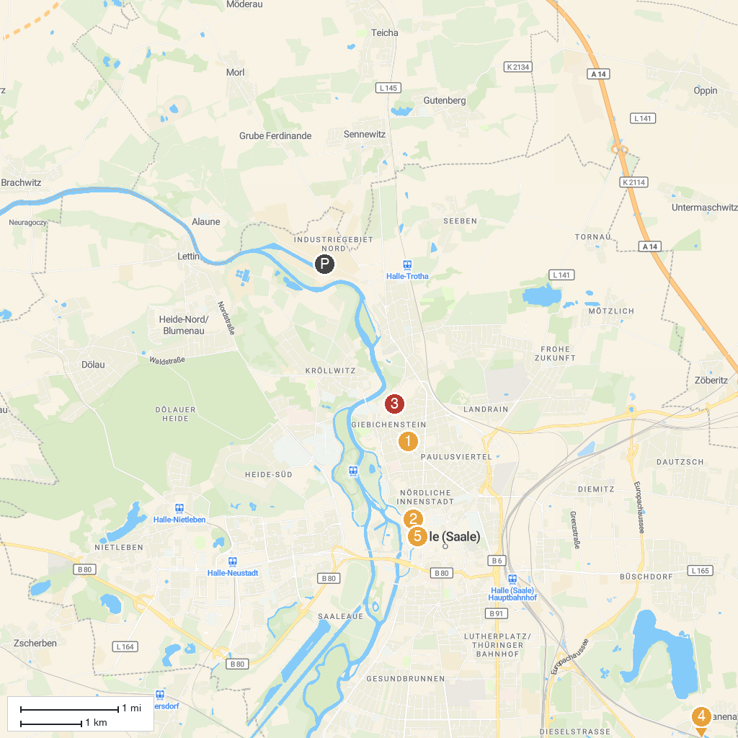
MAP KEY
1. State Museum of Prehistory Halle (Saale) | 5. Neue Residenz
2. Art Museum Moritzburg Halle (Saale) | 6. Porphyrlandschaft bei Gimritz
3. Reichardts Garten | 7. Museum Zappendorf
4. Dieskauer Park | 8. Tiefer Keller
P. Cruise port / terminal
Map © MapTiler © OpenStreetMap contributors · cruiseports.org

