Hamburg, Germany
Germany's gateway port blends red-brick Hanseatic grandeur with cutting-edge architecture — all within walking distance of the quay. A full day barely scratches the surface.
⚓ Docked (pier) · 🕒 Typical call: 8-12 hrs · 💶 Euro (€) · 🗣️ German (English widely spoken)
✍️ MY DAY IN PORT (FILL IN)
Ship / Date
In port | arrive ______ · all aboard ______
Booked excursion
Notes / meeting point
GETTING ASHORE
- Docking: Four dedicated terminals, all alongside — no tendering in Hamburg
- Walk to center: 5-25 min on foot (HafenCity) to shuttle required (Steinwerder)
- Best For: Architecture, history, harbor cruises, Miniatur Wunderland, Beatles trail
- Don't Miss: Elbphilharmonie Plaza (free), Speicherstadt, Miniatur Wunderland
GETTING AROUND
- 🚕 Taxi: €15–25 — Taxis wait at all terminals. Quickest door-to-door option — around 10–15 minutes to the city center from most terminals.
- 📱 Rideshare: ✅ Uber, Bolt, FREENOW
- 🚌 Hop-on hop-off: ✅
TOP THINGS TO DO
- Speicherstadt & Elbphilharmonie — Walk the world's largest historic warehouse district — a UNESCO World Heritage site of redbrick canals — then ride the escalator…
- Miniatur Wunderland — The world's largest model railway exhibition, in the heart of Speicherstadt.
- Inner Harbour Cruise — A one-hour guided boat tour from Landungsbrücken takes you past container terminals, the historic Speicherstadt, and the dramatic…
- Hamburg Rathaus & Altstadt — The neo-Renaissance City Hall dominates Rathausmarkt with 647 rooms and a free inner courtyard.
- Beatles History Tour — Walk in Lennon, McCartney & Co.'s footsteps along the Grosse Freiheit.
BEST WALKS
- Landungsbrücken to Speicherstadt & Elbphilharmonie: 3.5 km · ~50 min · flat — Start at the iconic St.
- HafenCity Waterfront Loop: 2.5 km · ~35 min · flat — A modern architecture walk through HafenCity's award-winning buildings, public plazas, and…
- Jungfernstieg & Alster Promenade: 2 km · ~30 min · flat — Hamburg's elegant shopping boulevard runs along the Binnenalster lake.
WEATHER · DAYLIGHT · MONEY
Month | High °F | Low °F | Rainy days
May | 64 | 47 | 12
Jul | 73 | 58 | 14
Sep | 67 | 53 | 10
Daylight: May 5:19AM–9:14PM · Jul 5:10AM–9:40PM · Sep 6:54AM–7:35PM
cruiseports.org/hamburg · Confirm terminal & all-aboard time with your ship

Hamburg, Germany — Port Map
Red = walkable sights · Amber = excursions farther out · P = cruise terminal
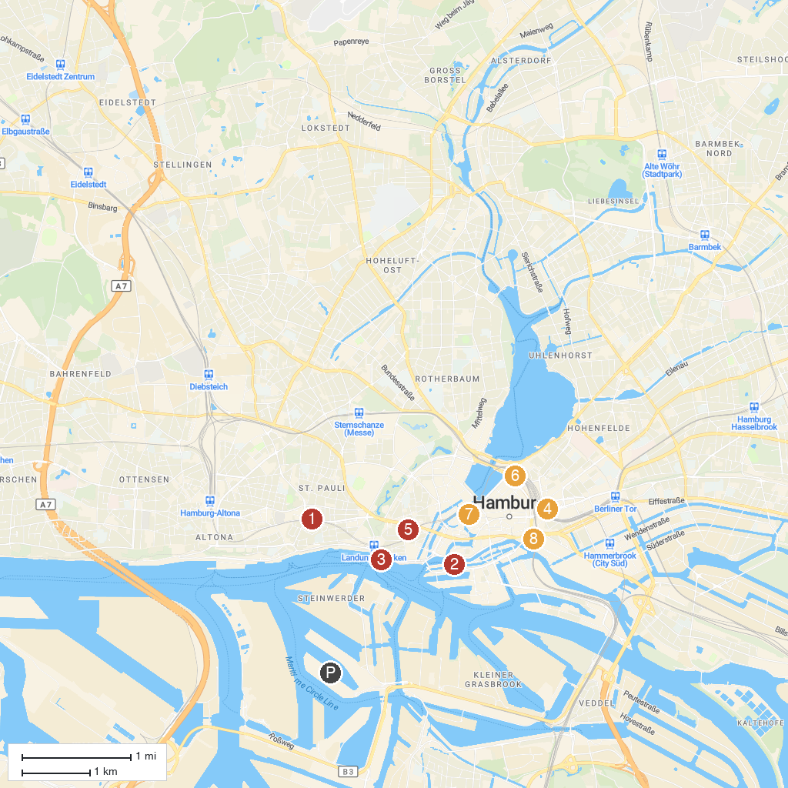
MAP KEY
1. Beatles-Platz | 5. St. Michael's Church
2. Miniatur Wunderland | 6. Hamburger Kunsthalle
3. Rickmer Rickmers | 7. Hamburg Townhall
4. Museum of Art and Industry | 8. Deichtorhallen
P. Cruise port / terminal
Map © MapTiler © OpenStreetMap contributors · cruiseports.org

