Hammerfest, Finnmark, Norway
One of the world's northernmost towns, Hammerfest wears its Arctic identity proudly — polar bears on the logo, reindeer on the streets, and a UNESCO monument marking where scientists first measured the Earth.
⚓ Pier (town center quay) · 🕒 Typical call: 6-8 hrs · 💵 Norwegian Krone (NOK) — cashless everywhere · 🗣️ Norwegian (English widely spoken) · ☀️ Midnight Sun: mid-May to late July
✍️ MY DAY IN PORT (FILL IN)
Ship / Date
In port | arrive ______ · all aboard ______
Booked excursion
Notes / meeting point
GETTING ASHORE
- Docking: Pier — main quay in town center; Fuglenes pier ~1 mile away
- Walk to Center: Steps off the gangway — town is immediately walkable
- Best For: Arctic history, unique souvenirs, scenic viewpoint hike
- Don't Miss: Joining the Royal and Ancient Polar Bear Society
GETTING AROUND
- 🚕 Taxi: ~100–175 NOK (€9–16) — Taxis wait at the pier and are the best option for reaching the Meridian Column or Mount Salen. Base fare ~100 NOK plus
- 📱 Rideshare: ❌ not available
TOP THINGS TO DO
- Royal & Ancient Polar Bear Society — Visit the Isbjørnklubben museum near the harbor for Arctic hunting and exploration history.
- Salen Viewpoint Hike — Follow the Zig-Zag Path up Salen hill (about 15-20 min on foot) for sweeping panoramic views over Hammerfest and the surrounding…
- Meridian Column (UNESCO) — A 10-minute walk or quick taxi ride to the Fuglenes peninsula reveals the Meridian Column, the northernmost point of the Struve…
- Reconstruction Museum — This moving museum tells the story of the Nazi scorched-earth policy that destroyed virtually all of Finnmark in 1944 and the…
- Seiland National Park Boat Trip — Venture by RIB or small boat to Seiland Island National Park, home to two of northern Europe's southernmost glaciers, dramatic…
BEST WALKS
- Town Center & Polar Bear Society Loop: 1.5 km · 30-40 min · flat — From the main quay, walk along Strandgata into the town center.
- Salen Viewpoint via Zig-Zag Path: 2.5 km round trip · 45 min · moderate uphill — Head uphill from the town center on the well-marked Zig-Zag Path to the Salen lookout.
- Fuglenes Peninsula & Meridian Column: 3 km round trip · 45-60 min · easy — Follow the waterfront path west from the main quay to the Fuglenes peninsula.
WEATHER · DAYLIGHT · MONEY
Month | High °F | Low °F | Rainy days
May | 43 | 34 | 16
Jul | 60 | 50 | 12
Sep | 51 | 43 | 16
Daylight: Sep 5:37AM–7:01PM
cruiseports.org/hammerfest · Confirm terminal & all-aboard time with your ship

Hammerfest, Finnmark, Norway — Port Map
Red = walkable sights · Amber = excursions farther out · P = cruise terminal
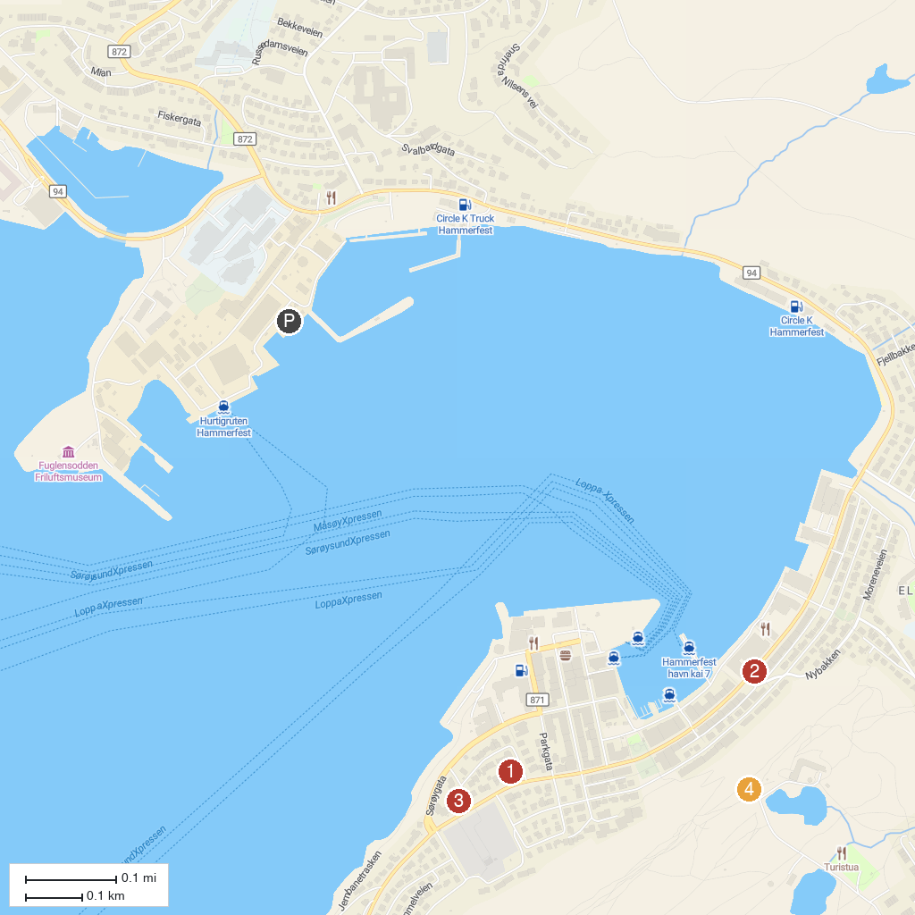
MAP KEY
1. Museum of Reconstruction | 3. Church of Hammerfest
2. Royal and Ancient Polar Bear Society | 4. Salen Viewpoint
P. Cruise port / terminal
Map © MapTiler © OpenStreetMap contributors · cruiseports.org

