Harbour Island, Eleuthera, Bahamas
"Briland" — Bahamas' most charming out-island. Three miles of bubblegum-pink sand, 18th-century pastel cottages, and no streetlights. This is where the Bahamas slows all the way down.
⚓ Tender (no pier) · 🕒 Typical call: 5–8 hrs · 💵 USD / Bahamian Dollar · 🗣️ English · 🏖️ Beach destination
✍️ MY DAY IN PORT (FILL IN)
Ship / Date
In port | arrive ______ · all aboard ______
Booked excursion
Notes / meeting point
GETTING ASHORE
- Docking: Tender to Government Dock, Dunmore Town
- Walk to Beach: ~0.5 miles (10–15 min) across island to Pink Sands
- Best For: Pink sand beach, golf cart exploring, Bahamian food
- Don't Miss: Conch salad at Queen Conch, horseback ride on Pink Sands
GETTING AROUND
- 🚕 Taxi: $5–$10 per person — Cruise ships anchor offshore and tender passengers to the Government Dock in Dunmore Town. The water taxi from North Ele
- 📱 Rideshare: ❌ not available
TOP THINGS TO DO
- Pink Sands Beach — Three miles of pale pink sand on the Atlantic side — the color comes from tiny red-shelled Foraminifera mixed into the white sand.
- Horseback Riding on the Beach — Ride along the shoreline of Pink Sands Beach with a local guide.
- Dunmore Town Historic Walk — Stroll the narrow flower-lined streets of the Bahamas' former colonial capital.
- Snorkeling at Current Cut — Book a local charter for the boat trip to Current Cut — a narrow tidal channel off northern Eleuthera (about 30–40 min by boat)…
- Conch Salad at Queen Conch — Watch fresh conch harvested and sliced into salad right in front of you at this open-air harbor-side shack.
BEST WALKS
- Government Dock to Pink Sands Beach: 0.5 mi | 10–15 min | Easy (flat) — Walk from the Government Dock through the center of Dunmore Town, past colonial cottages and local…
- Dunmore Town Heritage Stroll: 0.75 mi loop | 30–45 min | Easy — Loop through the historic core of Dunmore Town — take in the Loyalist Cottage on Bay Street, the…
WEATHER · DAYLIGHT · MONEY
Month | High °F | Low °F | Rainy days
May | 81 | 75 | 16
Jul | 86 | 80 | 18
Sep | 85 | 79 | 19
Daylight: May 6:21AM–7:44PM · Jul 6:25AM–7:59PM · Sep 6:52AM–7:10PM
cruiseports.org/harbour-island-bahamas · Confirm terminal & all-aboard time with your ship

Harbour Island, Eleuthera, Bahamas — Port Map
Red = walkable sights · Amber = excursions farther out · P = cruise terminal
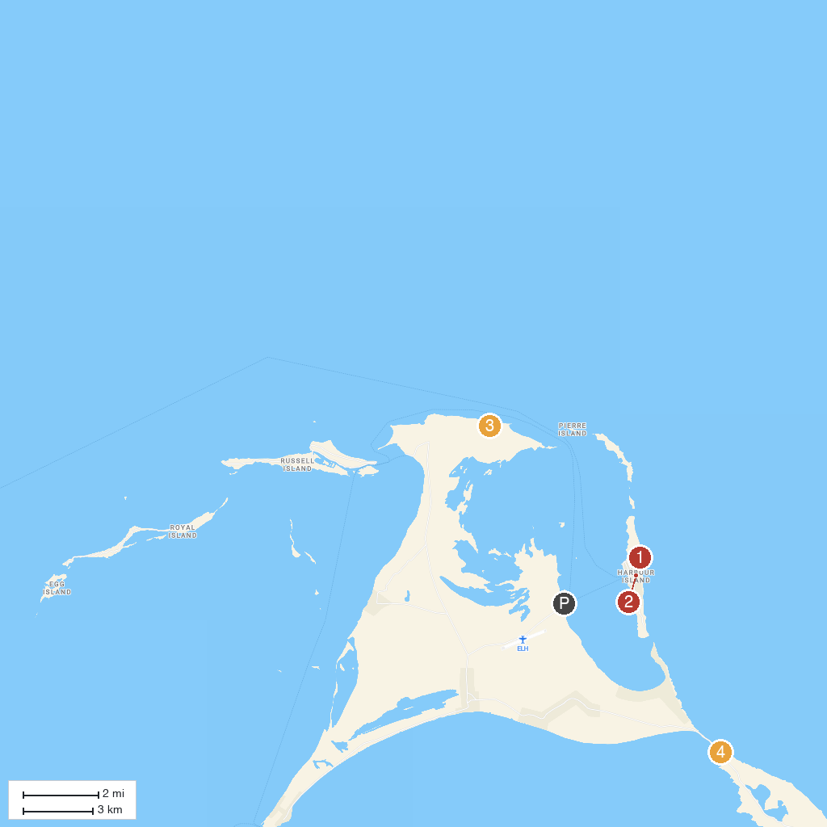
MAP KEY
1. Pink Sands Beach | 3. Preacher's Cave
2. Dunmore Town | 4. Queen's Baths
P. Cruise port / terminal
Map © MapTiler © OpenStreetMap contributors · cruiseports.org

