Harlingen, Friesland, Netherlands
One of the Netherlands' oldest seaports, Harlingen sits where Frisian culture meets the wild Wadden Sea — historic canal quays, traditional sailing ships, and a town centre you can walk to straight off the gangway.
⚓ Pier (small/medium ships) or Tender (large ships) · 🕒 Typical call: 6–8 hrs · 💶 Euro (cards widely accepted) · 🗣️ Dutch & West Frisian (English spoken everywhere)
✍️ MY DAY IN PORT (FILL IN)
Ship / Date
In port | arrive ______ · all aboard ______
Booked excursion
Notes / meeting point
GETTING ASHORE
- Docking: Pier (Wilhelmina Harbour, ships up to 160 m); larger ships tender from Wadden Sea (30–45 min)
- Walk to centre: 5–10 min from pier to Noorderhaven canal & Voorstraat
- Best For: Canal walks, Frisian culture, Wadden Sea wildlife, authentic Dutch atmosphere
- Don't Miss: The Whale of Harlingen fountain, hand-painted Frisian earthenware factory, kibbeling at the harbour
GETTING AROUND
- 🚕 Taxi: €10–€20 — Local taxis are available at the harbour. Short rides within Harlingen run roughly €10–€20; fixed-price transfers to Ams
- 📱 Rideshare: ✅ Uber
TOP THINGS TO DO
- Wadden Sea Seal & Sandbank Tour — Board a RIB or traditional sailing vessel to explore the UNESCO Wadden Sea tidal flats.
- Frisian Earthenware Workshop Visit — The Harlinger Aardewerk- en Tegelfabriek hand-paints traditional Frisian tin-glazed earthenware and tiles, reviving a Harlingen…
- Hannemahuis Museum — Harlingen's main museum occupies a magnificent 18th-century merchant's mansion and tells the story of the port's seafaring and…
- Independent Day Trip to Leeuwarden — Hop the direct train from Harlingen Haven station (right by the harbour) to Leeuwarden — Friesland's elegant capital, with grand…
BEST WALKS
- Harbour Canals Loop: 2.5 km · 45 min · Flat — Walk from the cruise pier along the Noorderhaven canal with its 17th-century warehouse facades and…
- Sea Dike & Beach Walk: 3 km · 50 min · Flat — Head west along the Westerzeedijk sea dike for open views across the Wadden Sea toward the islands…
WEATHER · DAYLIGHT · MONEY
Month | High °F | Low °F | Rainy days
May | 57 | 48 | 8
Jul | 66 | 59 | 10
Sep | 64 | 55 | 12
Daylight: May 5:39AM–9:30PM · Jul 5:30AM–9:57PM · Sep 7:12AM–7:53PM
cruiseports.org/harlingen · Confirm terminal & all-aboard time with your ship

Harlingen, Friesland, Netherlands — Port Map
Red = walkable sights · Amber = excursions farther out · P = cruise terminal
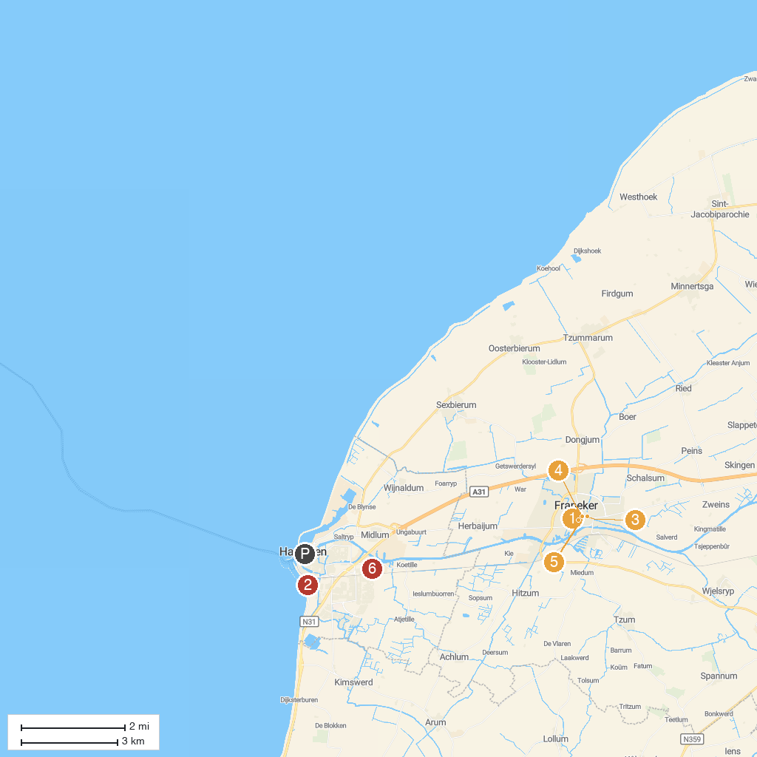
MAP KEY
1. Keatsmuseum | 5. Casemates Museum
2. De Stenen Man | 6. Zuidwaard Sloepverhuur Makkum
3. Korendragershuisje (National monument) | 7. Museum Martena
4. Eise Eisinga Planetarium | 8. Harlinger Aardewerk & Tegelfabriek
P. Cruise port / terminal
Map © MapTiler © OpenStreetMap contributors · cruiseports.org

