Härnösand, Västernorrland, Sweden
A charming Swedish cathedral city on the southern edge of the UNESCO High Coast, where dramatic granite coastline meets 18th-century architecture — and surströmming is a local rite of passage.
⚓ Pier (docked) · 🕒 Typical call: 6–8 hrs · 💵 SEK — near-cashless, cards everywhere · 🗣️ Swedish (English widely spoken) · 🌊 UNESCO High Coast gateway
✍️ MY DAY IN PORT (FILL IN)
Ship / Date
In port | arrive ______ · all aboard ______
Booked excursion
Notes / meeting point
GETTING ASHORE
- Docking: Pier (Southern Quay or Northern Pier, ~1.5 km from city center)
- Walk to center: 15–20 min on foot; shuttle often provided
- Best For: History, UNESCO scenery, Scandinavian food culture
- Don't Miss: Härnösand Art Hall (free Picasso & Chagall), Murberget open-air museum
GETTING AROUND
- 🚕 Taxi: 50–150 SEK (~$5–14) — Taxi Härnösand operates locally and can be booked via their app. The short distance to the center keeps fares low; fares
TOP THINGS TO DO
- Härnösand Art Hall — Free Masterworks — The Qvist Collection inside this Neo-Renaissance building holds genuine works by Picasso, Chagall, and Matisse.
- Murberget Open-Air Museum — One of Sweden's largest open-air museums, with 19th and early 20th-century farmsteads, workshops, and homes relocated to a…
- High Coast UNESCO World Heritage Drive — The iconic Högakustenbron (High Coast Bridge) is just 24 km north — an engineering landmark framing the dramatic…
- Hemsö Fortress (Cold War Mountain Base) — A Cold War-era Swedish military installation built into granite on Hemsön island, about an hour from Härnösand.
- Smitingen Beach & Nature Reserve — A popular sandy beach north of the city inside a nature reserve.
BEST WALKS
- City Center & Cathedral Loop: 🗺 1.5 km · ⏱ 45–60 min · 🚶 Easy, flat — A relaxed loop taking in Härnösand Cathedral, the 18th-century Östanbäcken quarter, the Art Hall…
- Vårdkasberget Viewpoint Hike: 🗺 2 km round trip · ⏱ 45–60 min · 🥾 Moderate uphill — Climb Vårdkasberget hill on Härnön for sweeping views over the city, the Ångerman River estuary…
WEATHER · DAYLIGHT · MONEY
Month | High °F | Low °F | Rainy days
May | 53 | 40 | 10
Jul | 67 | 55 | 13
Sep | 57 | 48 | 11
Daylight: May 3:49AM–9:42PM · Sep 6:13AM–7:11PM
cruiseports.org/harnosand · Confirm terminal & all-aboard time with your ship

Härnösand, Västernorrland, Sweden — Port Map
Red = walkable sights · Amber = excursions farther out · P = cruise terminal
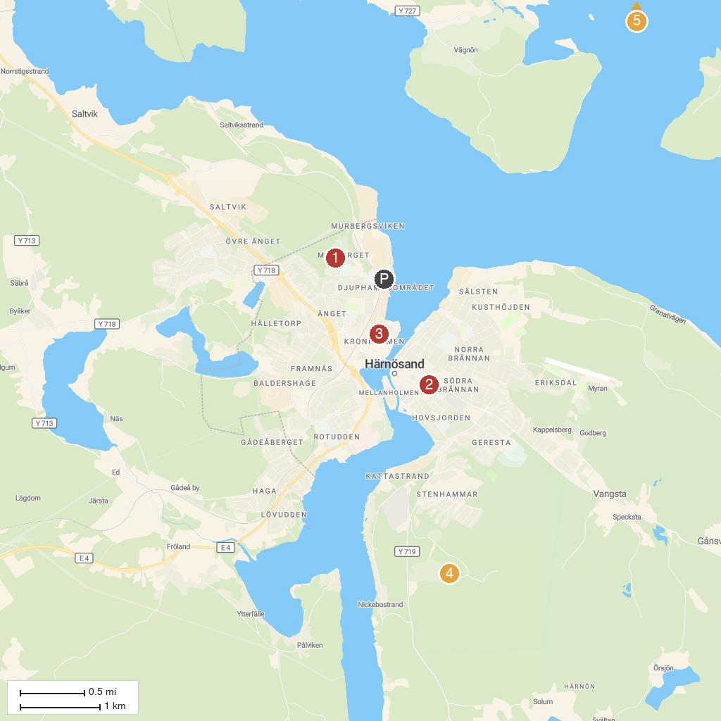
MAP KEY
1. Murberget County Museum | 4. Vårdkasens utsiktstorn
2. Höga Kusten Turism AB | 5. Hemson
3. Car Museum Härnösand + AWL
P. Cruise port / terminal
Map © MapTiler © OpenStreetMap contributors · cruiseports.org

