Hârsova, Constanța County, Romania
A sleepy Danube town built on Roman ruins, where limestone cliffs tower over the river and horse-drawn carts still share the road. Hârsova rewards curious passengers with 2,000 years of history and an unfiltered glimpse of rural Romanian life.
⚓ Docked (river pier) · 🕒 Typical call: 6-8 hrs · 💵 Romanian Leu (RON) · 🗣️ Romanian (little English spoken)
✍️ MY DAY IN PORT (FILL IN)
Ship / Date
In port | arrive ______ · all aboard ______
Booked excursion
Notes / meeting point
GETTING ASHORE
- Docking: Docked at riverside pontoon pier; walk straight ashore
- Walk to Center: ~10 min (500–800 m flat walk from pier)
- Best For: Roman history, geological cliffs, authentic local atmosphere
- Don't Miss: Carsium Fortress ruins overlook the Danube from a limestone promontory
GETTING AROUND
- 🚕 Taxi: 5–15 RON (~1–3 USD) — Local taxis are available near the port. Short rides within town are inexpensive; confirm the fare or ensure the meter i
TOP THINGS TO DO
- Carsium Fortress Ruins — Climb the limestone hill to the ruins of the Roman-Byzantine fortress of Carsium, established by Emperor Vespasian in the 1st…
- Carsium Museum — This small local museum displays Roman coins, pottery, bronze tools, and Ottoman-era artifacts excavated from the fortress and…
- Canaralele de la Hârsova — Limestone Cliffs — A protected geological reserve where 150-million-year-old Jurassic limestone formations rise 30 meters straight from the Danube's…
- Constanța & Black Sea Day Trip — Shore excursions run about 75 km to Constanța on the Black Sea — Romania's main port city.
- Histria — Oldest Greek Settlement in Romania — About 80 km from Hârsova, Histria was founded by Greek colonists from Miletus in the 7th century BC.
BEST WALKS
- Riverside to Carsium Fortress: 2.5 km round-trip | 45–60 min | Moderate — From the pier, walk along the Danube promenade past local fishermen and the limestone cliff base…
- Town Center Stroll: 1 km loop | 20–30 min | Easy — Walk from the pier along Strada Revoluției through the market, past the Church of St.
WEATHER · DAYLIGHT · MONEY
Month | High °F | Low °F | Rainy days
May | 72 | 54 | 9
Jul | 85 | 66 | 7
Sep | 77 | 59 | 4
cruiseports.org/harsova · Confirm terminal & all-aboard time with your ship

Hârsova, Constanța County, Romania — Port Map
Red = walkable sights · Amber = excursions farther out · P = cruise terminal
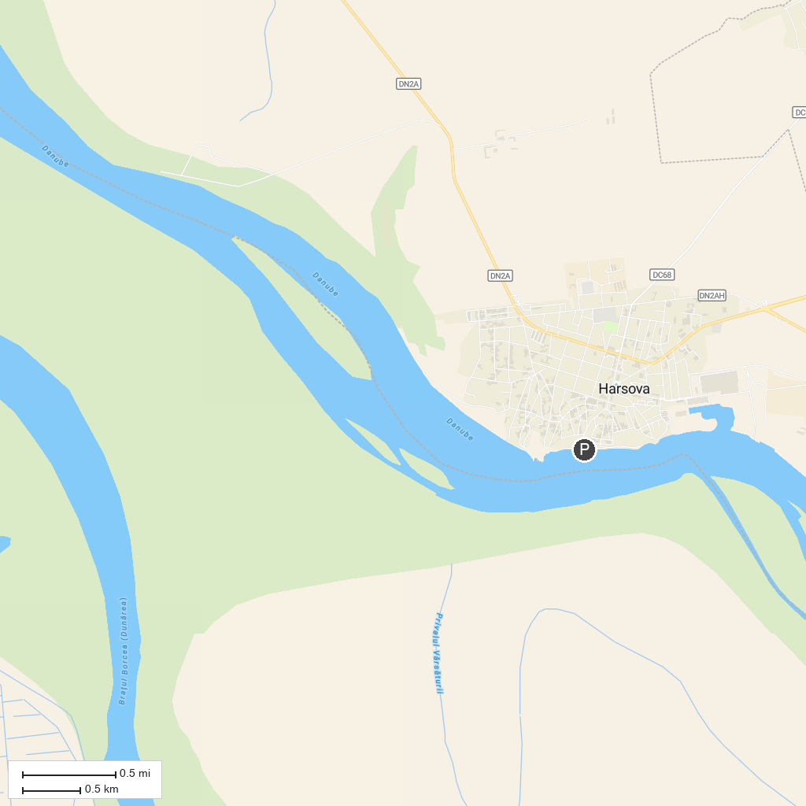
MAP KEY
1. "The Small Island of Brăila" Natural Park | 2. Muzeul de Artă "Dinu și Sevasta Vintilă"
P. Cruise port / terminal
Map © MapTiler © OpenStreetMap contributors · cruiseports.org

