Harvest Caye, Southern Belize, Belize
Norwegian Cruise Line's private 75-acre island in the Placencia Peninsula region puts the Belize Barrier Reef, Mayan ruins, and rainforest rivers all within reach — plus a sprawling 15,000-sq-ft resort lagoon pool if you'd rather not leave.
⚓ Docked (private pier) · 🕒 Typical call: 7-9 hrs · 💵 USD widely accepted · 🗣️ English (official) · 🏝️ NCL/Oceania/Regent private island
✍️ MY DAY IN PORT (FILL IN)
Ship / Date
In port | arrive ______ · all aboard ______
Booked excursion
Notes / meeting point
GETTING ASHORE
- Docking: Direct pier — no tender needed; complimentary tram runs pier to island
- Best For: Beach days, barrier reef snorkel, Mayan ruin excursions, ziplining
- Don't Miss: Belize Barrier Reef snorkel (UNESCO) and the Flighthouse ziplines from a 136-ft tower (soaring ~100 ft over the lagoon)
- Note: Food & drinks on island are NOT included — bring cash or card; ship beverage package doesn't apply
GETTING AROUND
- 🚕 Taxi: ~$1.50–4 USD per person — Once ashore in Placencia, local taxis are available for short hops around town. Fares within the village run about 3–8 B
- 📱 Rideshare: ❌ not available
TOP THINGS TO DO
- Belize Barrier Reef Snorkel — The world's second-longest barrier reef runs parallel to the coast offshore.
- The Flighthouse Zipline & Ropes Course — A 136-foot Flighthouse tower anchors over 3,000 feet of ziplines across the island, soaring up to ~100 ft over the beach, pool…
- Nim Li Punit Mayan Ruins — A rarely-crowded archaeological site in the foothills of the Maya Mountains, Nim Li Punit features around 26 stelae (8 of them…
- Manatee & Mangrove Boat Tour — A slow-boat cruise into protected lagoons and mangrove channels near Placencia to spot endangered West Indian manatees, tropical…
- Monkey River Wildlife Hike — Boat upriver to a rainforest village then hike jungle trails with a guide searching for howler monkeys, crocodiles, herons, and…
BEST WALKS
- Island Orientation Stroll: 1-1.5 hrs · Flat · Easy — Walk the full perimeter of Harvest Caye from the pier welcome area along the 7-acre beach to the…
- Placencia Village Wander: 2-3 hrs · Flat · Easy · Ferry required — Take the island ferry to Placencia Village on the mainland peninsula.
WEATHER · DAYLIGHT · MONEY
Month | High °F | Low °F | Rainy days
May | 86 | 77 | 22
Jul | 85 | 76 | 29
Sep | 85 | 76 | 29
Daylight: May 5:23AM–6:17PM · Jul 5:30AM–6:30PM · Sep 5:42AM–5:55PM
cruiseports.org/harvest-caye-belize · Confirm terminal & all-aboard time with your ship

Harvest Caye, Southern Belize, Belize — Port Map
Red = walkable sights · Amber = excursions farther out · P = cruise terminal
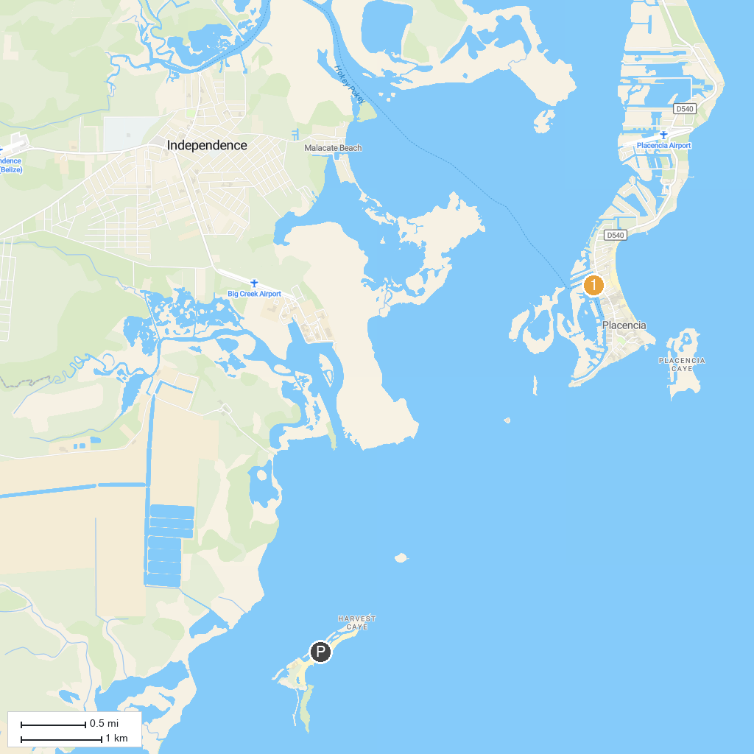
MAP KEY
1. Placencia Wildside Adventures | 2. Belize Spicefarm and Botanical Gardens
P. Cruise port / terminal
Map © MapTiler © OpenStreetMap contributors · cruiseports.org

