Hasselt, Limburg, Belgium
The self-styled 'Capital of Taste', Hasselt deals in jenever, street art murals, Europe's largest Japanese garden, and a walkable Flemish city center that rewards the curious.
⚓ Docked (Kanaalkom quay, Quartier Bleu) · 🕒 Typical call: 6–8 hrs · 💶 Euro (€) · 🗣️ Dutch/Flemish (English widely spoken)
✍️ MY DAY IN PORT (FILL IN)
Ship / Date
In port | arrive ______ · all aboard ______
Booked excursion
Notes / meeting point
GETTING ASHORE
- Docking: Alongside the Kanaalkom quay at Quartier Bleu (linked to the Albert Canal); no tender required
- Walk to center: 10–15 min (≈800 m) to Grote Markt — flat, paved
- Best For: Jenever tasting, street art, Japanese garden, Belgian cuisine
- Don't Miss: Nationaal Jenevermuseum tasting & Japanse Tuin in bloom
GETTING AROUND
- 🚕 Taxi: €8–10 — Fixed short-trip rate to the city center is approximately €8.50. Credit card payments accepted at most taxis (may carry
- 📱 Rideshare: ✅ Uber
TOP THINGS TO DO
- Nationaal Jenevermuseum — Belgium's national jenever museum occupies a preserved 19th-century distillery.
- Japanse Tuin (Japanese Garden) — The largest traditional Japanese garden in Europe, gifted by Hasselt's sister city Itami (Japan).
- Herkenrode Abbey — Once the richest women's abbey in the Low Countries, Herkenrode sits just outside the city with restored buildings, an herb…
- Street Art Trail — Over 80 large-scale murals are spread through Hasselt's streets, making it one of Belgium's top street art cities.
- Bokrijk Open-Air Museum — A 15-minute taxi or bus ride from the port, this vast open-air museum recreates Flemish rural life with transplanted historic…
BEST WALKS
- Canal to Grote Markt Loop: 2.5 km · 45 min · Easy · Flat — From the quay walk through Quartier Bleu's modern waterfront, past the Fashion Museum, through the…
- Street Art & Hidden Courtyards: 3 km · 1 hr · Easy · Self-guided — Pick up the free street art map at the Tourism Office and follow the mural trail through Hasselt's…
WEATHER · DAYLIGHT · MONEY
Month | High °F | Low °F | Rainy days
May | 65 | 48 | 11
Jul | 74 | 58 | 12
Sep | 69 | 53 | 10
Daylight: May 5:49AM–9:21PM · Jul 5:42AM–9:46PM · Sep 7:14AM–7:52PM
cruiseports.org/hasselt · Confirm terminal & all-aboard time with your ship

Hasselt, Limburg, Belgium — Port Map
Red = walkable sights · Amber = excursions farther out · P = cruise terminal
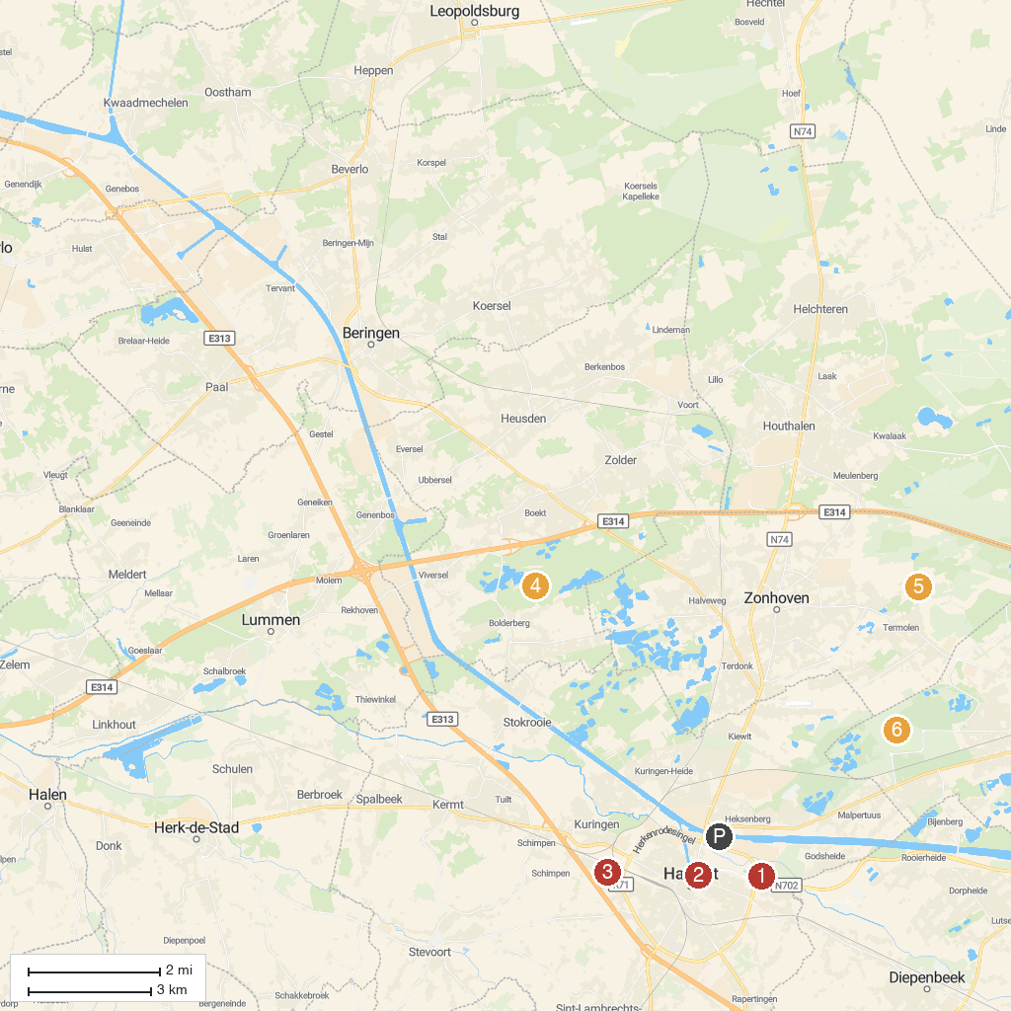
MAP KEY
1. Plopsa Indoor Hasselt | 5. De Holsteen
2. Gin Museum Hasselt | 6. Bokrijk Open Air Museum
3. Tommelen | 7. Park Olmenhof
4. Kluis van Bolderberg
P. Cruise port / terminal
Map © MapTiler © OpenStreetMap contributors · cruiseports.org

