Havana, La Habana, Cuba
Havana is unlike any other port in the Caribbean. A UNESCO-listed old city, 1950s American cars frozen in time, crumbling colonial grandeur, and live salsa on every corner — all within walking distance of the pier.
⚓ Docked (Sierra Maestra Terminal) · 🕒 Typical call: 8-12 hrs · 💵 Cuban Peso (CUP) / Euros accepted at some venues · 🗣️ Spanish · 🌡️ Hot & humid; cooler Nov–Feb
✍️ MY DAY IN PORT (FILL IN)
Ship / Date
In port | arrive ______ · all aboard ______
Booked excursion
Notes / meeting point
GETTING ASHORE
- Docking: Terminal Sierra Maestra, directly adjacent to Old Havana (Habana Vieja)
- Walk to center: Walkable — Old Havana's main plazas are 5-10 min on foot from the pier
- Best For: Colonial architecture, vintage car rides, Cuban music, and living history
- Don't Miss: Plaza de la Catedral and a daiquiri at El Floridita, Hemingway's old haunt
GETTING AROUND
- 🚕 Taxi: $10–25 USD — Iconic convertible or coupe taxis line up at the port. Negotiate the fare before you get in; prices vary widely and mete
- 📱 Rideshare: ❌ not available
- 🚌 Hop-on hop-off: ✅ Habana Bus Tour
TOP THINGS TO DO
- Old Havana Walking Tour — UNESCO-listed Habana Vieja is the core of any Havana visit.
- Classic Car City Tour — Havana's fleet of perfectly maintained 1950s American cars is genuinely remarkable — and renting one for a private city tour is…
- Live Music & Rum Experience — Cuba is the birthplace of son cubano, salsa, and mambo.
- Fortaleza de San Carlos de la Cabaña — One of the largest fortresses in the Americas, built by the Spanish in the 18th century to defend Havana Harbor after the British…
- Cuban Food & Market Tour — Beyond mojitos and ropa vieja, Havana has a developing private-restaurant (paladar) scene worth exploring.
BEST WALKS
- The Four Plazas of Habana Vieja: 2 km · 60-90 min · Easy — From the waterfront, walk to Plaza de San Francisco de Asís (the old trading square), then north…
- The Malecón Stroll: 2 km one-way · 30-40 min · Easy — Walk west from the edge of Old Havana along the Malecón, Havana's famous 8-km seawall boulevard.
WEATHER · DAYLIGHT · MONEY
Month | High °F | Low °F | Rainy days
May | 87 | 74 | 16
Jul | 90 | 77 | 18
Sep | 88 | 77 | 19
Daylight: May 6:48AM–8:03PM · Jul 6:53AM–8:17PM · Sep 7:16AM–7:32PM
cruiseports.org/havana · Confirm terminal & all-aboard time with your ship

Havana, La Habana, Cuba — Port Map
Red = walkable sights · Amber = excursions farther out · P = cruise terminal
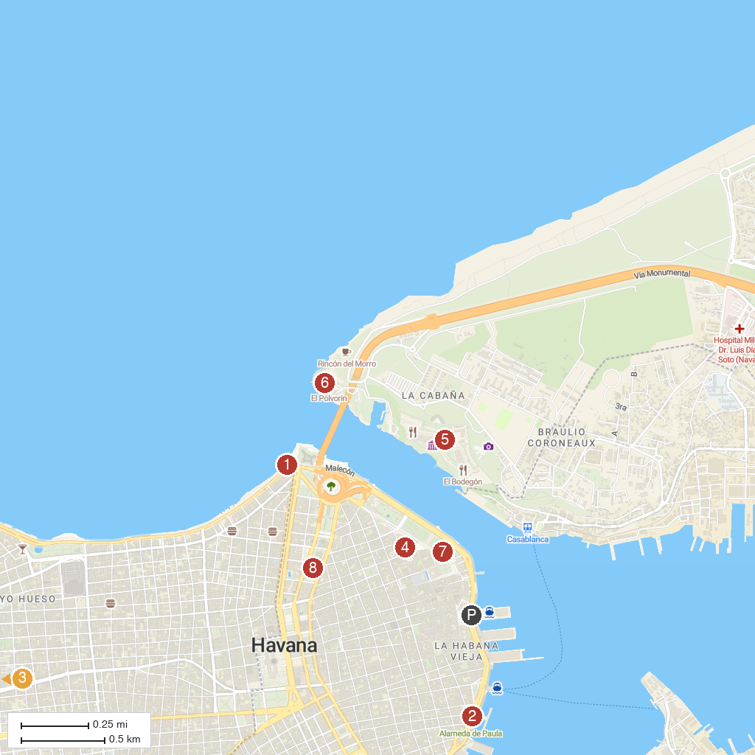
MAP KEY
1. Malecón de Habana | 5. Fort Of San Carlos Of The Cabin
2. Alameda de Paula | 6. Castle of the Three Kings of Morro
3. Monumento a José Miguel Gómez | 7. Havana Castle Of The Royal Force
4. Cathedral of the Immaculate Conception of the Virgin Mary | 8. National Museum of Fine Arts - Cuban Art
P. Cruise port / terminal
Map © MapTiler © OpenStreetMap contributors · cruiseports.org

