Havøysund, Finnmark, Norway
Perched at the top of Norway on the edge of the Barents Sea, Havøysund is a working Arctic fishing village where reindeer wander the streets and stockfish dries on waterfront racks — as far from a polished cruise port as it gets.
⚓ Pier (coastal/expedition ships) or tender (larger ships) · 🕒 Typical call: 4–6 hrs · 💳 Cashless — cards everywhere, no NOK needed · 🗣️ Norwegian (English widely spoken) · 🌤️ Arctic — dress in layers year-round
✍️ MY DAY IN PORT (FILL IN)
Ship / Date
In port | arrive ______ · all aboard ______
Booked excursion
Notes / meeting point
GETTING ASHORE
- Docking: Hurtigruten & expedition ships dock at Havøysund Kai; larger vessels anchor and tender
- Walk to center: 2–5 min from pier; entire village walkable in under 30 min
- Best For: Arctic scenery, seabird colonies, stockfish culture, authentic Norway
- Don't Miss: Gavlen viewpoint, Havøysund Church, reindeer on the streets
GETTING AROUND
- 🚕 Taxi: NOK 150–300 — Havøysund Taxi (local operator) serves the area. Taxis are scarce — call ahead if possible. Norwegian taxis are pricey;
TOP THINGS TO DO
- Hjelmsøya Seabird Cliffs — One of Norway's largest seabird colonies lives on the island of Hjelmsøya nearby — puffins, razorbills, kittiwakes, and sea…
- National Scenic Route Fv889 — Havøysund sits at the end of one of Norway's 18 designated National Scenic Routes.
- King Crab Safari — The Barents Sea is prime territory for giant red king crab.
- Måsøy Museum — A small but evocative museum in an old rectory covering the region's fishing heritage, whale-hunting history, and the WWII…
BEST WALKS
- Village & Harbor Stroll: 1.5 km · 20 min · Flat — A gentle loop around the compact village center taking in the harbor, the stockfish drying racks…
- Gavlen Viewpoint Hike: 5 km return · 1.5–2 hrs · Uphill — Climb the paved road from the village to the Gavlen cliffs at the island's high point.
- Bridge Walk: 1 km · 15 min · Easy — Walk out to the distinctive cantilever bridge connecting Havøya island to the mainland.
WEATHER · DAYLIGHT · MONEY
Month | High °F | Low °F | Rainy days
May | 42 | 35 | 16
Jul | 58 | 49 | 12
Sep | 50 | 43 | 17
Daylight: Sep 5:32AM–6:58PM
cruiseports.org/havoysund · Confirm terminal & all-aboard time with your ship

Havøysund, Finnmark, Norway — Port Map
Red = walkable sights · Amber = excursions farther out · P = cruise terminal
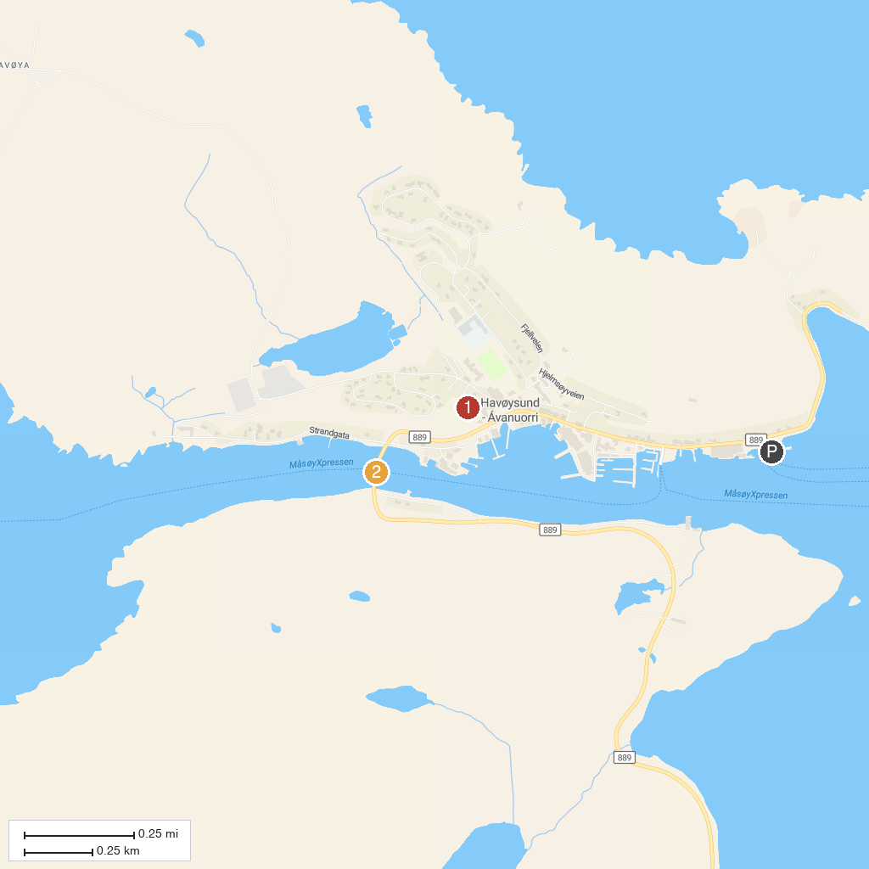
MAP KEY
1. Havøysund Church | 2. Havøysundtunnelen
P. Cruise port / terminal
Map © MapTiler © OpenStreetMap contributors · cruiseports.org

