Havre-Saint-Pierre, Quebec, Canada
One of North America's most remote cruise calls, Havre-Saint-Pierre opens the door to surreal limestone monoliths, Atlantic puffin colonies, and proud Acadian traditions on the subarctic North Shore of the Gulf of St. Lawrence.
⚓ Tender port (ships anchor offshore) · 🕒 Typical call: 7-9 hrs · 💵 Canadian Dollar (CAD) · 🗣️ French (Acadian dialect) · 🌿 National Park gateway
✍️ MY DAY IN PORT (FILL IN)
Ship / Date
In port | arrive ______ · all aboard ______
Booked excursion
Notes / meeting point
GETTING ASHORE
- Docking: Tender — ships anchor; small boats ferry passengers to the town pier
- Walk to center: 5 min from tender dock to main street (Rue de la Digue)
- Best For: Mingan Archipelago boat tours, puffin-watching, Acadian culture
- Don't Miss: Chicoutai (cloudberry) pie at Chez Julie; puffins on Île aux Perroquets
GETTING AROUND
- 🚕 Taxi: ~CAD 10–15 per trip — Local taxis serve the town; fares are short given the small size of Havre-Saint-Pierre. Ask at the pier or check with yo
- 📱 Rideshare: ❌ not available
TOP THINGS TO DO
- Mingan Archipelago Monolith Boat Tour — Cruise among the largest concentration of erosion monoliths in Canada — surreal limestone formations carved into pillars, arches…
- Puffin Colony at Île aux Perroquets — This island hosts a breeding colony of Atlantic Puffins (June–late August) alongside a historic lighthouse.
- Acadian & Innu Cultural Visit — Explore the Maison de la Culture Roland-Jomphe in the old Hudson's Bay Company building for multimedia exhibits on the Cayens…
- Boardwalk & Town Self-Guided Walk — The Sentier de la Digue boardwalk runs along the St.
- North Shore Seafood & Cloudberry Tasting — Chez Julie on Rue de la Digue is a port institution serving legendary seafood pizza piled with shrimp, scallops, and crab, plus…
BEST WALKS
- Boardwalk & Town Centre Loop: 1.5 km · 20-25 min · Easy — From the tender dock, walk along the Sentier de la Digue boardwalk past whale-watching benches and…
- Church & La Grande Plage Stroll: 2 km · 30 min · Easy — Head inland briefly to see the historic wooden Saint-Pierre Church, then continue to La Grande…
WEATHER · DAYLIGHT · MONEY
Month | High °F | Low °F | Rainy days
May | 50 | 35 | 10
Jul | 67 | 55 | 13
Sep | 59 | 48 | 12
Daylight: May 4:27AM–7:55PM · Jul 4:21AM–8:18PM · Sep 5:50AM–6:27PM
cruiseports.org/havre-saint-pierre · Confirm terminal & all-aboard time with your ship

Havre-Saint-Pierre, Quebec, Canada — Port Map
Red = walkable sights · Amber = excursions farther out · P = cruise terminal
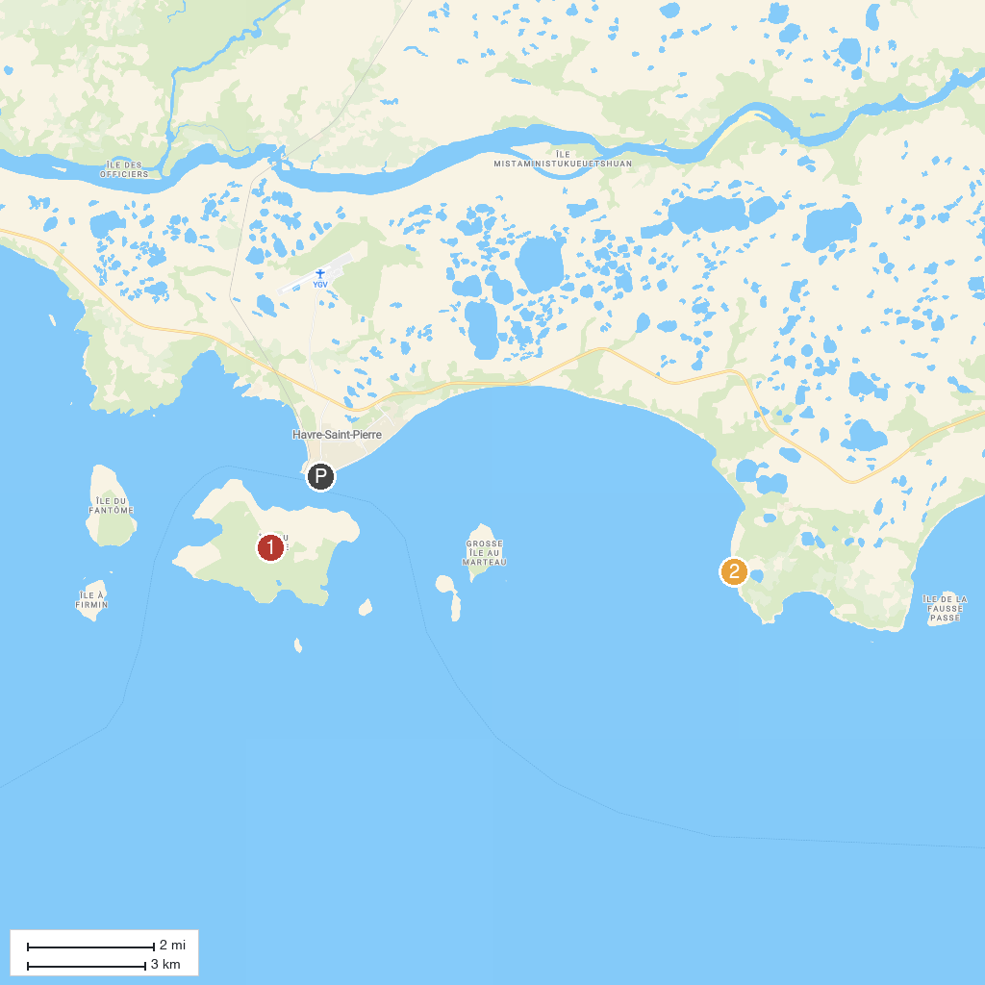
MAP KEY
1. Réserve de parc national de l'Archipel-de-Mingan | 2. Cap Ferré
P. Cruise port / terminal
Map © MapTiler © OpenStreetMap contributors · cruiseports.org

