Heilbronn, Baden-Württemberg, Germany
Germany's red wine capital sits where the Neckar bends through vineyard-covered hills. Ships tie up steps from an astronomical clock, a futuristic science museum, and Swabian Maultaschen that earns every calorie.
⚓ Pier (river quayside) · 🕒 Typical call: 7–9 hrs · 💶 Euro (€) · 🗣️ German · 🍷 Wine region
✍️ MY DAY IN PORT (FILL IN)
Ship / Date
In port | arrive ______ · all aboard ______
Booked excursion
Notes / meeting point
GETTING ASHORE
- Docking: Pier — ships tie up directly to the Neckar riverbank, no tender
- Walk to center: 2–5 min from central Experimenta dock; 15–20 min from Wertwiesenpark dock
- Best For: Wine lovers, science fans, history buffs, easy pedestrian city walking
- Don't Miss: Astronomical clock on the 1580 Town Hall and a glass of local Trollinger red wine
GETTING AROUND
- 🚕 Taxi: €10–20 — Taxis are available near the port and city center. Base fare €4.20 with €2.50–3.20/km; expect €10–20 for most in-city tr
- 🚌 Hop-on hop-off: ✅ citytour.de
TOP THINGS TO DO
- Historic Marketplace & Astronomical Clock — The 1580 Renaissance Town Hall holds one of Germany's finest astronomical clocks — watch it strike the hour as mechanical figures…
- St. Kilian's Church (Kilianskirche) — A towering Gothic and Renaissance landmark on the marketplace.
- experimenta Science Center — Germany's largest science center occupies a futuristic riverside building right at the main dock.
- Neckar Wine & Swabian Food Tour — Heilbronn is Germany's red wine capital, famous for Trollinger (light, served chilled) and Lemberger (rich, full-bodied).
- Wartberg Hill Vineyard Walk — A 45-minute uphill walk (or short taxi ride) through working vineyards leads to the Wartberg tower and sweeping panoramas over…
BEST WALKS
- Old Town Loop: 1.5 km · ~30 min · flat — From the central dock, cross the Adolf-Cluss-Brücke and walk to the Marketplace, passing St.
- Wertwiesenpark Riverside Stroll: 2 km · ~35 min · flat — If docked at Wertwiesenpark, enjoy a scenic walk north through the rose gardens and reed-lined…
WEATHER · DAYLIGHT · MONEY
Month | High °F | Low °F | Rainy days
May | 66 | 49 | 13
Jul | 78 | 60 | 11
Sep | 70 | 53 | 9
Daylight: May 5:40AM–8:59PM · Jul 5:34AM–9:22PM · Sep 6:59AM–7:35PM
cruiseports.org/heilbronn · Confirm terminal & all-aboard time with your ship

Heilbronn, Baden-Württemberg, Germany — Port Map
Red = walkable sights · Amber = excursions farther out · P = cruise terminal
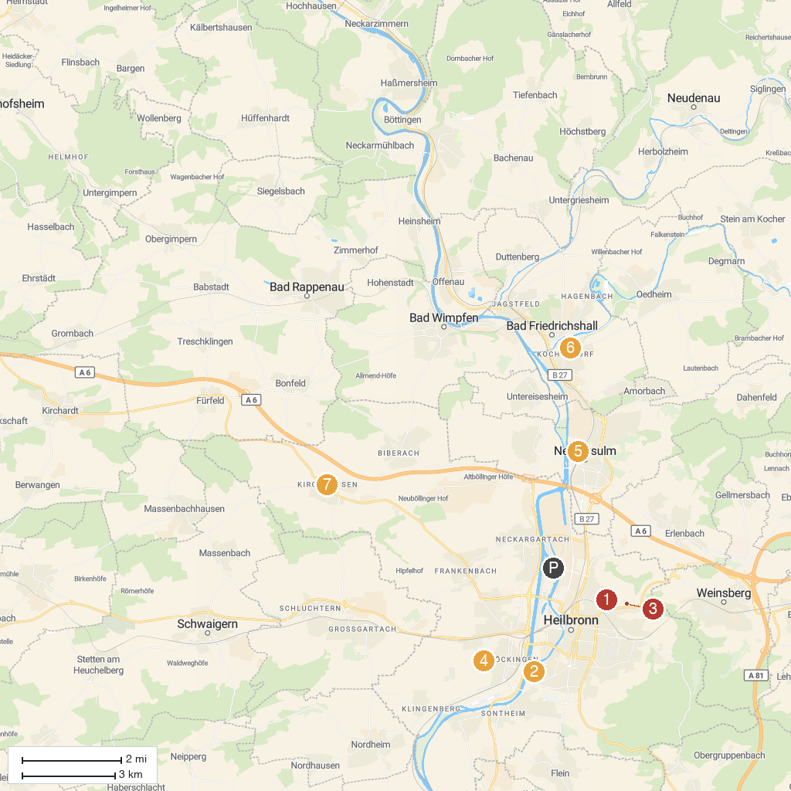
MAP KEY
1. Botanical Fruit Garden Heilbronn | 5. Audi Forum Neckarsulm
2. Wertwiesen Park | 6. Grecken Castle Bad Friedrichshall
3. Wein Panorama Weg | 7. Deutschordensschloss Heilbronn - Kirchhausen
4. Ziegeleipark Böckingen | 8. Lauffener Neckarschlinge
P. Cruise port / terminal
Map © MapTiler © OpenStreetMap contributors · cruiseports.org

