Heligoland, Schleswig-Holstein, Germany
A car-free North Sea island with duty-free prices, fiery red cliffs, seabird colonies by the millions, and a wartime past blasted into its bedrock.
⚓ Tender (no cruise pier) · 🕒 Typical call: 6–8 hrs · 💶 Euro (duty-free island) · 🗣️ German / English widely spoken · 🛍️ EU duty-free zone
✍️ MY DAY IN PORT (FILL IN)
Ship / Date
In port | arrive ______ · all aboard ______
Booked excursion
Notes / meeting point
GETTING ASHORE
- Docking: Tender — ships anchor offshore, tenders bring you to the inner harbour
- Walk to centre: 5 min from tender landing to Hummerbuden & duty-free shops
- Best For: Duty-free spirits & perfumes, birdwatching, cliffside walks, North Sea seafood
- Don't Miss: Lange Anna sea stack, Lummenfelsen gannet colony, Düne Island seals
GETTING AROUND
- 🚕 Taxi: Varies — Small electric taxis are available year-round for those with mobility needs or heavy luggage. Useful for reaching the Ob
- 📱 Rideshare: ❌ not available
TOP THINGS TO DO
- Lummenfelsen Gannet & Seabird Colony — The Lummenfelsen cliff on the Oberland hosts one of Germany's largest seabird colonies — thousands of Northern Gannets…
- Lange Anna Sea Stack — The island's most photographed landmark — a 47-metre freestanding red sandstone pinnacle on the northwest tip.
- Düne Island Seals & Beaches — A short harbour ferry hop to Heligoland's sandy satellite island.
- WWII Bunker Tour — Heligoland was a massive German naval base; after WWII the British detonated one of history's largest non-nuclear explosions here.
- Duty-Free Shopping & Hummerbuden — Heligoland sits outside EU VAT and customs, making spirits, tobacco, perfume, and optics 20–40% cheaper than the mainland.
BEST WALKS
- Oberland Cliff Trail to Lange Anna: 2.5 km loop · 45–60 min · Easy–Moderate — Take the lift or steps from Unterland to the Oberland plateau.
- Harbour & Hummerbuden Stroll: 0.5 km · 15 min · Easy — A flat walk from the tender landing along the inner harbour promenade past the colourful…
WEATHER · DAYLIGHT · MONEY
Month | High °F | Low °F | Rainy days
May | 53 | 49 | 9
Jul | 64 | 60 | 13
Sep | 63 | 59 | 14
Daylight: May 5:24AM–9:25PM · Jul 5:15AM–9:52PM · Sep 7:02AM–7:44PM
cruiseports.org/heligoland-island-germany · Confirm terminal & all-aboard time with your ship

Heligoland, Schleswig-Holstein, Germany — Port Map
Red = walkable sights · Amber = excursions farther out · P = cruise terminal
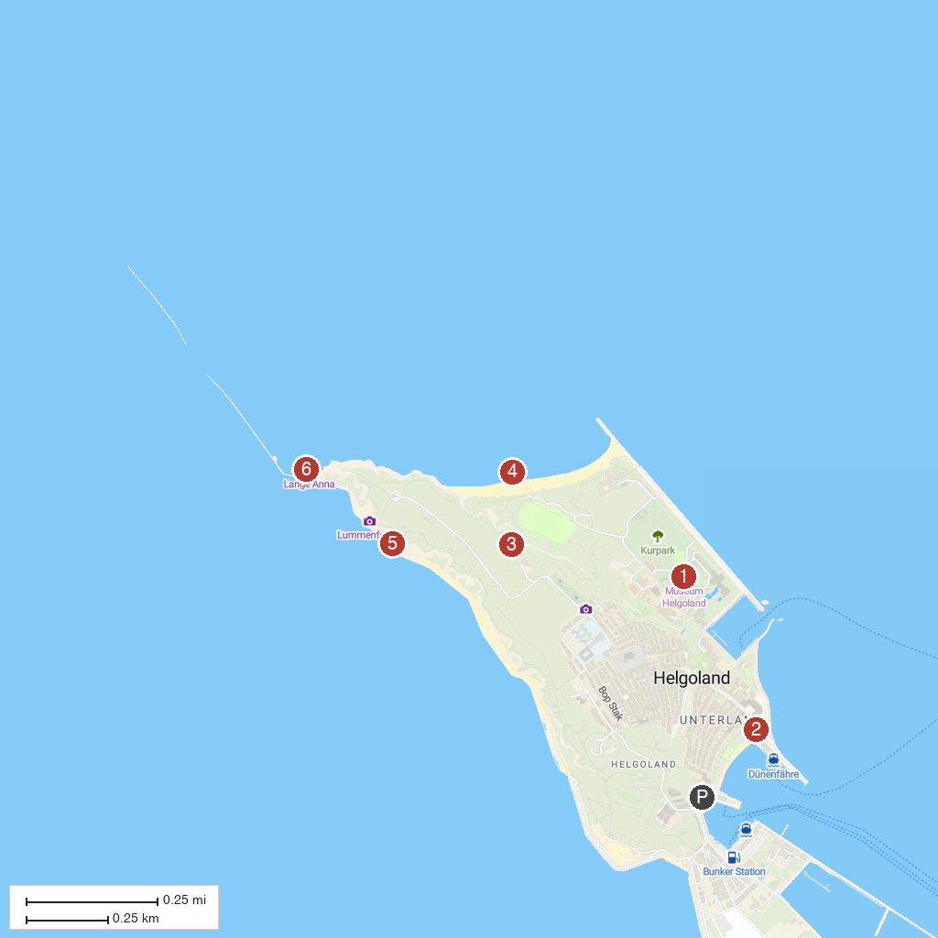
MAP KEY
1. Heligoland Museum | 4. Helgoländer Felssockel
2. Inselbahn Rundfahrten Helgoland | 5. Lummenfelsen der Insel Helgoland
3. Crater of a 5000 kg bomb | 6. Lange Anna (Nathurn Stak)
P. Cruise port / terminal
Map © MapTiler © OpenStreetMap contributors · cruiseports.org

