Hellevoetsluis, South Holland, Netherlands
A perfectly preserved Dutch fortress town where 17th-century naval bastions meet Europe's oldest stone dry dock — compact, walkable, and quietly extraordinary.
⚓ Docked at town quay · 🕒 Typical call: 6-8 hrs · 💶 Euro (€) · 🗣️ Dutch (English widely spoken)
✍️ MY DAY IN PORT (FILL IN)
Ship / Date
In port | arrive ______ · all aboard ______
Booked excursion
Notes / meeting point
GETTING ASHORE
- Docking: River/small ships dock at the town quay — no tender needed
- Walk to center: Under 5 min from quay to historic fortress core
- Best For: History buffs, naval heritage, leisurely fortress walks
- Don't Miss: Droogdok Jan Blanken — oldest stone dry dock in Europe
GETTING AROUND
- 🚕 Taxi: €10–€20 (local) — Local taxi companies (Schiphol Taxi Hellevoetsluis, Denar Taxi) serve the area. Longer transfers to Rotterdam port run €
- 📱 Rideshare: ✅ Uber
TOP THINGS TO DO
- Droogdok Jan Blanken — The oldest stone dry dock in Europe, built in the early 19th century and still intact.
- Vesting Hellevoetsluis Fortress Walk — Stroll the ramparts, bastions, and casemates of the remarkably preserved 17th-century fortress.
- National Firefighting Museum — The Nationaal Brandweermuseum holds one of Europe's most impressive collections of historic firefighting equipment, from…
- Kinderdijk Windmills Day Trip — The UNESCO-listed Kinderdijk windmill network is roughly 40 km away — a classic Dutch experience popular as a longer excursion…
- Haringvliet Waterway & Marina — The broad Haringvliet estuary framing the town is superb for kayaking, stand-up paddleboarding, and boat trips.
BEST WALKS
- Fortress Core Loop: ~2 km • 45 min • Flat, paved — From the town quay, walk to Droogdok Jan Blanken, continue past the Prinsehuis to the…
- Marina & Waterfront Stroll: ~1 km • 20 min • Flat — An easy walk along the Hellevoetsluis marina and Haringvliet waterfront — good for watching boats…
WEATHER · DAYLIGHT · MONEY
Month | High °F | Low °F | Rainy days
May | 62 | 49 | 12
Jul | 71 | 59 | 14
Sep | 67 | 56 | 11
Daylight: May 5:50AM–9:30PM · Jul 5:42AM–9:55PM · Sep 7:18AM–7:57PM
cruiseports.org/hellevoetsluis · Confirm terminal & all-aboard time with your ship

Hellevoetsluis, South Holland, Netherlands — Port Map
Red = walkable sights · Amber = excursions farther out · P = cruise terminal
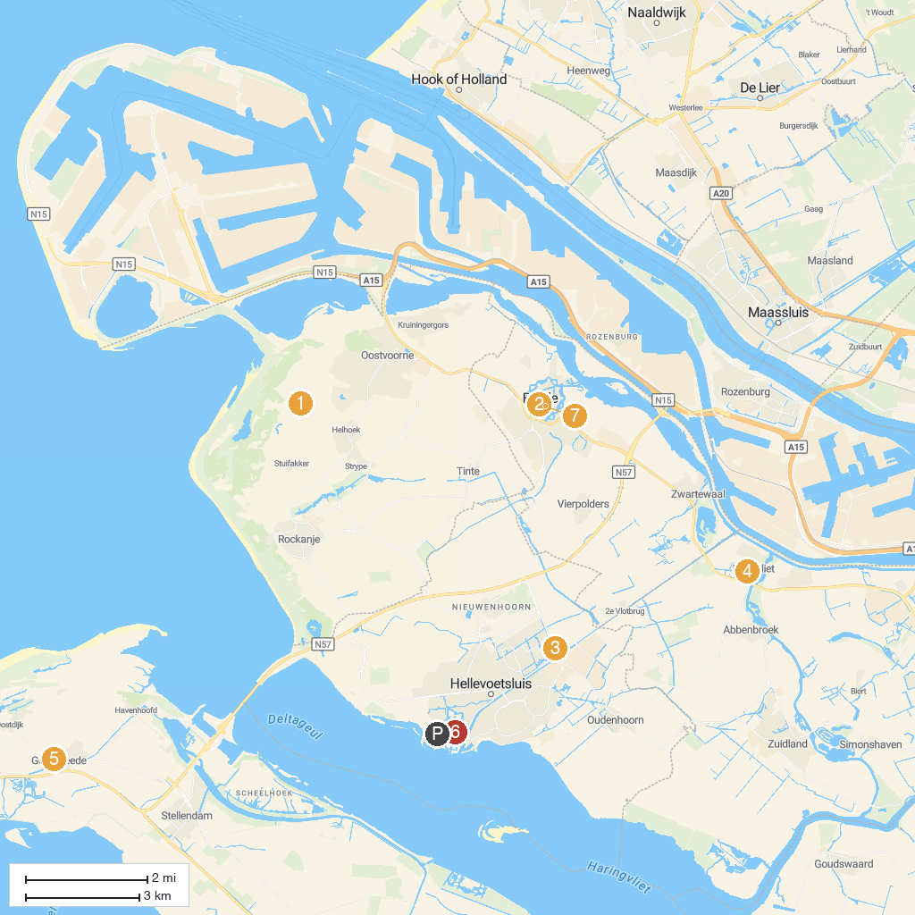
MAP KEY
1. Openluchtmuseum De Duinhuisjes | 5. Torenmuseum Goedereede
2. St. Catharijnekerk | 6. Fluisterboot de IJsvogel
3. Historyland | 7. National Firefighting Museum
4. Slot Ravesteyn | 8. Historical Museum Den Briel
P. Cruise port / terminal
Map © MapTiler © OpenStreetMap contributors · cruiseports.org

