Helsingør, Zealand, Denmark
Where Shakespeare set Hamlet, the Danish Sound once taxed every ship in Europe. Kronborg Castle dominates the headland; the town behind it is cobblestone, color, and surprisingly great food.
⚓ Pier (small ships) or Tender (large ships) · 🕒 Typical call: 6–9 hrs · 💵 Danish Krone (DKK) — cashless-friendly · 🗣️ Danish / English universally spoken
✍️ MY DAY IN PORT (FILL IN)
Ship / Date
In port | arrive ______ · all aboard ______
Booked excursion
Notes / meeting point
GETTING ASHORE
- Docking: Royal Quay (ships ≤150 m) or tender to floating pier — both deliver you to the heart of town
- Walk to center: 5 min from Royal Quay; 2 min from tender pier to Culture Yard
- Best For: History, Shakespeare fans, architecture, easy Sweden day-trip
- Don't Miss: Kronborg Castle casemates — meet the sleeping Holger Danske
GETTING AROUND
- 🚕 Taxi: ~50–100 DKK — Taxis operate on a meter in Denmark. For the very short port-to-town distance the fare is mostly the base charge; useful
- 📱 Rideshare: ✅ Uber, Bolt
TOP THINGS TO DO
- Kronborg Castle — UNESCO World Heritage Site and the real-world inspiration for Hamlet's Elsinore.
- M/S Maritime Museum of Denmark — Built underground inside a 1950s shipyard dry dock by architect Bjarke Ingels, this museum tells Denmark's story as one of…
- Ferry to Helsingborg, Sweden — The narrowest point of the Øresund — just 4 km across.
- Hornbæk Beach Day — Nicknamed the 'Danish Riviera,' Hornbæk has wide white-sand beaches, rolling dunes, and a charming harbor village.
- Old Town & Carmelite Priory Walk — Wander Stengade and its side lanes — Bjergegade, Glahns Allé — lined with half-timbered houses from the 16th–18th centuries.
BEST WALKS
- Harbor Path to Kronborg Castle: 1.5 km · 15 min · Flat · ★ Essential — The easiest and most scenic walk in port.
- Old Town Lanes Loop: 1 km · 20 min · Flat · Free — From Axeltorv square, duck into Stengade for shops and cafés, then detour through Bjergegade and…
WEATHER · DAYLIGHT · MONEY
Month | High °F | Low °F | Rainy days
May | 60 | 47 | 11
Jul | 70 | 58 | 14
Sep | 64 | 54 | 11
Daylight: May 4:56AM–9:16PM · Jul 4:44AM–9:45PM · Sep 6:41AM–7:26PM
cruiseports.org/helsingor · Confirm terminal & all-aboard time with your ship

Helsingør, Zealand, Denmark — Port Map
Red = walkable sights · Amber = excursions farther out · P = cruise terminal
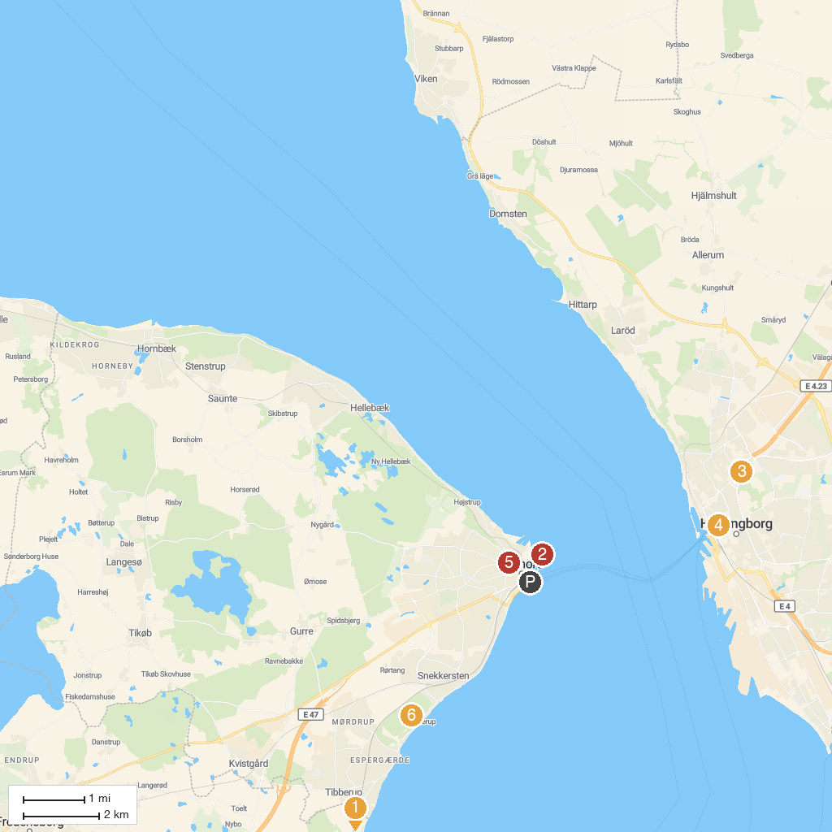
MAP KEY
1. Louisiana Museum of Modern Art | 5. Nivågård’s Malerisamling
2. Kronborg Castle | 6. St. Vincent's Church
3. Tropikariet | 7. Egebæksvang
4. St. Mary Church
P. Cruise port / terminal
Map © MapTiler © OpenStreetMap contributors · cruiseports.org

