Herm Island, Channel Islands, UK
The smallest publicly accessible Channel Island and one of the English Channel's best-kept secrets — a 1.5-mile car-free haven of white-sand beaches, wildflower paths, and cliff-top views stretching to Guernsey, Sark, and France.
⚓ Tender (no pier — Herm Harbour or Rosaire Steps) · 🕒 Typical call: 4–6 hrs · 💷 Currency: British Pound (GBP) · 🗣️ Language: English · 🏖️ Best beaches in the Channel Islands
✍️ MY DAY IN PORT (FILL IN)
Ship / Date
In port | arrive ______ · all aboard ______
Booked excursion
Notes / meeting point
GETTING ASHORE
- Docking: Tender to Herm Harbour (high tide) or Rosaire Steps (low tide)
- Walk to beach: Shell Beach 20–25 min from harbour; Belvoir Bay 25 min
- Best For: Beaches, walking, puffin watching, total escape from cars & crowds
- Don't Miss: Shell Beach, Mermaid Tavern crab sandwich, St. Tugual's Chapel
GETTING AROUND
- 📱 Rideshare: ❌ not available
TOP THINGS TO DO
- Shell Beach & Coastal Walk — Follow the main spine path north-east to Shell Beach, famous for millions of tiny shell fragments deposited by the Gulf Stream.
- Belvoir Bay Swim & Sunbathe — Herm's most sheltered cove, tucked between low cliffs on the east coast.
- St. Tugual's Chapel & Herm Common — A tiny 11th-century Norman chapel in Manor Village near the island's centre, with stained-glass windows depicting local scenes…
- Puffin Watching (April–July) — A colony of Atlantic puffins nests on the cliffs off Herm's south-east coast (Puffin Bay) from mid-April through July.
- Kayak & SUP on Shell Beach — During peak summer months, kayaks and stand-up paddleboards are available to rent directly on Shell Beach, giving a unique…
BEST WALKS
- Harbour to Shell Beach: ~25 min one way | Easy | Flat gravel path — From Herm Harbour follow the main central path north-east past the White House Hotel gardens.
- Full Island Circuit: ~5 km | 1.5–2 hrs | Easy–moderate — Circumnavigate the island clockwise: north from the harbour along the west coast to Herm Common…
cruiseports.org/herm-island · Confirm terminal & all-aboard time with your ship

Herm Island, Channel Islands, UK — Port Map
Red = walkable sights · Amber = excursions farther out · P = cruise terminal
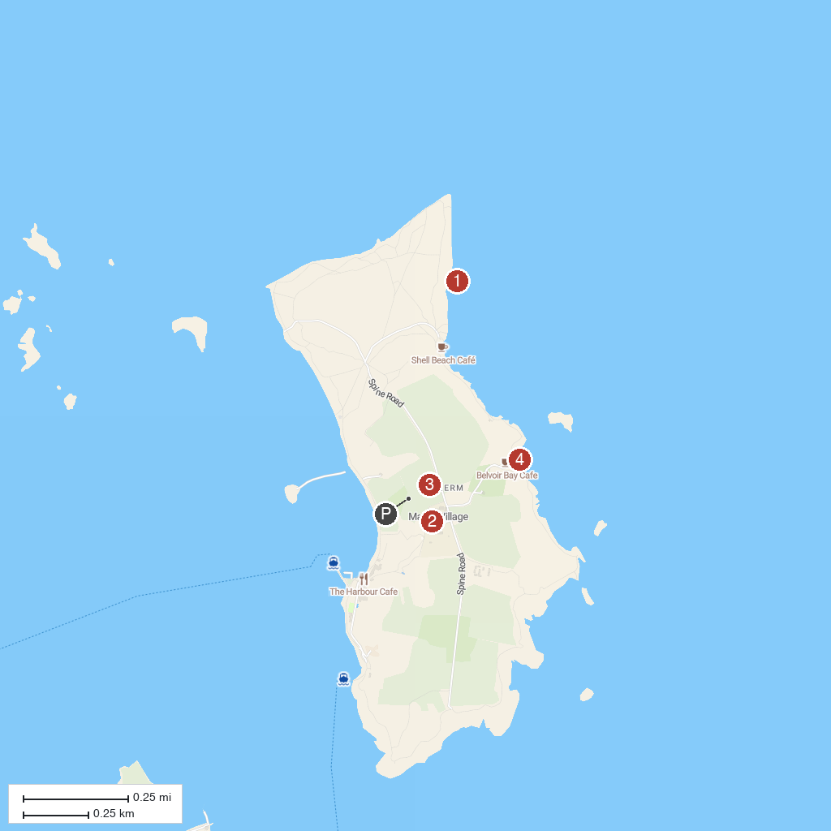
MAP KEY
1. Shell Beach | 3. Herm Common
2. St Tugual's Chapel | 4. Belvoir Bay
P. Cruise port / terminal
Map © MapTiler © OpenStreetMap contributors · cruiseports.org

