Herradura, Puntarenas, Costa Rica
Where five-star marina luxury meets raw Costa Rican rainforest — scarlet macaws soar overhead while sportfishing charters and catamaran day trips depart from one of the Pacific's finest marina villages.
⚓ Tender (no pier) · 🕒 Typical call: 7–9 hrs · 💵 USD widely accepted · 🗣️ Spanish / English spoken · 🌿 Pura Vida wildlife & adventure
✍️ MY DAY IN PORT (FILL IN)
Ship / Date
In port | arrive ______ · all aboard ______
Booked excursion
Notes / meeting point
GETTING ASHORE
- Docking: Tender to Los Sueños Marina dock
- Walk to center: Marina Village shops & restaurants at the tender dock
- Best For: Sportfishing, Carara rainforest, catamaran to Tortuga Island
- Don't Miss: Scarlet macaws at Carara NP & fresh ceviche at marina
GETTING AROUND
- 🚕 Taxi: $21–$26 USD — Official taxis from Los Sueños Marina to Jacó Beach take 13–18 minutes. Confirm fare before departure; night rates are h
TOP THINGS TO DO
- Carara National Park Guided Hike — Drive 20 minutes north to one of Costa Rica's most accessible rainforest reserves, a transition zone where scarlet macaws…
- Catamaran Day Trip to Tortuga Island — Sail to the uninhabited Tortuga Island for white-sand beaches, snorkeling over coral, banana boat rides, and a gourmet lunch…
- World-Class Sportfishing — Los Sueños Marina is Costa Rica's fishing capital.
- Zipline & Canopy Tour — Vista Los Sueños Adventure Park sits minutes from the marina, offering ziplines through the forest canopy with Pacific views.
- Tarcoles River Crocodile & Mangrove Safari — Board a flat-bottomed boat on the Tarcoles River to drift past American crocodiles — some over 4 metres — plus herons, iguanas…
BEST WALKS
- Marina Village Promenade & Playa Herradura: 1–2 km · 20–40 min · Easy · Flat — From the tender dock, stroll through Los Sueños Marina Village past restaurants and boutiques, then…
- Walk to Jacó Town Center: ~4 km · 45 min · Easy · Road walk — taxi recommended — Jacó is about 4 km south along the main road.
WEATHER · DAYLIGHT · MONEY
Month | High °F | Low °F | Rainy days
May | 86 | 75 | 20
Jul | 85 | 74 | 20
Sep | 83 | 73 | 24
Daylight: May 5:22AM–5:48PM · Jul 5:29AM–6:00PM · Sep 5:32AM–5:35PM
cruiseports.org/herradura · Confirm terminal & all-aboard time with your ship

Herradura, Puntarenas, Costa Rica — Port Map
Red = walkable sights · Amber = excursions farther out · P = cruise terminal
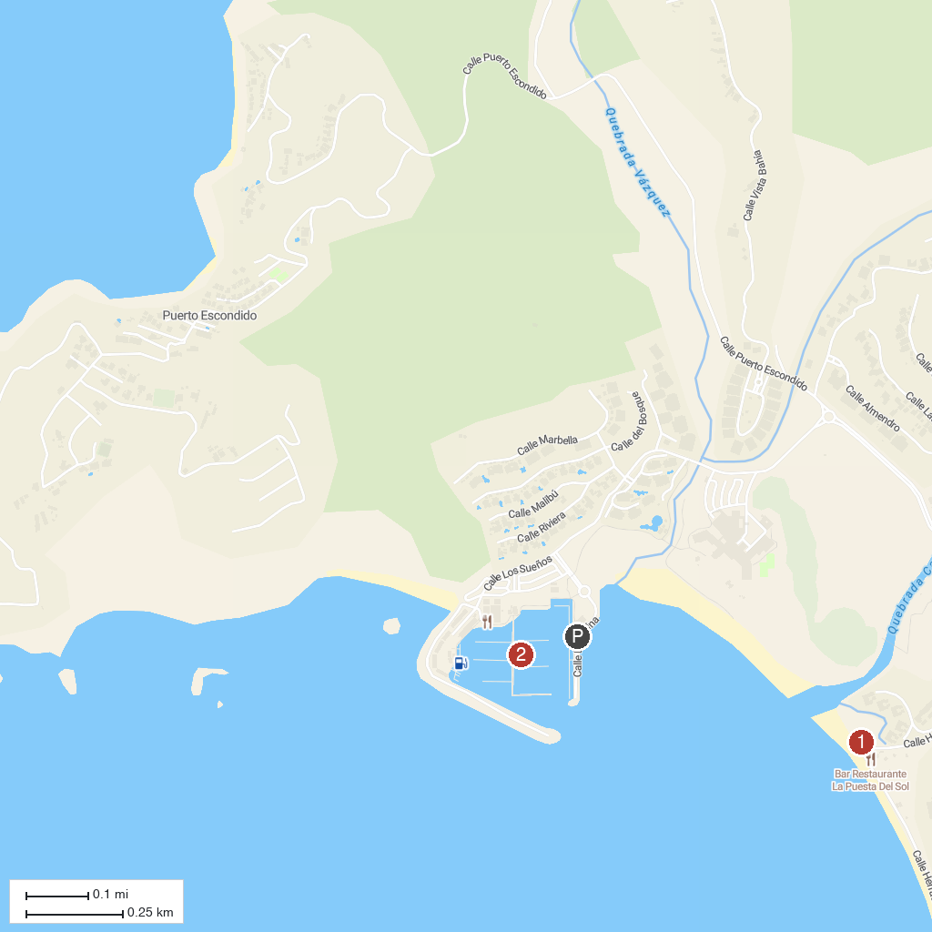
MAP KEY
1. Playa Herradura | 3. Tarcoles River Crocodile Bridge
2. Carara National Park | 4. Jaco Beach
P. Cruise port / terminal
Map © MapTiler © OpenStreetMap contributors · cruiseports.org

