Hirtshals, North Jutland, Denmark
A real working port on Denmark's wild northern tip — fresh fish, wartime bunkers, a record-breaking aquarium, and a train ride away from the place where two seas collide.
⚓ Docked (pier) · 🕒 Typical call: 7-9 hrs · 💵 Danish Krone (DKK) — nearly cashless · 🗣️ Danish / English widely spoken · 🐟 Fishing & ferry hub
✍️ MY DAY IN PORT (FILL IN)
Ship / Date
In port | arrive ______ · all aboard ______
Booked excursion
Notes / meeting point
GETTING ASHORE
- Docking: Pier — ships dock at the commercial harbour; no tender required
- Walk to centre: ~15-20 min (1–1.5 km) via Trappen staircase
- Best For: WWII history, world-class seafood, aquarium, Skagen day-trip
- Don't Miss: Nordsøen Oceanarium's 4.5-million-litre tank and a Stjerneskud lunch
GETTING AROUND
- 🚕 Taxi: 30–55 DKK to town center — Local taxis are available at the port. Godis Taxi (+45 9894 1789) and Hirtshals Taxi (+45 9894 4000) serve the area; sho
TOP THINGS TO DO
- Nordsøen Oceanarium — Northern Europe's largest aquarium centres on a 4.5-million-litre ocean tank — home to giant Mola mola sunfish, sharks, and vast…
- Bunkermuseum Hirtshals — 10th Battery — Denmark's most complete WWII coastal-defence site: 69 bunkers and 3.5 km of trenches preserved in the dunes beside the lighthouse.
- Day Trip to Skagen — About 2 hours by train (changing at Hjørring), Skagen is the northernmost town in Denmark — its Grenen headland is where the…
- Hirtshals Lighthouse & Town Walk — Climb the 1863 lighthouse (144 steps, ~20 DKK) for panoramic North Sea views, then loop back through the old fisherman's quarter…
- Harbour Seafood & Stjerneskud Lunch — Hirtshals is one of Denmark's top fishing ports — the catch here goes directly to local restaurants.
BEST WALKS
- Harbour to Town Centre via Trappen: 1.2 km • 15-20 min • Easy (one staircase climb) — Leave the pier, follow the quayside to the Trappen monumental staircase, climb to town-plateau…
- Coastal Loop: Lighthouse & Bunkers: 4-5 km round trip • 1.5-2 hrs • Easy — From the town centre head west along the coastal path past Husmoderstranden beach to the 1863…
WEATHER · DAYLIGHT · MONEY
Month | High °F | Low °F | Rainy days
May | 57 | 47 | 11
Jul | 67 | 58 | 13
Sep | 62 | 55 | 12
Daylight: May 4:58AM–9:35PM · Jul 4:44AM–10:06PM · Sep 6:50AM–7:38PM
cruiseports.org/hirtshals · Confirm terminal & all-aboard time with your ship

Hirtshals, North Jutland, Denmark — Port Map
Red = walkable sights · Amber = excursions farther out · P = cruise terminal
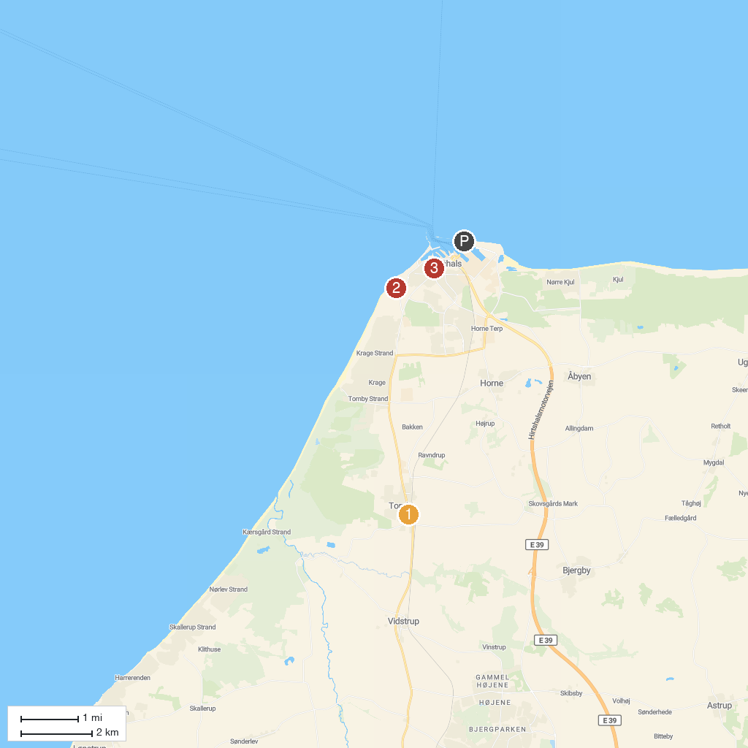
MAP KEY
1. Church of Tornby | 3. Hirtshals fyr
2. Bindslev Gl. Elværk | 4. Hirtshals Museum
P. Cruise port / terminal
Map © MapTiler © OpenStreetMap contributors · cruiseports.org

