Hitachinaka, Ibaraki, Japan
A working port that erupts in color each spring — 4.5 million blue nemophila blanket the hillsides of Hitachi Seaside Park while the fish market below serves oysters pulled from the Pacific that morning.
⚓ Pier (industrial wharf) · 🕒 Typical call: 8–10 hrs · 💴 Japanese Yen (JPY) · 🗣️ Japanese (limited English) · 🌸 Best Apr–May & Oct
✍️ MY DAY IN PORT (FILL IN)
Ship / Date
In port | arrive ______ · all aboard ______
Booked excursion
Notes / meeting point
GETTING ASHORE
- Docking: Pier — Center Wharf or Nakajima Wharf; no tendering
- Walk to Center: Walking outside port gates is prohibited; free shuttle to Katsuta Station or Hitachi Seaside Park
- Best For: Seasonal flowers, fresh seafood, day trips to Mito or Tokyo
- Don't Miss: Hitachi Seaside Park (nemophila in spring, kochia in autumn) & Nakaminato Fish Market
GETTING AROUND
- 🚕 Taxi: ¥3,200–¥4,000 (~$21-27 USD) — Taxis wait at the pier and take about 15–20 minutes to Katsuta Station. Fares are metered; having your destination in Ja
- 📱 Rideshare: ✅ Uber
TOP THINGS TO DO
- Hitachi Seaside Park — Over 350 hectares of gardens famous for 4.5 million blue nemophila in spring and vivid red kochia in autumn.
- Kairakuen Garden & Mito — One of Japan's Three Great Gardens, Kairakuen features 3,000 plum trees, bamboo groves, and the Edo-era Kobuntei pavilion.
- Nakaminato Fish Market — A bustling waterfront fish market where you can watch fresh Pacific catches arrive and eat rock oysters shucked on the spot for a…
- Tokyo Day Trip — The JR Joban Line Limited Express from Katsuta reaches Tokyo/Ueno in about 75–85 minutes.
- Aqua World Oarai Aquarium — One of Japan's largest aquariums, with over 50 shark species, daily dolphin and sea lion shows, and panoramic Pacific ocean views.
BEST WALKS
- Hitachi Seaside Park Nemophila Walk: 3–4 km • Easy • 1.5–2 hrs • Shuttle or bus from Katsuta Station — From the park's west gate, follow the main path up Miharashi Hill for 360° views of the blue…
- Nakaminato Waterfront Stroll: 1.5 km • Easy • 45 min • Taxi or bus from Katsuta — Walk the Nakaminato fishing harbor from the fish market stalls along the river mouth to the public…
WEATHER · DAYLIGHT · MONEY
Month | High °F | Low °F | Rainy days
May | 69 | 56 | 12
Jul | 80 | 71 | 16
Sep | 77 | 69 | 16
Daylight: May 4:31AM–6:37PM · Jul 4:31AM–6:55PM · Sep 5:20AM–5:45PM
cruiseports.org/hitachinaka · Confirm terminal & all-aboard time with your ship

Hitachinaka, Ibaraki, Japan — Port Map
Red = walkable sights · Amber = excursions farther out · P = cruise terminal
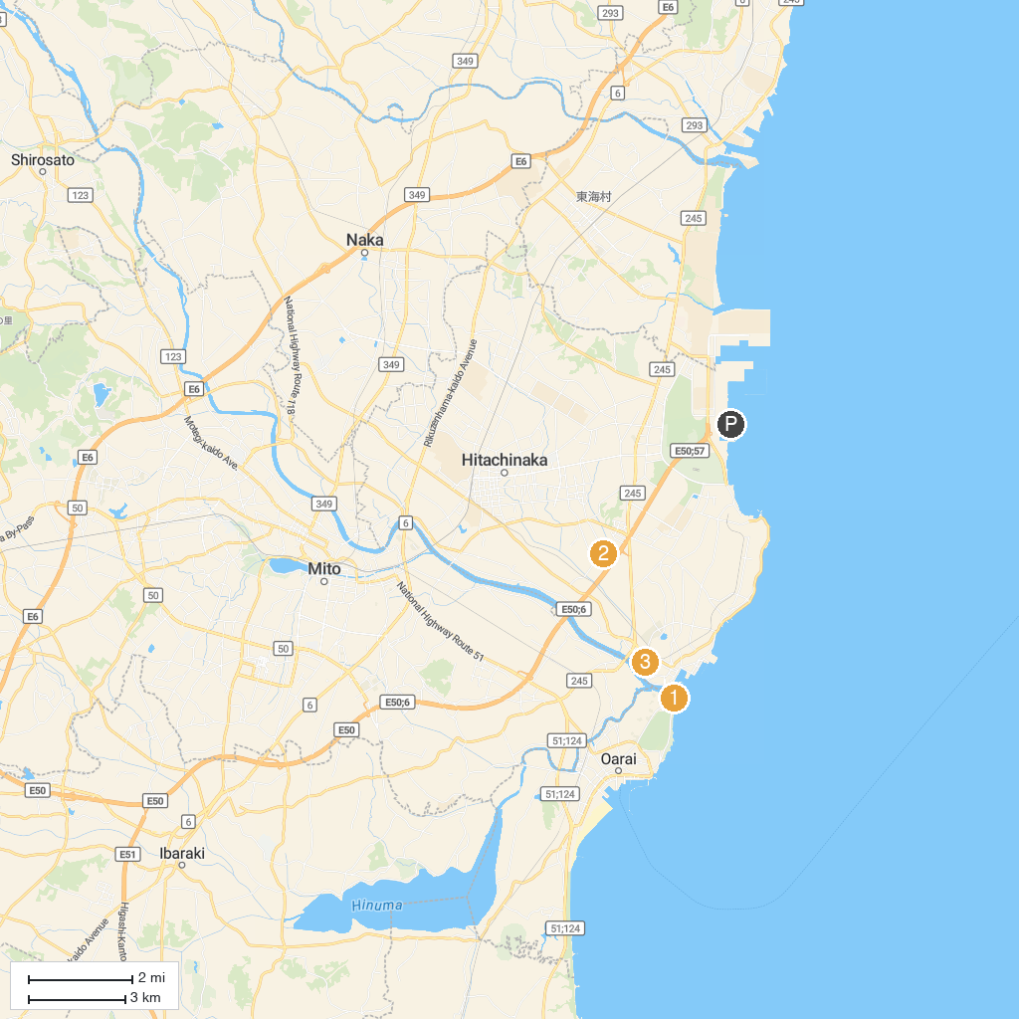
MAP KEY
1. Kozogawa Dam | 5. Mito City Museum
2. Aqua World Ibaraki Oarai Aquarium | 6. Kairakuen
3. Art Tower Mito | 7. Howaen
4. Torazuka Mounded Tomb | 8. Nakaminato Reverberatory Furnace Ruin
P. Cruise port / terminal
Map © MapTiler © OpenStreetMap contributors · cruiseports.org

