Hjørundfjord, Sunnmøre, Norway
One of Norway's last truly wild fjords, Hjørundfjord carves deep through the Sunnmøre Alps — jagged peaks soaring 1,700 m straight from the water, tiny farm villages clinging to the slopes, and not a megaship in sight.
⚓ Tender port (no cruise pier) · 🕒 Typical call: 6–8 hrs · 💵 Norwegian Krone (NOK) — but cashless cards accepted everywhere · 🗣️ Norwegian (English widely spoken) · 🥾 Best for hikers and nature lovers
✍️ MY DAY IN PORT (FILL IN)
Ship / Date
In port | arrive ______ · all aboard ______
Booked excursion
Notes / meeting point
GETTING ASHORE
- Docking: Tender to floating pontoon at Urke village
- Walk to center: You step off the tender into Urke — the entire village is under 10 min on foot
- Best For: Epic fjord hiking, scenic silence, historic Hotel Union Øye
- Don't Miss: The sunken village at Lyngstøylvatnet lake in Norangsdalen valley
GETTING AROUND
- 🚕 Taxi: NOK 500–1,400 per trip — Norwegian taxis are available but expensive. Norgestaxi (08000) and local operators serve the Sunnmøre region; pre-booki
- 📱 Rideshare: ❌ not available
TOP THINGS TO DO
- Norangsdalen Valley & Lyngstøylvatnet — Drive or cycle into the wild Norangsdalen valley, flanked by sheer rock walls, to reach Lyngstøylvatnet — a lake formed by a 1908…
- Mt. Slogen Hike (1,564 m) — The 'Queen of the Sunnmøre Alps' rewards fit hikers with a dramatic pyramid summit and views spanning dozens of peaks and fjord…
- Mt. Saksa Hike (1,030 m) — A challenging but achievable summit above Urke with roughly 1,000 m of ascent.
- Hotel Union Øye Lunch or Afternoon Tea — One of Europe's great historic hotels (1891), about 6 km from Urke at the village of Øye.
- Fjord Kayaking — Paddle at water level beneath 1,700 m walls of rock — the best way to appreciate the scale of the Sunnmøre Alps.
BEST WALKS
- Urke Village & Shoreline Stroll: 500 m · 10 min · Flat · Free — From the tender pontoon, walk the full length of Urke past traditional Norwegian farmhouses…
- Walk to Hotel Union Øye: 6 km one way · 1.5 hrs · Flat · Scenic — A flat, paved road hugs the southern shore of the fjord from Urke to the historic hamlet of Øye.
WEATHER · DAYLIGHT · MONEY
Month | High °F | Low °F | Rainy days
May | 54 | 42 | 18
Jul | 66 | 54 | 22
Sep | 60 | 49 | 19
Daylight: May 4:38AM–10:23PM · Jul 4:14AM–11:02PM · Sep 6:59AM–7:56PM
cruiseports.org/hjorundfjord · Confirm terminal & all-aboard time with your ship

Hjørundfjord, Sunnmøre, Norway — Port Map
Red = walkable sights · Amber = excursions farther out · P = cruise terminal
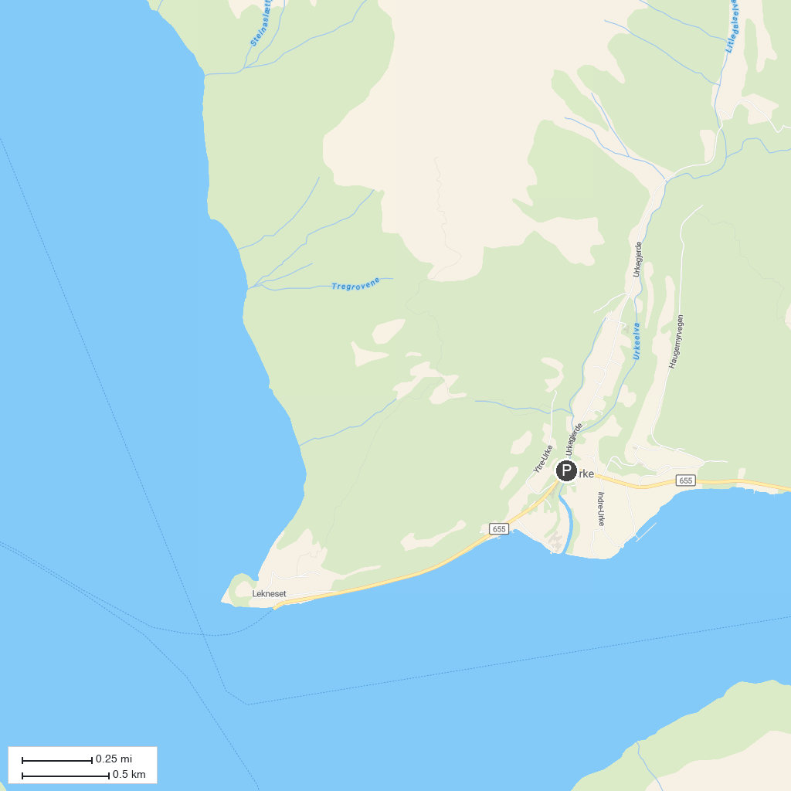
MAP KEY
1. Ørsta Skisenter | 3. Aarneset swimming area
2. Paddeland
P. Cruise port / terminal
Map © MapTiler © OpenStreetMap contributors · cruiseports.org

