Hoi An, Quảng Nam, Vietnam
A UNESCO World Heritage town of canary-yellow merchant houses, thousand silk lanterns, and legendary street food — reached by a scenic drive from Da Nang or Chan May port.
⚓ Docked at Da Nang or Chan May (no pier in Hoi An) · 🕒 Typical call: 8–10 hrs · 💵 Vietnamese Dong (VND); USD accepted at shops · 🗣️ Vietnamese · 🏛️ UNESCO World Heritage
✍️ MY DAY IN PORT (FILL IN)
Ship / Date
In port | arrive ______ · all aboard ______
Booked excursion
Notes / meeting point
GETTING ASHORE
- Docking: Ships berth at Tien Sa Port (Da Nang, ~35 km) or Chan May Port (~75 km) — both are pier berths
- Transfer to Town: 45–60 min from Da Nang; 1.5–2 hrs from Chan May by taxi or tour bus
- Best For: History, street food, custom tailoring, lantern-lit evenings, beach
- Don't Miss: Cao Lau noodles, the Japanese Covered Bridge, a basket boat ride in the coconut forest
GETTING AROUND
- 📱 Rideshare: ✅ Grab
TOP THINGS TO DO
- Hoi An Ancient Town Self-Guided Walk — Wander Tran Phu and Nguyen Thai Hoc streets, pop into the Japanese Covered Bridge, explore a 200-year-old merchant house (Tan Ky…
- Street Food & Cooking Class — Hunt down Cao Lau at a local stall, grab a legendary bánh mì at Bánh Mì Phượng, taste White Rose dumplings, then join a half-day…
- Basket Boat Ride — Cam Thanh Coconut Forest — Paddle through the water coconut palm groves southeast of town in a round bamboo basket boat.
- An Bang Beach Half-Day — Ten minutes by taxi from the Ancient Town, An Bang is one of Vietnam's best beaches — soft sand, clear water, beachfront…
- My Son Sanctuary — Cham Ruins — A half-day trip to the Hindu temple complex built by the Cham civilization between the 4th and 14th centuries — a UNESCO site set…
BEST WALKS
- Ancient Town Heritage Loop: 1.5–2 km | Easy | 1–2 hrs — The classic circuit through Hoi An's old quarter, hitting the main sights and riverside promenade.
- River Walk to An Hoi Islet: 1 km | Easy | 30–45 min — Cross the pedestrian bridge from the old town to An Hoi islet — home to the lantern market stalls…
WEATHER · DAYLIGHT · MONEY
Month | High °F | Low °F | Rainy days
May | 91 | 79 | 13
Jul | 92 | 80 | 17
Sep | 88 | 78 | 22
Daylight: May 5:17AM–6:08PM · Jul 5:23AM–6:21PM · Sep 5:35AM–5:48PM
cruiseports.org/hoi-an · Confirm terminal & all-aboard time with your ship

Hoi An, Quảng Nam, Vietnam — Port Map
Red = walkable sights · Amber = excursions farther out · P = cruise terminal
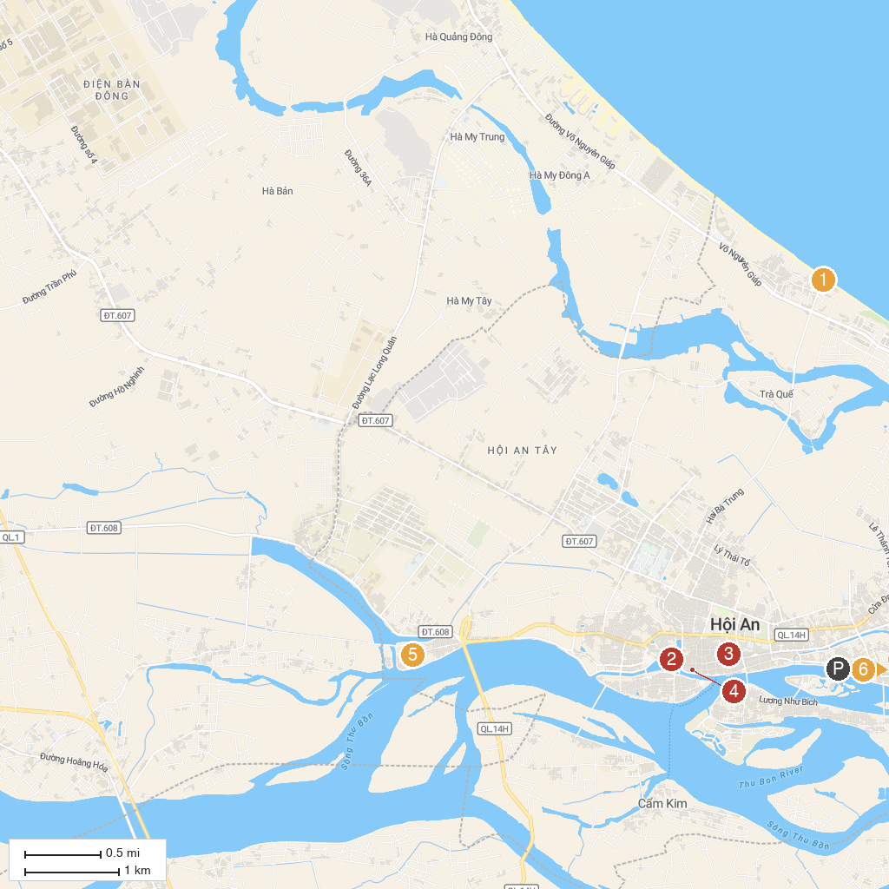
MAP KEY
1. An Bang Beach | 5. Thanh Hà Terracotta Park
2. Nguyen Tuong Family Chapel | 6. Cua Dai Lighthouse
3. Rehahn Gallery | 7. Legend Danang Golf Resort
4. Old House of Tan Ky | 8. Museum of Sa Huynh - Champa culture
P. Cruise port / terminal
Map © MapTiler © OpenStreetMap contributors · cruiseports.org

