Homer, Alaska, USA
The 'Cosmic Hamlet by the Sea' at the end of the road — Homer dishes up world-class halibut fishing, sea otter sightings off the Spit docks, and floatplane flights to bear country.
⚓ Pier or tender (ship-size dependent) · 🕒 Typical call: 8-10 hrs · 💵 USD · 🗣️ English · 🐻 Bear-viewing hub
✍️ MY DAY IN PORT (FILL IN)
Ship / Date
In port | arrive ______ · all aboard ______
Booked excursion
Notes / meeting point
GETTING ASHORE
- Docking: Deep Water Dock (mid-size ships); larger ships anchor & tender to Small Boat Harbor
- Walk to Town: Spit shops 10-15 min walk from dock; downtown Homer ~4.5 miles (shuttle/taxi needed)
- Best For: Halibut fishing, bear-viewing flights, kayaking Kachemak Bay, local art galleries
- Don't Miss: Salty Dawg Saloon, sea otters at the boat harbor, Bishop's Beach tide pools
GETTING AROUND
- 🚕 Taxi: $15–$25 one-way (estimated) — Several local taxi companies serve Homer including Homer Yellow Cab, Bayside Taxi, Cole's Cab, and Nick's Taxi. Most off
TOP THINGS TO DO
- Bear Viewing Floatplane to Katmai or Lake Clark — Homer's signature bucket-list experience: a floatplane hop to Katmai or Lake Clark National Park to watch massive brown bears…
- Halibut Fishing Charter — Homer is the Halibut Fishing Capital of the World.
- Water Taxi to Halibut Cove — Cross Kachemak Bay to Halibut Cove, a tiny artist enclave built on pilings over the water, reachable only by boat.
- Kayaking Kachemak Bay State Park — Take a water taxi across the bay and paddle through protected coves and kelp forests.
- Homer Spit Boardwalk & Art Galleries — The Spit's colorful boardwalks are lined with local artists' galleries, charter offices, and quirky boutiques.
BEST WALKS
- Homer Spit Stroll: ~1.5 miles one-way | Flat & paved | 30-45 min — Walk the length of the Spit from the dock area toward the Seafarer's Memorial and back.
- Bishop's Beach Tide Pool Walk: ~1 mile | Easy | Low tide best | Shuttle to downtown — Take the trolley or taxi to downtown and walk down to Bishop's Beach.
WEATHER · DAYLIGHT · MONEY
Month | High °F | Low °F | Rainy days
May | 55 | 40 | 14
Jul | 63 | 50 | 14
Sep | 57 | 44 | 17
Daylight: May 5:30AM–10:36PM · Jul 5:14AM–11:08PM · Sep 7:36AM–8:24PM
Representative sunrise/sunset — 2025, 15th of each month; local civil time including DST (America/Anchorage). Source: Astral; not a forecast or climate average.
cruiseports.org/homer-ak · Confirm terminal & all-aboard time with your ship

Homer, Alaska, USA — Port Map
Red = walkable sights · Amber = excursions farther out · P = cruise terminal
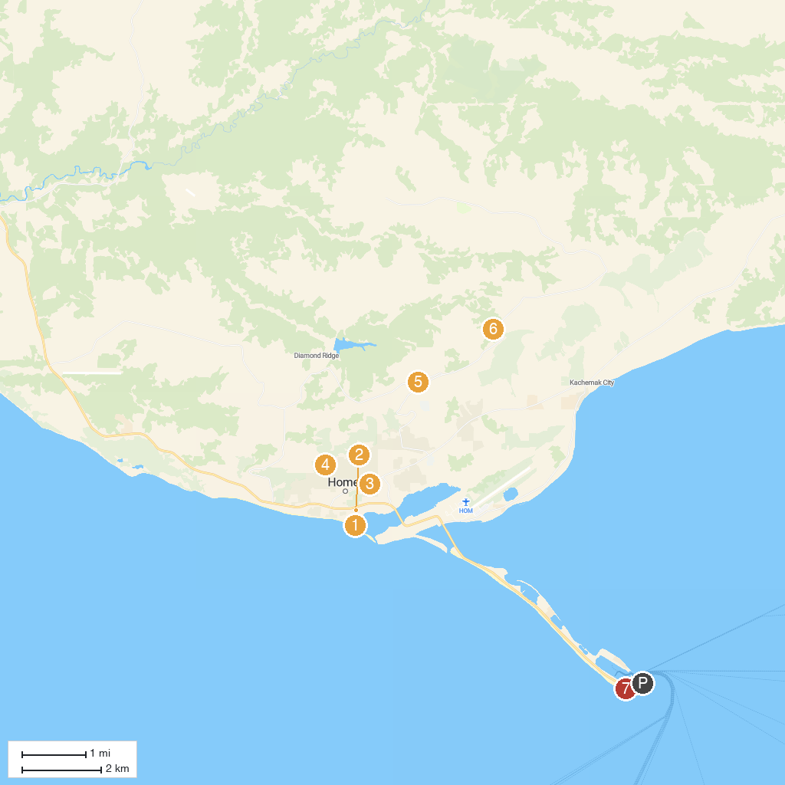
MAP KEY
1. Bishop’s Beach | 5. Viewpoint Skyline Dr
2. Alaska Maritime National Wildlife Refuge Visitor Center (Islands and Ocean) | 6. Wynn Nature Center - Center for Alaskan Coastal Studies
3. Ptarmigan Arts | 7. Seafarer's Memorial
4. Karen Hornaday Park
P. Cruise port / terminal
Map © MapTiler © OpenStreetMap contributors · cruiseports.org

