Honfleur, Normandy, France
Unchanged since the 17th century, Honfleur's slate-fronted harbour houses and cobbled lanes inspired Monet and Boudin — and they'll stop you in your tracks too. Pair that with Normandy cider, fresh mussels, and a wooden church built by shipwrights, and you've got one of France's most rewarding port days.
⚓ Pier (small–medium ships) · 🕒 Typical call: 6–8 hrs · 💶 Euro · 🗣️ French
✍️ MY DAY IN PORT (FILL IN)
Ship / Date
In port | arrive ______ · all aboard ______
Booked excursion
Notes / meeting point
GETTING ASHORE
- Docking: Pier — Quai en Seine, ~1.5 km from Vieux Bassin; large ships use Le Havre
- Walk to centre: 15–20 min on foot; shuttle buses and taxis available at pier
- Best For: Historic architecture, Impressionist art, Norman food & cider
- Don't Miss: Vieux Bassin harbour, Église Sainte-Catherine (largest wooden church in France)
GETTING AROUND
- 🚕 Taxi: ~€70 each way — Taxis are available at the Le Havre cruise terminal. The fare is roughly €70 each way for the car (not per person), so s
- 📱 Rideshare: ✅ Uber
TOP THINGS TO DO
- Vieux Bassin & Old Town Walk — The 1681 inner harbour lined with 6-storey slate-faced houses is Honfleur's centrepiece.
- Musée Eugène Boudin — Honfleur's premier art museum celebrates its most famous son and the pre-Impressionist painters who gathered here.
- Église Sainte-Catherine — Built by shipwrights after the Hundred Years' War, this is France's largest wooden church.
- Les Maisons Satie — An immersive, audio-guided museum honouring composer Erik Satie, born here in 1866.
- Norman Cider & Seafood Lunch — Head one street back from the harbour to find authentic bistros serving moules à la normande, buckwheat galettes, fresh oysters…
BEST WALKS
- Vieux Bassin Harbour Loop: 1.5 km · 30–45 min · Easy · Free — Start at the Lieutenancy gatehouse on the east quay of the Old Harbour, walk the full harbour…
- Promenade to Plage du Butin: 3 km round-trip · 50 min · Easy · Free — Follow the Promenade des Personnalités along the Seine estuary from the Jardin des Personnalités to…
WEATHER · DAYLIGHT · MONEY
Month | High °F | Low °F | Rainy days
May | 63 | 49 | 12
Jul | 73 | 59 | 10
Sep | 68 | 55 | 11
Daylight: May 6:15AM–9:36PM · Jul 6:09AM–9:59PM · Sep 7:35AM–8:11PM
cruiseports.org/honfleur · Confirm terminal & all-aboard time with your ship

Honfleur, Normandy, France — Port Map
Red = walkable sights · Amber = excursions farther out · P = cruise terminal
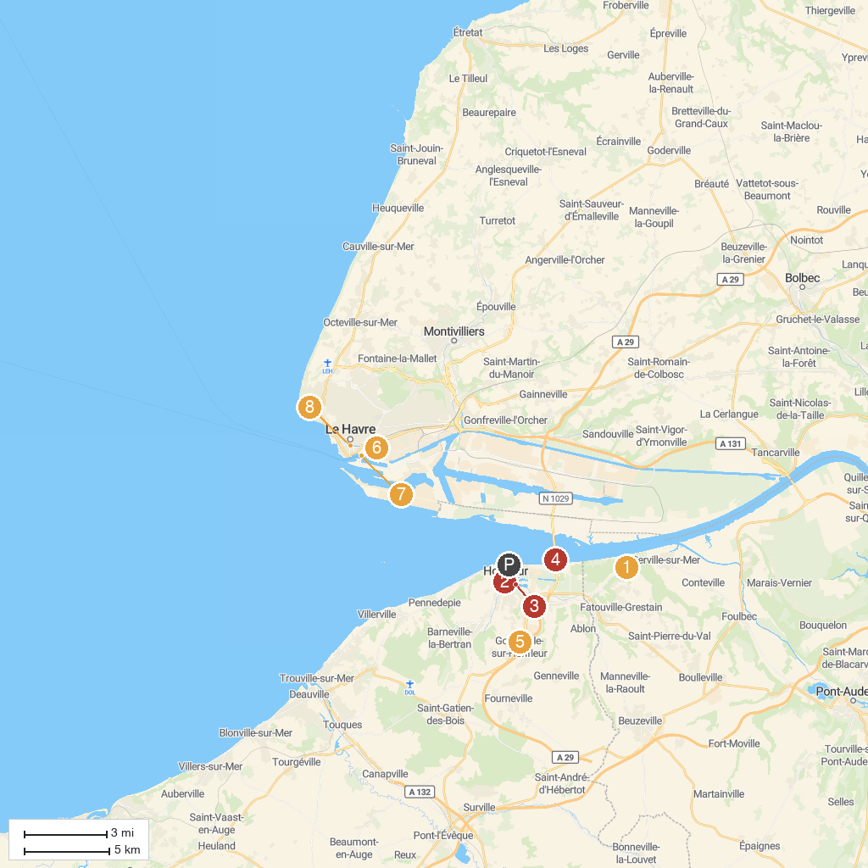
MAP KEY
1. Grestain Abbey | 5. DOMAINE DE LA POMMERAIE
2. Jardin du Tripot | 6. Gulli Parc
3. Blockhaus de l'ancienne Gare Ferroviaire | 7. Port Center - Haropa Place
4. Pont de Normandie | 8. Monuments aux morts
P. Cruise port / terminal
Map © MapTiler © OpenStreetMap contributors · cruiseports.org

