Hong Kong, China
Vertical skyscrapers meet ancient temples, neon night markets, and a harbour that glitters at 8 PM. Hong Kong rewards every type of cruiser — from the dim sum devotee to the cable-car adventurer — and its world-class MTR makes it all effortlessly reachable.
⚓ Docked (Ocean Terminal or Kai Tak) · 🕒 Typical call: 8-12 hrs · 💵 Hong Kong Dollar (HKD ~7.8:1 USD) · 🗣️ Cantonese & English
✍️ MY DAY IN PORT (FILL IN)
Ship / Date
In port | arrive ______ · all aboard ______
Booked excursion
Notes / meeting point
GETTING ASHORE
- Docking: Ocean Terminal (central Tsim Sha Tsui) or Kai Tak Cruise Terminal (Kowloon Bay — not walkable to city centre)
- Walk to centre: Ocean Terminal: steps from Harbour City mall and Star Ferry. Kai Tak: taxi or shuttle required (~15-25 min to TST)
- Best For: Harbour skylines, dim sum and Cantonese food, street markets, temples, cable cars, and the Big Buddha
- Don't Miss: Victoria Peak at golden hour and the Star Ferry crossing at dusk — ideally timed for the 8 PM Symphony of Lights
GETTING AROUND
- 🚕 Taxi: Ask the operator for the current fare — Red taxis are metered and widely available. Ask for the metered fare from Kai Tak to Tsim Sha Tsui or Central. Ocean Ter
- 📱 Rideshare: ✅ Uber
- 🚌 Hop-on hop-off: ✅
TOP THINGS TO DO
- Victoria Peak & Peak Tram — Ride the historic funicular railway up a steep incline to Hong Kong's most famous viewpoint.
- Lantau Island — Big Buddha, Po Lin & Tai O — Take the MTR to Tung Chung then the Ngong Ping 360 cable car for sweeping South China Sea views before reaching the 34-metre Tian…
- Star Ferry & Symphony of Lights — The 10-minute Star Ferry crossing between Tsim Sha Tsui and Central costs HKD 3-4 and delivers a front-row seat to one of the…
- Dim Sum & Cantonese Food Tour — Dim sum in Hong Kong is a ritual — steamer baskets of har gow, siu mai, char siu bao, and egg tarts in a packed teahouse is…
- Kowloon Temples — Wong Tai Sin & Chi Lin Nunnery — Wong Tai Sin Temple is one of Hong Kong's most vivid Taoist shrines — colourful, active, and alive with fortune-tellers (kau cim…
BEST WALKS
- Tsim Sha Tsui Waterfront to Mong Kok Markets: 4 km · Easy · ~2 hrs — Start at Ocean Terminal and walk the TST Promenade past the Avenue of Stars and the Clock Tower for…
- Central Mid-Levels Escalator & Hollywood Road: 2 km · Easy · ~1 hr — Ride the world's longest outdoor covered escalator system from Central Market up through SoHo…
WEATHER · DAYLIGHT · MONEY
Month | High °F | Low °F | Rainy days
May | 82 | 76 | 23
Jul | 86 | 80 | 25
Sep | 85 | 78 | 20
Daylight: May 5:43AM–6:55PM · Jul 5:48AM–7:10PM · Sep 6:10AM–6:26PM
cruiseports.org/hong-kong · Confirm terminal & all-aboard time with your ship

Hong Kong, China — Port Map
Red = walkable sights · Amber = excursions farther out · P = cruise terminal
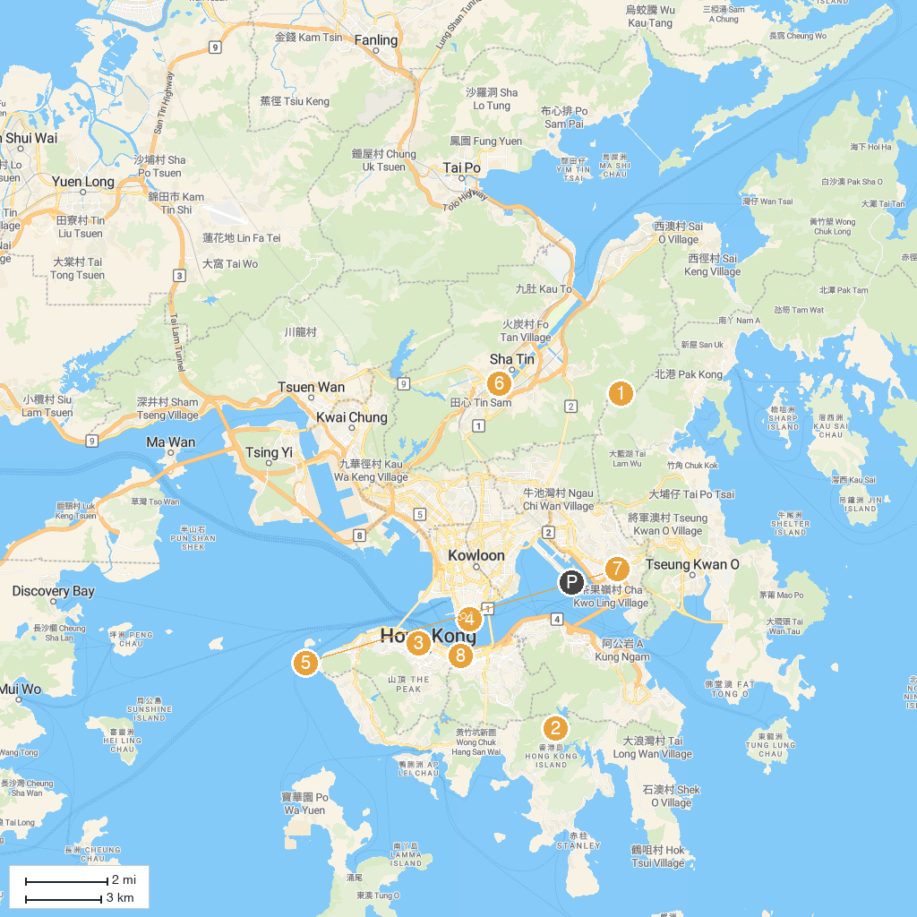
MAP KEY
1. Wong Ngau Shan (604m) | 5. Hong Kong Cultural Centre
2. Tai Tam Country Park | 6. Hong Kong Heritage Museum
3. The Center | 7. Hong Kong Space Museum
4. Avenue of Stars HK | 8. Hong Kong Arts Centre
P. Cruise port / terminal
Map © MapTiler © OpenStreetMap contributors · cruiseports.org

