Honiara, Guadalcanal, Solomon Islands
The capital of the Solomon Islands sits on the shore of Ironbottom Sound, where dozens of WWII warships and aircraft rest on the ocean floor. Raw, authentic, and unforgettable — Honiara is history you can swim through.
⚓ Docked (new Millennium Terminal, 2024) · 🕒 Typical call: 7-9 hrs · 💵 Solomon Islands Dollar (SBD) — cash preferred · 🗣️ English & Solomon Pijin · ⚔️ Major WWII history site
✍️ MY DAY IN PORT (FILL IN)
Ship / Date
In port | arrive ______ · all aboard ______
Booked excursion
Notes / meeting point
GETTING ASHORE
- Docking: Pier at Point Cruz — new Millennium Cruise Passenger Terminal opened Dec 2024; very large ships may still tender
- Walk to center: 5–10 min flat walk to Mendana Ave; 15–20 min to Central Market
- Best For: WWII history, shipwreck snorkeling, local markets, Melanesian culture
- Don't Miss: Ironbottom Sound overlook, Honiara Central Market, Vilu Military Museum
GETTING AROUND
- 🚕 Taxi: SBD 50–150 (~USD 6–18) per trip — Taxis have no meters — agree on the fare before you get in. Short city hops from the wharf are inexpensive; negotiate fi
TOP THINGS TO DO
- Vilu Military Museum & WWII Relics — About 45 minutes west of town, this open-air museum displays Japanese and American fighter planes, artillery, and vehicles…
- Skyline Ridge US Guadalcanal Memorial — High above town, this memorial honors Allied soldiers killed during the Guadalcanal Campaign and looks out over Ironbottom Sound…
- Bonegi Beach Shipwreck Snorkeling — The Kinugawa Maru, a massive Japanese transport ship, lies grounded right on Bonegi Beach 30 minutes west of town.
- Bloody Ridge (Edson's Ridge) Battlefield — Scene of one of Guadalcanal's fiercest battles, now a National Peace Park.
- Honiara Central Market & Town Walk — The Central Market on Mendana Avenue is a sensory overload of tropical fruit, fresh fish, betel nut, shell money, and hand-woven…
BEST WALKS
- Mendana Avenue Town Loop: 1.5 km · 30–40 min · flat — Walk from Point Cruz terminal along Mendana Avenue past the National Museum, BSP bank, and shops to…
- National Parliament Building: 1 km each way · easy · 20 min — Head uphill from Mendana Avenue to the distinctive conical-roofed Parliament Building.
WEATHER · DAYLIGHT · MONEY
Month | High °F | Low °F | Rainy days
May | 84 | 76 | 21
Jul | 83 | 75 | 18
Sep | 84 | 75 | 20
Daylight: May 6:26AM–6:06PM · Jul 6:37AM–6:14PM · Sep 6:14AM–6:16PM
cruiseports.org/honiara · Confirm terminal & all-aboard time with your ship

Honiara, Guadalcanal, Solomon Islands — Port Map
Red = walkable sights · Amber = excursions farther out · P = cruise terminal
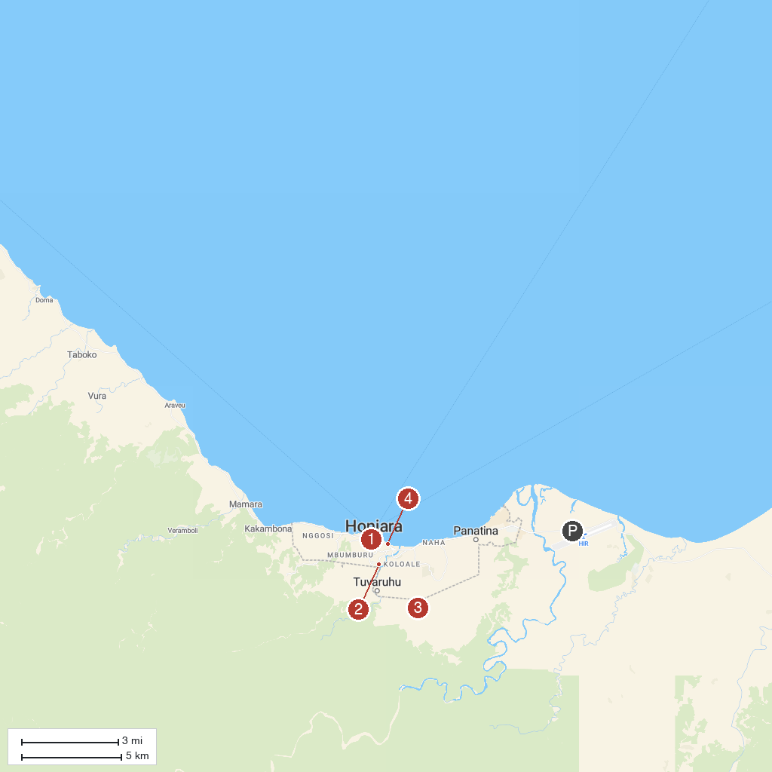
MAP KEY
1. National Museum of Solomon Islands | 4. Bloody Ridge Battlefield
2. Vilu War Museum | 5. Central Market Honiara
3. Guadalcanal American Memorial
P. Cruise port / terminal
Map © MapTiler © OpenStreetMap contributors · cruiseports.org

