Hopedale, Nunatsiavut, Canada
One of Canada's most remote cruise calls, Hopedale is the legislative capital of Nunatsiavut — an Inuit self-governing territory on the wild Labrador coast, where 18th-century Moravian mission buildings and living Indigenous culture coexist at the edge of the Arctic.
⚓ Tender (no cruise pier) · 🕒 Typical call: 5–7 hrs · 💵 Canadian Dollar (CAD) · 🗣️ English & Inuttitut · 🧭 Expedition itineraries
✍️ MY DAY IN PORT (FILL IN)
Ship / Date
In port | arrive ______ · all aboard ______
Booked excursion
Notes / meeting point
GETTING ASHORE
- Docking: Tender — ships anchor in Hopedale Run; Zodiacs to government wharf
- Walk to center: 5 min from wharf to Moravian Mission; everything within 15 min
- Best For: Inuit culture, historic mission, indigenous art, sub-Arctic scenery
- Don't Miss: Hopedale Moravian Mission National Historic Site & Nunatsiavut Assembly
GETTING AROUND
TOP THINGS TO DO
- Hopedale Moravian Mission National Historic Site — The oldest surviving frame-building complex of European construction in Canada east of Quebec, established 1782.
- Nunatsiavut Assembly & Inuit Art — Visit the striking igloo-inspired parliament building of the Inuit self-government, adorned with soapstone carvings and Inuit…
- Nanuk Hill Lookout Hike — A short but steep climb behind the community rewards you with sweeping panoramic views over the harbor, the surrounding islands…
- Zodiac / Coastal Wildlife Cruise — Many expedition ships offer optional Zodiac tours around the harbor and nearby islands, where you can spot seals, seabirds, and…
- Inuit-Moravian Brass Band & Throat Singing — When coordinated with the ship, local performers showcase the extraordinary Hopedale brass band — a living tradition of Inuit…
BEST WALKS
- Town & Mission Loop: 1.5 km · 20–30 min · Easy gravel roads — From the government wharf, walk along the waterfront to the Moravian Mission complex, continue past…
- Nanuk Hill Lookout: 0.8 km · 30 min round-trip · Moderate incline — From behind the Moravian Mission, a rough track climbs Nanuk Hill for commanding views over the…
WEATHER · DAYLIGHT · MONEY
Month | High °F | Low °F | Rainy days
May | 45 | 30 | 13
Jul | 61 | 46 | 13
Sep | 53 | 40 | 14
Daylight: May 5:00AM–8:05PM · Jul 4:40AM–8:25PM · Sep 6:05AM–6:25PM
cruiseports.org/hopedale-nl · Confirm terminal & all-aboard time with your ship

Hopedale, Nunatsiavut, Canada — Port Map
Red = walkable sights · Amber = excursions farther out · P = cruise terminal
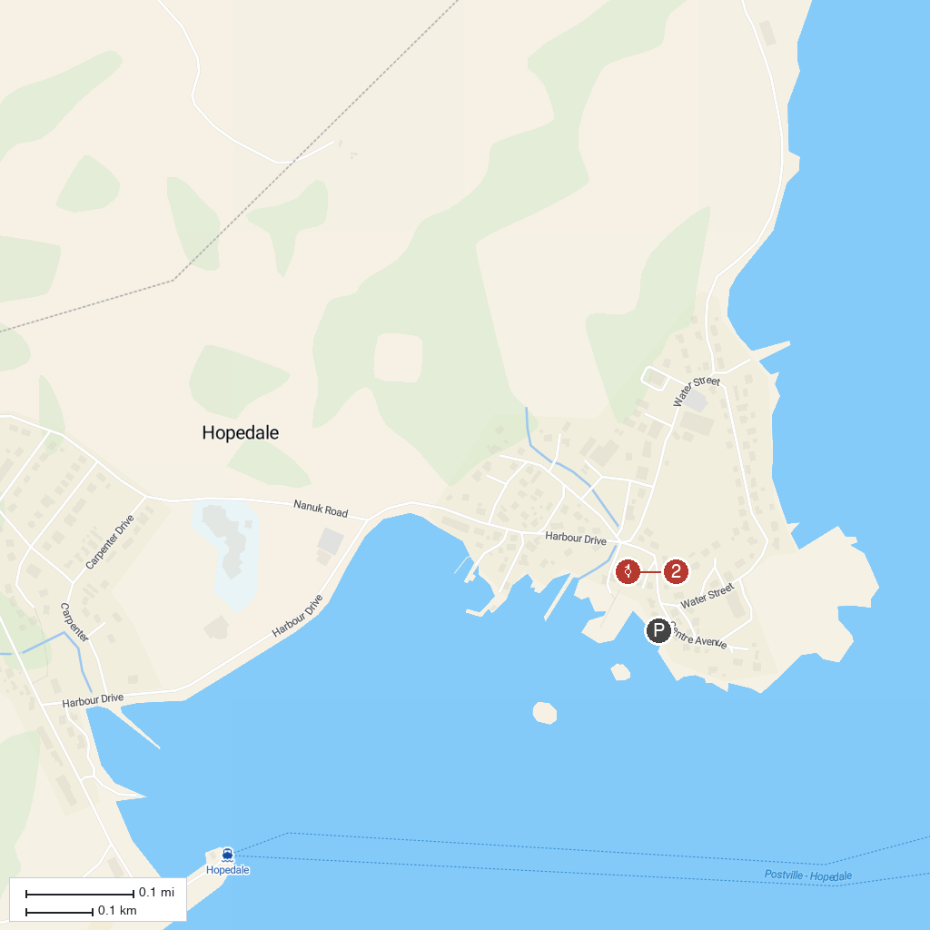
MAP KEY
1. Hopedale Mission National Historic Site | 2. Agvituk Historical Society Museum
P. Cruise port / terminal
Map © MapTiler © OpenStreetMap contributors · cruiseports.org

