Houghton, Michigan, USA
A college town carved into copper country, Houghton sits on the Portage Waterway at the edge of the Keweenaw Peninsula — America's first great mining boom region, still wild and unhurried.
⚓ Docked (Houghton City Pier) · 🕒 Typical call: 8-10 hrs · 💵 USD · 🗣️ English (Finnish heritage) · 🏔️ Upper Peninsula, Michigan
✍️ MY DAY IN PORT (FILL IN)
Ship / Date
In port | arrive ______ · all aboard ______
Booked excursion
Notes / meeting point
GETTING ASHORE
- Docking: Houghton City Pier (350+ ft); larger ships may anchor off Dollar Bay and tender
- Walk to downtown: Under 5 min from pier to Shelden Ave shops
- Best For: Copper mining history, Keweenaw scenery, Finnish culture
- Don't Miss: Quincy Mine tour, A.E. Seaman Mineral Museum, pasties
GETTING AROUND
- 🚕 Taxi: $8–25+ — Several local services operate in the area, including Copper Country Limo & Taxi (906-370-4761) and Superior Transportat
- 📱 Rideshare: ✅ Uber, Lyft
TOP THINGS TO DO
- Quincy Mine Tour — Ride a cog-rail tram down the hillside, then descend into a shaft of this historic copper mine, which operated from the 1840s…
- A.E. Seaman Mineral Museum — Michigan's official state mineral museum on the Michigan Tech campus holds one of the finest collections in the country…
- Keweenaw Peninsula Scenic Drive — Head north on US-41 through Copper Harbor to Brockway Mountain Drive, with panoramic Lake Superior views from 1,300 feet.
- Keweenaw National Historical Park — Over 20 heritage sites spread across the peninsula tell the story of the world's greatest copper rush, which drew Finnish…
- Isle Royale Ferry Day Trip — Houghton is a main gateway to Isle Royale National Park.
BEST WALKS
- Waterfront to Downtown Houghton: 0.5 miles · Easy-moderate · 15 min — From the City Pier, walk up the hill to Shelden Avenue — the main street lined with pasty shops…
- Houghton Waterfront Trail: 1.5 miles · Easy · 30 min — Flat paved trail along the Keweenaw Waterway heading east from the pier.
- Michigan Tech Campus & Mineral Museum: 1 mile · Moderate (uphill) · 20 min walk — Head uphill from downtown to the Michigan Technological University campus.
WEATHER · DAYLIGHT · MONEY
Month | High °F | Low °F | Rainy days
May | 60 | 43 | 9
Jul | 76 | 60 | 8
Sep | 67 | 55 | 12
Daylight: May 6:18AM–9:23PM · Jul 6:14AM–9:45PM · Sep 7:32AM–8:05PM
cruiseports.org/houghton-mi · Confirm terminal & all-aboard time with your ship

Houghton, Michigan, USA — Port Map
Red = walkable sights · Amber = excursions farther out · P = cruise terminal
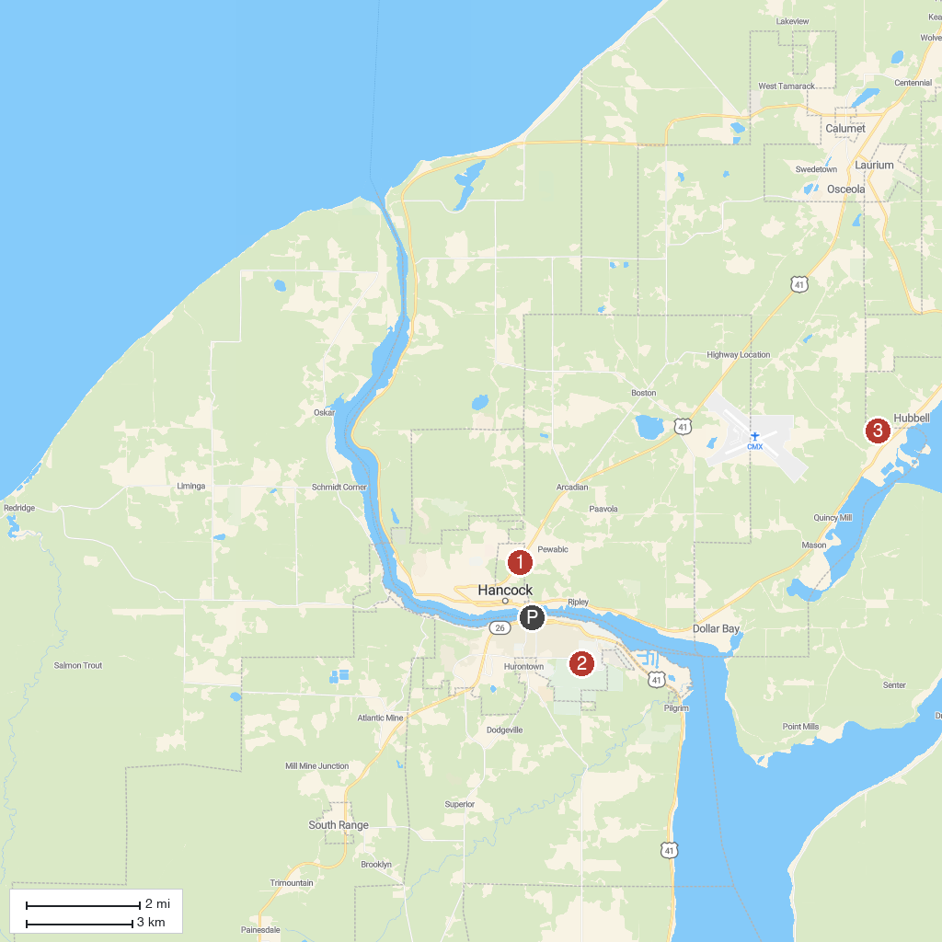
MAP KEY
1. Quincy Mine | 4. F.J. McLain State Park
2. A.E. Seaman Mineral Museum | 5. Keweenaw National Historical Park
3. Hungarian Falls
P. Cruise port / terminal
Map © MapTiler © OpenStreetMap contributors · cruiseports.org

