Huatulco, Oaxaca, Mexico
Nine emerald bays carved into a jungle-backed coastline — Huatulco is Mexico's eco-certified gem where Oaxacan food culture meets swim-ready Pacific beaches steps from your gangway.
⚓ Pier (docked) · 🕒 Typical call: 7-9 hrs · 💵 Mexican Peso (USD accepted) · 🗣️ Spanish · 🌿 UNESCO-recognized eco-destination
✍️ MY DAY IN PORT (FILL IN)
Ship / Date
In port | arrive ______ · all aboard ______
Booked excursion
Notes / meeting point
GETTING ASHORE
- Docking: Pier — Santa Cruz Bay cruise terminal
- Walk to beach: 3–5 min to Playa Santa Cruz
- Best For: Beaches, snorkeling, Oaxacan food
- Don't Miss: Tlayudas and mezcal in La Crucecita
GETTING AROUND
- 🚕 Taxi: $3–$6 USD — Official fixed-rate taxis operate from the cruise pier to La Crucecita (city center) for approximately 45–80 MXN (~$3–$5
- 📱 Rideshare: ❌ not available
TOP THINGS TO DO
- Nine Bays Boat Tour — Charter a panga or catamaran from the marina to cruise the bays accessible only by sea — snorkel in hidden coves, spot dolphins…
- Beach Day at Playa Maguey — Ten minutes by taxi, this golden-sand bay is lined with palapa restaurants.
- Snorkeling at Playa La Entrega — A protected cove with a coral reef teeming with tropical fish.
- Copalita Archaeological Zone — The only major Mesoamerican site on Mexico's Pacific coast — 2,500-year-old ruins with a ball court and museum set in jungle, 20…
- La Crucecita Market & Oaxacan Lunch — Walk the zócalo, see the famous 65-foot Virgin of Guadalupe ceiling mural, then sit down for mole negro and mezcal at a local…
BEST WALKS
- Pier to Playa Santa Cruz & Marina: 10–15 min · Easy · Free — A flat waterfront stroll from the ship to the beach and marina.
- La Crucecita Town Walk: 30 min walk or 5-min taxi · Easy · Free — The real town of Huatulco.
WEATHER · DAYLIGHT · MONEY
Month | High °F | Low °F | Rainy days
May | 88 | 73 | 19
Jul | 86 | 71 | 23
Sep | 83 | 71 | 27
Daylight: May 5:55AM–6:47PM · Jul 6:02AM–7:00PM · Sep 6:13AM–6:26PM
cruiseports.org/huatulco · Confirm terminal & all-aboard time with your ship

Huatulco, Oaxaca, Mexico — Port Map
Red = walkable sights · Amber = excursions farther out · P = cruise terminal
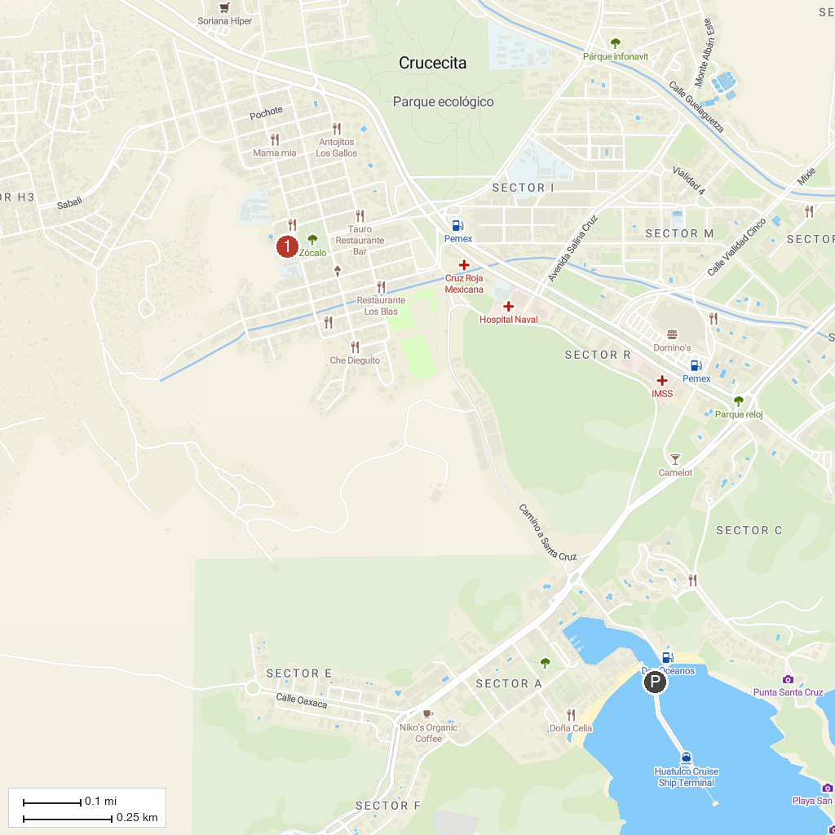
MAP KEY
1. Hagia Sofia Huatulco | 2. Iglesia de la Crucecita
P. Cruise port / terminal
Map © MapTiler © OpenStreetMap contributors · cruiseports.org

