Hubbard Glacier, Alaska, USA
No town, no pier — just 400-foot walls of ancient ice collapsing into the sea with a boom heard miles away. Hubbard Glacier is North America's largest tidewater glacier and one of the few still advancing, making every ship visit a front-row seat to a living, roaring spectacle.
⚓ Scenic cruising — no docking or tendering · 🕒 Typical time: 3-6 hrs in bay · 💵 No shore spending (onboard only) · 🗣️ English · 🧊 Active calving glacier
✍️ MY DAY IN PORT (FILL IN)
Ship / Date
In port | arrive ______ · all aboard ______
Booked excursion
Notes / meeting point
GETTING ASHORE
- Docking: No pier — ships cruise Disenchantment Bay, 0.5–1 mile from the face
- Glacier Size: 76 miles long, 7 miles wide at its face; ice cliffs up to 400 ft above waterline
- Best For: Glacier calving, wildlife spotting, photography, onboard naturalist talks
- Don't Miss: Bow deck as the ship rotates — and listening for 'White Thunder' calving booms
GETTING AROUND
- 📱 Rideshare: ❌ not available
TOP THINGS TO DO
- Glacier Wilderness Explorer (Ship-Launched) — Board a custom expedition catamaran or small vessel directly from your cruise ship and cruise through Disenchantment Bay among…
- Wildlife Spotting from Deck — Harbor seals haul out on ice floes near the glacier face.
- Zodiac or Kayak Launch (Expedition Lines) — Smaller expedition ships (Lindblad, Quark, Hurtigruten) deploy Zodiacs and kayaks to paddle among icebergs within Disenchantment…
- Onboard Naturalist Program — Most Alaska cruise lines station a naturalist on the bridge deck during the glacier visit.
BEST WALKS
- Deck Walk: Bow to Stern for Best Views: Onboard · Any fitness level · 30–90 min — Make a full circuit of the ship's outer decks as the captain rotates.
WEATHER · DAYLIGHT · MONEY
Month | High °F | Low °F | Rainy days
May | 51 | 43 | 15
Jul | 60 | 53 | 15
Sep | 56 | 47 | 20
Daylight: May 4:43AM–9:48PM · Jul 4:28AM–10:20PM · Sep 6:48AM–7:37PM
cruiseports.org/hubbard-glacier · Confirm terminal & all-aboard time with your ship

Hubbard Glacier, Alaska, USA — Port Map
Red = walkable sights · Amber = excursions farther out · P = cruise terminal
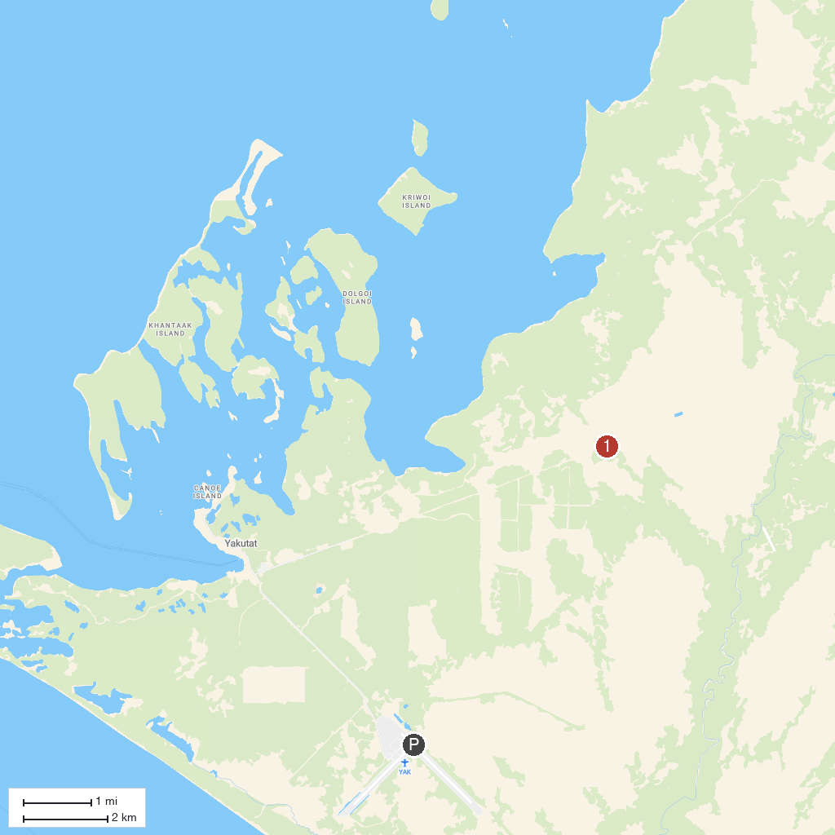
MAP KEY
1. Hubbard Glacier
P. Cruise port / terminal
Map © MapTiler © OpenStreetMap contributors · cruiseports.org

