Icy Strait Point, Hoonah, Alaska, USA
A private Alaska Native-owned port built around adventure — dock steps from the world's largest ZipRider, brown bear habitat, and the real Tlingit village of Hoonah just up the road.
⚓ Docked (private pier) · 🕒 Typical call: 7–9 hrs · 💵 US Dollar (USD) · 🐻 Brown bear country · 🗣️ English
✍️ MY DAY IN PORT (FILL IN)
Ship / Date
In port | arrive ______ · all aboard ______
Booked excursion
Notes / meeting point
GETTING ASHORE
- Docking: Private pier — walk directly ashore
- Walk to village: ~1.5 miles to Hoonah (shuttle available)
- Best For: ZipRider · Bears · Tlingit culture
- Don't Miss: Brown bear viewing tour
GETTING AROUND
- 🚕 Taxi: $7–$10 per person — Local taxis serve the short run from the port to Hoonah (about 3 minutes). Fares run $7–$10 per person each way.
- 📱 Rideshare: ❌ not available
TOP THINGS TO DO
- ZipRider — World's Largest Zip Line — Six side-by-side tracks drop roughly 1,300 feet of vertical over about 5,330 feet to sea level.
- Brown Bear Viewing — A guided tour by boat and/or vehicle into prime brown bear habitat around Hoonah.
- Whale Watching in Icy Strait — Icy Strait is one of Southeast Alaska's premier humpback whale feeding grounds.
- Hoonah Village & Tlingit Culture — The port is built on land owned by the Huna Totem Corporation, and the nearby village of Hoonah is a real Alaska Native community.
- Kayaking & Nature Trails — Sea kayak in the protected waters off the port or hike the Icy Strait Point Nature Trail through old-growth Sitka spruce forest…
BEST WALKS
- Icy Strait Point Nature Trail: ~1.1 mile loop · Easy · ~30 min — A gentle forested loop trail starting behind the cannery, winding through old-growth rainforest…
- Port to Hoonah Village Stroll: ~1.5 miles one-way · Easy · Flat shore path — Skip the shuttle and walk the paved shore path from the port into Hoonah village (about 20–30…
WEATHER · DAYLIGHT · MONEY
Month | High °F | Low °F | Rainy days
May | 54 | 43 | 14
Jul | 62 | 53 | 16
Sep | 56 | 48 | 19
Daylight: May 4:36AM–9:21PM · Jul 4:22AM–9:51PM · Sep 6:32AM–7:19PM
cruiseports.org/icy-strait-point · Confirm terminal & all-aboard time with your ship

Icy Strait Point, Hoonah, Alaska, USA — Port Map
Red = walkable sights · Amber = excursions farther out · P = cruise terminal
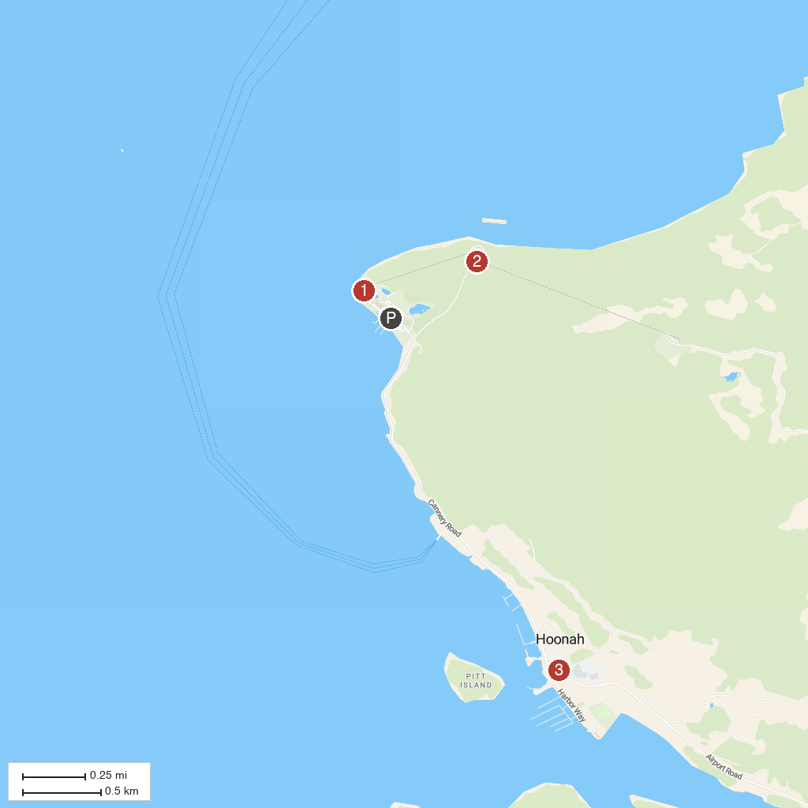
MAP KEY
1. Icy Strait Point ZipRider | 3. Hoonah Totem Park
2. Skyline Gondola
P. Cruise port / terminal
Map © MapTiler © OpenStreetMap contributors · cruiseports.org

