Igoumenitsa, Epirus, Greece
Northwest Greece's gateway port punches above its modest looks. Dock steps from a pine-rimmed gulf, then fan out to UNESCO monasteries perched on Meteora's spires, the mythological Acheron River, or the candy-colored town of Parga.
⚓ Pier (always docked) · 🕒 Typical call: 8–10 hrs · 💶 Euro (€) · 🗣️ Greek / English widely spoken at port
✍️ MY DAY IN PORT (FILL IN)
Ship / Date
In port | arrive ______ · all aboard ______
Booked excursion
Notes / meeting point
GETTING ASHORE
- Docking: Deep-water berth at New Port — always docked, no tender
- Walk to center: ~1.5 km (15–20 min flat walk) to waterfront promenade
- Best For: Day trips: Meteora, Parga, Acheron River, Butrint (Albania)
- Don't Miss: Bella Vraka beach at Syvota — shallow turquoise walk to a tiny island
GETTING AROUND
- 🚕 Taxi: €4–€6 — Taxis wait at the port exit. Base fare is €3, plus ~€1/km; the short ride to the city center costs roughly €4–6 includin
- 📱 Rideshare: ❌ not available
TOP THINGS TO DO
- Meteora Monasteries — Six Eastern Orthodox monasteries perched atop towering sandstone pillars — one of the most surreal sights in all of Europe.
- Acheron River (River Styx) — Trek through the crystal-clear gorge of the mythological underworld river.
- Parga — the Ionian Jewel — A colorful hillside town draped around a Venetian castle overlooking turquoise bays.
- Butrint Archaeological Site, Albania — Greek, Roman, Byzantine, and Venetian ruins layered inside a national park on an Albanian peninsula.
- Bella Vraka Beach at Syvota — Walk through knee-deep turquoise water to a green islet — dubbed the 'Caribbean of Greece'.
BEST WALKS
- Waterfront Promenade Walk: 1.5 km · 20 min · Flat — From the New Port terminal, walk north along the coastal road to the city's main Paralia (promenade).
- Town Center & Archaeological Museum: 2 km loop · 40 min · Flat — Continue from the promenade into the town center to find the Archaeological Museum of Igoumenitsa…
WEATHER · DAYLIGHT · MONEY
Month | High °F | Low °F | Rainy days
May | 73 | 58 | 9
Jul | 88 | 72 | 2
Sep | 80 | 66 | 8
Daylight: May 6:25AM–8:45PM · Jul 6:24AM–9:05PM · Sep 7:20AM–7:47PM
cruiseports.org/igoumenitsa · Confirm terminal & all-aboard time with your ship

Igoumenitsa, Epirus, Greece — Port Map
Red = walkable sights · Amber = excursions farther out · P = cruise terminal
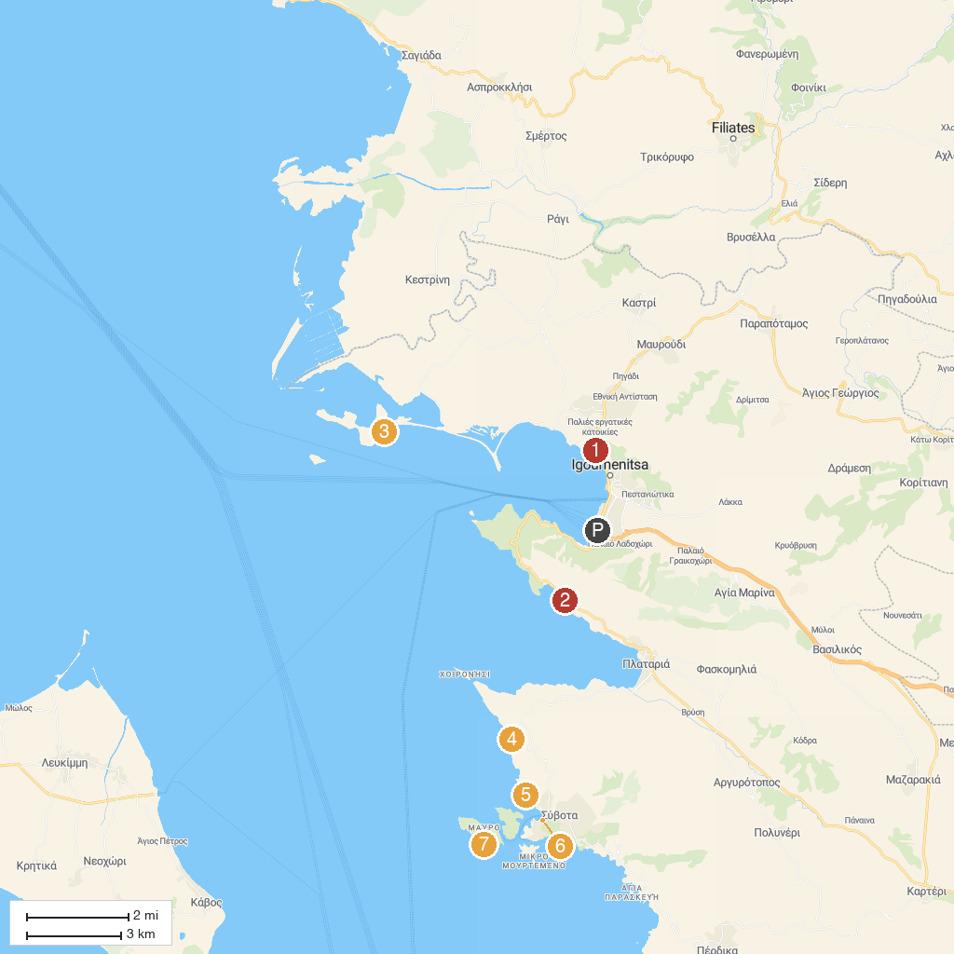
MAP KEY
1. Archaeological Museum of Igoumenitsa | 5. Zeri Beach
2. Παραλία Ελιά | 6. #Sivota
3. Παραλία Πεθαμένου | 7. Papanikolis Cave, Syvota Greece
4. Παραλία Πλάκες
P. Cruise port / terminal
Map © MapTiler © OpenStreetMap contributors · cruiseports.org

